Contents
1 Introduction 5
1.1 Purpose and Scope 5
2 Terminology and concepts 5
2.1 Glossary 5
3 Existing Architectural Overview 6
3.1 Common STK TSY 7
3.2 Component Dependencies 7
3.3 CTSY-LTSY Interface 8
3.3.1 CTSY-LTSY Messages 10
4 Introducing CtsyDispatcher 11
4.1 New Component View 11
4.2 CtsyDispatcher-LicenseeTSY Interface 12
5 Rules and Naming Conventions 17
5.1 Interface Naming Conventions 17
5.1.1 LTSY interface naming conventions (CtsyDispatcher->LTSY) 17
5.1.2 Callback function naming convention (LTSY->CtsyDispatcher) 17
5.2 Rules of the CtsyDispatcher-LTSY interface 18
5.2.1 Version handling between CtsyDispatcher and LTSY 19
6 LTSY Skeleton 28
6.1 Class Layout 28
6.2 Using a separate thread for receiving events from baseband 30
6.3 Removal of Symbian Test Macros 32
6.4 Error Code Mapping 32
6.5 Logging 33
7 Using the SIM ATK TSY. 34
8 LTSY Implementation Guidelines per Functional Area 35
8.1 Call Control Functional Unit 35
8.1.1 Use Case 1: Dial call accepted then hung up 35
8.1.2 Use Case 2: Dialling call fails 41
8.1.3 Use Case 3: Remote Party Reject Call 41
8.1.4 Use Case 4 and 5: Remote Party Hang Up With and Without Inband Info 42
8.1.5 Use Case 6: Dial data call 43
8.1.6 Use Case 7: Answer incoming voice call 49
8.1.7 Use Case 8: Reject Incoming Call 52
8.1.8 Use Case 9 and 10: Cancel dialling when call is in dialling / connecting state 53
8.1.9 Use Case 11: Missed incoming call 54
8.1.10 Use Case 12, 13, 14, 15: Hold, resume and swap a Call 55
8.1.11 Use Case 16: Hold a call and dial another and swap them 60
8.1.12 Use Case 17: Dialling an ISV call 63
8.1.13 Use Case 18: Answering an incoming call from an ISV client 64
8.1.14 Use Case 19, 20: Dialling an Emergency Call (success and immediate failure scenarios) 64
8.1.15 Use Case 21, 22: Transferring a call (success and failure) 67
8.1.16 Use Case 23, 24: Sending a DTMF string 69
8.1.17 Other APIs in this functional unit: 74
8.2 Phone Functional Unit 76
8.2.1 Use-case 1: Boot Phone 77
8.2.2 Use-case 2: Manual Network Detection and Selection 80
8.2.3 Use-case 3: Network Information Updates 82
8.2.4 Additional Phone API’s 84
8.2.5 Implementation Notes 85
8.3 Security Functional Unit 85
8.3.1 Use Case 1: Set FDN Setting with Security Check 85
8.3.2 Use Case 2: Set Lock Setting 89
8.3.3 Use Case 3: Set Lock Setting with Access Denied 91
8.3.4 Use Case 4: Abort Verification of Security Code 93
8.4 EN Phonebook store Functional Unit 96
8.4.1 Use Case 1: Read All entries from the storage 96
8.5 Cell Broadcast Functional Unit 99
8.5.1 Use Case 1: ReceiveMessage – completing with GSM broadcast message 99
8.5.2 Use Case 2: ReceiveMessage – completing with WCDMA broadcast message 102
8.6 ON Phonebook Store Functional Unit 104
8.6.1 Use Case 1: GetInfo, StoreAll entries, ReadAll entries, DeleteAll entries 104
8.7 Phonebook Store Functional Unit 112
8.7.1 Use-case 1,2: Phonebook Store - Open 112
8.7.2 Use-case 3,4: Phonebook Store - Read Entry 116
8.7.3 Use-case 5: Phonebook Store - Delete Entry 118
8.7.4 Use-case 6: Phonebook Store – Delete All 120
8.7.5 Use-case 7: Phonebook Store – Write 121
8.7.6 Use-case 10: Phonebook Store – Get Phonebook Store Information 123
8.7.7 Use-case 11: Phonebook Store – Get Store Information 125
8.7.8 Use-case 12: Phonebook Store – Refresh 126
8.7.9 Use-case 13: Read SMS Entry 128
8.7.10 Use-case 14: Read All SMS Entries 129
8.8 SIM Functional Unit 133
8.8.1 Use-case 1: Managing Access Point Name (APN) Control List 133
8.8.2 Use-case 2: Message Waiting Indicators 137
8.8.3 Other SIM FU API’s 141
8.9 Sms Functional Unit 143
8.9.1 Use Case 1: ReceiveMessage 144
8.9.2 Use Case 2: SendMessage 147
8.10 Multiparty Call Control Functional Unit 151
8.10.1 Use Case 1, 2, 3 - Create and hang up a multiparty conference call (including failure cases) 151
8.10.2 Use Case 4: hang up of remote party in conference call 154
8.10.3 Use Case 5: swap a conference call, add a call to an existing conference 154
8.10.4 Use Case 6: failure to swap a conference call 158
8.10.5 Use Case 7: failure to add a call to a conference 158
8.10.6 Use Case 8, 10 Going one to one in a conference call with two remote parties (success and failure) 158
8.10.7 Use Case 9: Go one-to-one with a conference with a party in a conference with three remote parties 161
8.10.8 Use Case 11: Send DTMF through a conference call 162
8.11 Supplementary Services Functional Unit 162
8.11.1 Use Case 1: Call Barring 162
8.11.2 Use Case 2: Call Forward 166
8.11.3 Use Case 3: Call Waiting 170
8.11.4 Use Case 4: Network Service 174
8.11.5 Use Case 5: USSD 176
8.12 Packet Services Functional Unit 180
8.12.1 Use Case 1 : Attach/Detach 181
8.12.2 Use Case 2 : Set Default Configuration 186
8.12.3 Use Case 3 : Activation - Initialise Context 187
8.12.4 Use Case 3 : Activation - Set Configuration 189
8.12.5 Use Case 3 : Activation - Set QoS 190
8.12.6 Use Case 3 : Activation – Activating/Activated 192
8.12.7 User Case 4 : Modify Existing Context 195
8.12.8 User Case 5: Two Contexts Activation 197
8.12.9 User Case 6: Secondary Context Activation 198
8.12.10 User Case 7: Secondary Context Activation - Remove Packet Filter 200
8.12.11 Unit Test 19: Initialise MBMS Context 202
8.12.12 Unit Test 20: Get MBMS network service status 204
8.12.13 Unit Test 21 & 22: Update the MBMS monitored service list & Update the MBMS Session List 207
8.13 SAT Functional Unit 210
8.13.1 Use Case 1 : Initialisation 210
8.13.2 Use Case 2 : Sample Proactive Command Session with User interaction 212
8.13.3 Use Case 3 : Getting Icon Ef(Img) records, Icon instances and Icon CLUTs 216
8.13.4 Use Case 4 : Setting up the Event list, and example event download (User Activity) 216
8.13.5 Use Case 5 : Call Control functionality 217
8.13.6 Use Case 6 : Timer Management functionality 220
8.13.7 Use Case 7 : Setting the polling interval 220
8.13.8 Use Case 8 : Mo SMS Control functionality 221
8.13.9 Use Case 9 : Sms PP and Cell Broadcast Data Download 224
8.13.10 Use Case 10 : Refresh 226
9 Further Information 228
9.1 People 228
9.2 References 228
Appendix A - Building the CTSY, CtsyDispatcher, LtsySkeleton and MockLTSY 229
Appendix B - Frequently Asked Questions 229
B.1 Why does CtsyDispatcher require that callback APIs be invoked from ETEL thread of execution? 229

Introduction

Purpose and Scope
This document is to aid development of a Licensee TSY. It is written as a supplement to [R2], [R3]. The primary scope of this document is to describe the new LTSY interface that is being written by Symbian that provides a shim between the original CTSY-LTSY interface. This shim is known as CtsyDispatcher.

Terminology and concepts

Glossary
Term | Definition
.h | Header File
API | Application Programming Interface
BB | Baseband
BER-TLV | Basic Encoding Rules - Tag Length Value
Common STK TSY | Common Sim Application Toolkit TSY. Platform independent part of STK TSY
CSTK TSY | Common STK TSY – see above
CTSY | Common TSY. Platform independent part of TSY
CtsyDispatcher | Shim between CTSY and LTSY
CustomAPI | Symbian “custom” API introduced as part of Core OS transfer.
DLL | Dynamic Link Library
ECOM | Epoc Component Object Model
ENUM | Enumeration
EPOC | Precursor to Symbian OS.
Etel (Etel server) | Symbian Telephony Server
Etelmm | Symbian Etel multimode API
Etelpckt | Symbian Etel packet API.
EtelSat | Symbian Etel Sim Application Toolkit API
HAI | Hardware Adaptation Interface
IMEI | International Mobile Equipment Identity
IMPLIB | Implementation Library loading mechanism
IPC | Inter-Process Communication
LIB | Library
Licensee STK TSY | Licensee Sim Application Toolkit TSY. Platform dependent part of STK TSY
LSTK TSY | Licensee STK TSY – see above
LTSY | Licensee TSY. Platform dependent part of TSY. Maps requests coming from CTSY to baseband interface.
MBMS | Multimedia Broadcast Multicast Service
MO | Mobile Originated.
OS | Operating System
QoS | Quality of Service
ROM | Read Only Memory
RSAT | Resource SAT Engine
S60 | Series 60 – User Interface
SAT | Sim Application Toolkit
SIM | Subscriber Identity Module
SMS | Short Messaging Service
STK | Sim Application Toolkit
TSY | Telephony System
UICC | Universal Integrated Circuit Card

Existing Architectural Overview
The typical diagram that is used to show the layering in the Symbian Telephony stack is below. This demonstrates the split of TSY functionality into the two layers – Common TSY layer and Licensee TSY layer.
_
id Component Model
Application layer
Client APIs
Server
Platform independent TSY layer
Platform dependent LTSY layer
Baseband interface
«symbian server»
Etel server
«library»
Etel Core API
«library»
Etelpckt API
«library»
Etelsat API
«library»
Etelmm API
«library»
Licensee API
Licensee Phone Suite
«plugin»
CTSY
Common LTSY
CSTK TSY
SIM ATK LTSY
Baseband
BB Implementation
«library»
custom API
LTSY plugin API
LTSY plugin API
Figure 1 Symbian Telephony stack
Light blue indicates non-Symbian OS components (i.e. Licensee specific).
Component | Description | Symbian standard
Licensee Phone Suite | Suite of applications, engines and utilities that invoke telephony APIs. | No
Etel Core API | Library containing core Etel APIs. | Yes
Etelpckt API | Library containing APIs relating to the packet domain functionality e.g. attach/detach, activate/deactivate context, set/get QoS. | Yes
EtelSat API | Library containing APIs relating to SAT functionality. | Yes
Etelmm API | Library containing APIs covering many telephony areas e.g. SS, call control, network info/registration, sim access | Yes
Licensee API | Custom extension API. Providing additional telephony functionality not offered through Symbian standard APIs | No
Custom API | Originally S60 custom extension API that transferred to Symbian as part of Core OS. | Yes
Etel Server | Symbian telephony server | Yes
CTSY | Generic handling for APIs from Etelpckt, Etel core, EtelMM and custom API. | Yes
CSTK TSY | Generic handling for APIs from EtelSat. | Yes
Common LTSY | LTSY implementation mapping to baseband interface. | No
SIM ATK LTSY | Licensee STK TSY implementation mapping to baseband for SAT related commands | No
Baseband | Baseband interface | No
BB Implementation | Implementation behind baseband interface. | No

Common STK TSY
The Common STK TSY is a much simpler TSY than the CTSY firstly because it only handles the EtelSat IPCs but also because it holds very little state and in fact primarily assembles and disassembles the BER-TLV formatted buffers that correspond to each proactive command and response.
This means the data structures being passed from the CTSY->LTSY are BER-TLV encoded structures, likewise the data passed from SIM ATK LTSY->CTSY is BER-TLV.
The CSTK TSY on receipt of a BER-TLV data message (e.g. proactive command) from the LSTK TSY will decode the structure and map it to the correct EtelSat structure and complete the pending client request.
Likewise, for example, a Terminal Response to be sent to the SAT on the UICC shall be encoded in the CSTK TSY and the BER-TLV buffer then sent to the LSTK TSY for transfer to the UICC.
Note that the CSTK TSY functionality is provided as a test component.

Component Dependencies
Although Figure 1 is correct it does not show the actual library dependencies.
_
id Library dependencies
Compile Time Dependencies
Runtime Dependencies
«plugin dll»
phonetsy.tsy
TSY Plugin Interface
«library dll»
commontsy.lib
«library dll»
licenseetsy.lib
commonstktsy.lib
«component»
etel.dll
«plugin dll»
phonetsy.tsy
TSY Plugin Interface
«component»
etel.dll
commonstktsy.dll
commontsy.dll
licenseetsy.dll
Baseband
«include»
includes
includes
«loads»
«include»
«include»
«include»
«use»
«use»
«use»
Figure 2 Component Dependencies
Typically plugin implementations that are required to be loaded by common Symbian components will use either the Symbian plugin framework ECOM or the basic Euser APIs to load libraries, namely RLibrary::Load(<plugin dll name>). As an example the Etel.dll uses RLibrary::Load to dynamically load the TSY DLL at runtime when provided with the DLL name to load from the client.
The phonetsy.tsy has a similar problem to solve where, at runtime it must load the licensee’s LTSY DLL. To simplify this mechanism we avoided using the true dynamic loading mechanisms (ECOM or RLibrary::Load) but instead make use of the special IMPLIB target type that allows us to generate a .lib file (licenseetsy.lib) and export a header. The combination of .lib and .h allows us to build the phonetsy.tsy but no runtime licenseetsy.dll is created. This would be created by the licensee for inclusion in any ROMs.
Therefore a licensee writing an LTSY must in fact create a DLL named licenseetsy.dll which has a single export that when invoked returns an interface handle that is used to continue the creation of the various objects to establish the communication between the common and licensee TSY parts.
(Although it may appear overly complicated it is in fact a very simple mechanism that simplifies the loading of the licenseetsy)

CTSY-LTSY Interface
The CTSY-LTSY interface is described in [R2].
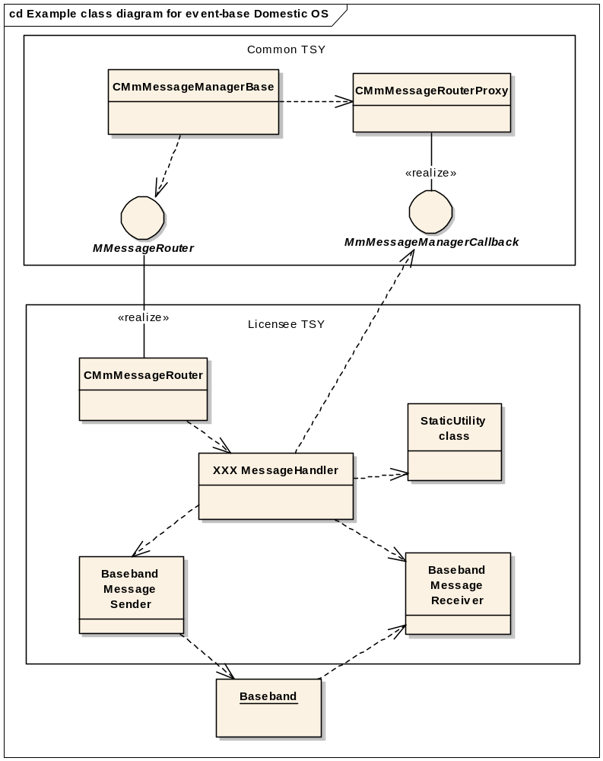
Figure 3 Class structure between CTSY and LTSY
The key point illustrated here is the interface is implemented as a message passing mechanism where a message comprises {IPC, data} and is issued to the LTSY. The LTSY will then service this request and respond back to the CTSY with a completion consisting of the tuple {IPC, completion data, result code}.
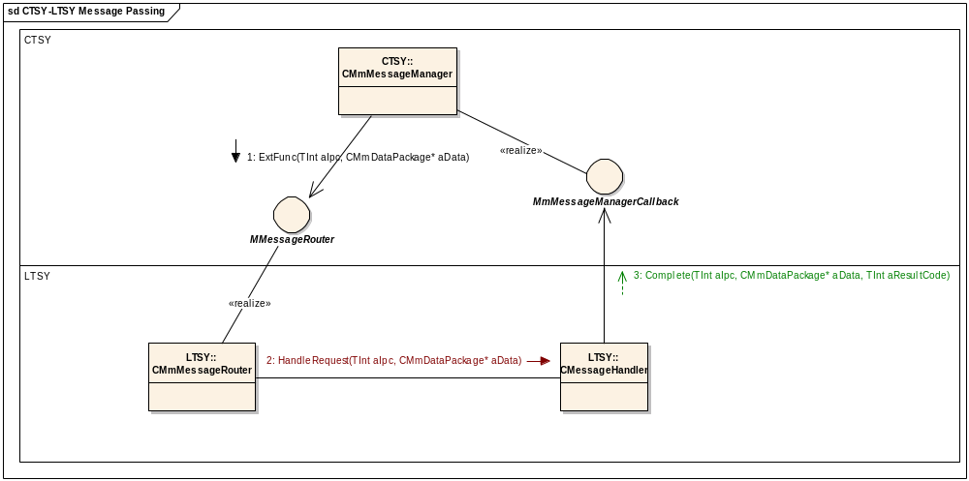
Figure 4 - CTSY-LTSY Message Passing
- Every request message from the CTSY must have a response (a completion) by the LTSY.
- The LTSY may send unsolicited messages to the CTSY (i.e. not a response to a previous request message) that are used for notification of changes to some event, data or state.
The passing of data within the messages is done via structures derived from a base class CMmDataPackage.
This class provides packing methods overloads of
template <typename T, typename S> inline void PackData( T* aObject1, S* aObject2 ) )
and unpacking methods, overloads of
template <typename T, typename S> inline void UnPackData( T** aObject1, S** aObject2 ) const)
to aid the insertion and extraction of data.
[R3] describes the sequence of message exchange that takes place between the CTSY and LTSY for many different scenarios.

CTSY-LTSY Messages
The messages are either command/response IPCs meaning the CTSY issues the message to the LTSY and expects a response using the same IPC, or they are unsolicited notifications where the LTSY may send a message to the CTSY at any time it receives indication that some data has changed e.g. EEtelLineNotifyIncomingCall.
The IPCs used between the CTSY and LTSY are typically either the enum as defined in one of the standard Symbian Etel headers (ET_CLSVR.H, ETELMMCS.H, pcktcs.h) such as EMobileConferenceCallHangUp or sometimes a new IPC has been defined, that is internal to CTSY-LTSY and therefore has no direct mapping to a corresponding Etel API. An example of this type is EMmTsyGetCallForwardingNumberIPC. This set of internally defined IPCs can be found in mmtsy_ipcdefs.h.

Introducing CtsyDispatcher
To simplify LTSY development a new layer has been provided under the existing CTSY that is being developed and maintained by Symbian, the purposes of which are:
- Reduce code base for licensee LTSY by hiding all packing and unpacking functionality that is necessary for each IPC exchanged between CTSY and LTSY
- Present a simple to use function based interface that allows for rapid development by licensee engineers who are likely to be unfamiliar with Symbian Telephony and possibly even Symbian OS principles.
- To clean up data exchanged between CTSY and LTSY such that [in] and [out] arguments are clearly documented
- (Where possible) Simplify the callback logic (for events sent by LTSY to CTSY) to remove hidden ordering dependencies. E.g. Hide from LTSY CTSY internal requirements that may impose callbacks to be made in a specific order.
This has resulted in the introduction of a new layer beneath the existing CTSY that is referred to as the CtsyDispatcher layer. This layer implements the existing CTSY-LTSY interface including the packing and unpacking of IPC data and makes requests down to LTSY for actual servicing. The LTSY will still handle the translation to the appropriate baseband requests. The LTSY is being provided with a callback interface to be used for completions to enable it to pass data and event information up to the CtsyDispatcher. The CtsyDispatcher then packs this into the appropriate {IPC, data} for sending to the CTSY.

New Component View
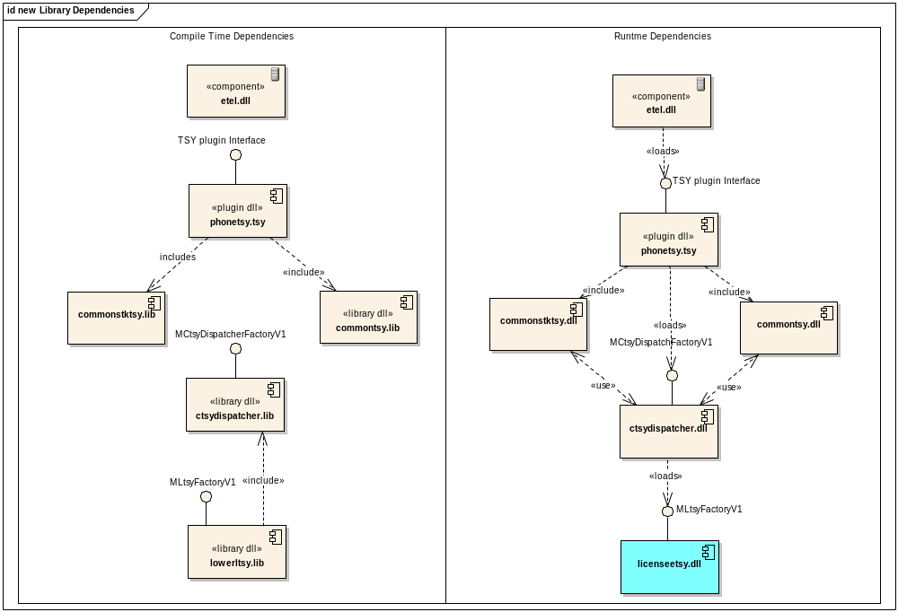
Figure 5 Dependencies in new LTSY architecture
The main thing to note with the addition the ctsydispatcher.dll is that it’s now the component that will load the licenseetsy.dll. Note lowerltsy.lib refers to whichever library is relevant for the licensee to load, in the testing case this is licenseeskeletontsy.lib.

CtsyDispatcher-LicenseeTSY Interface
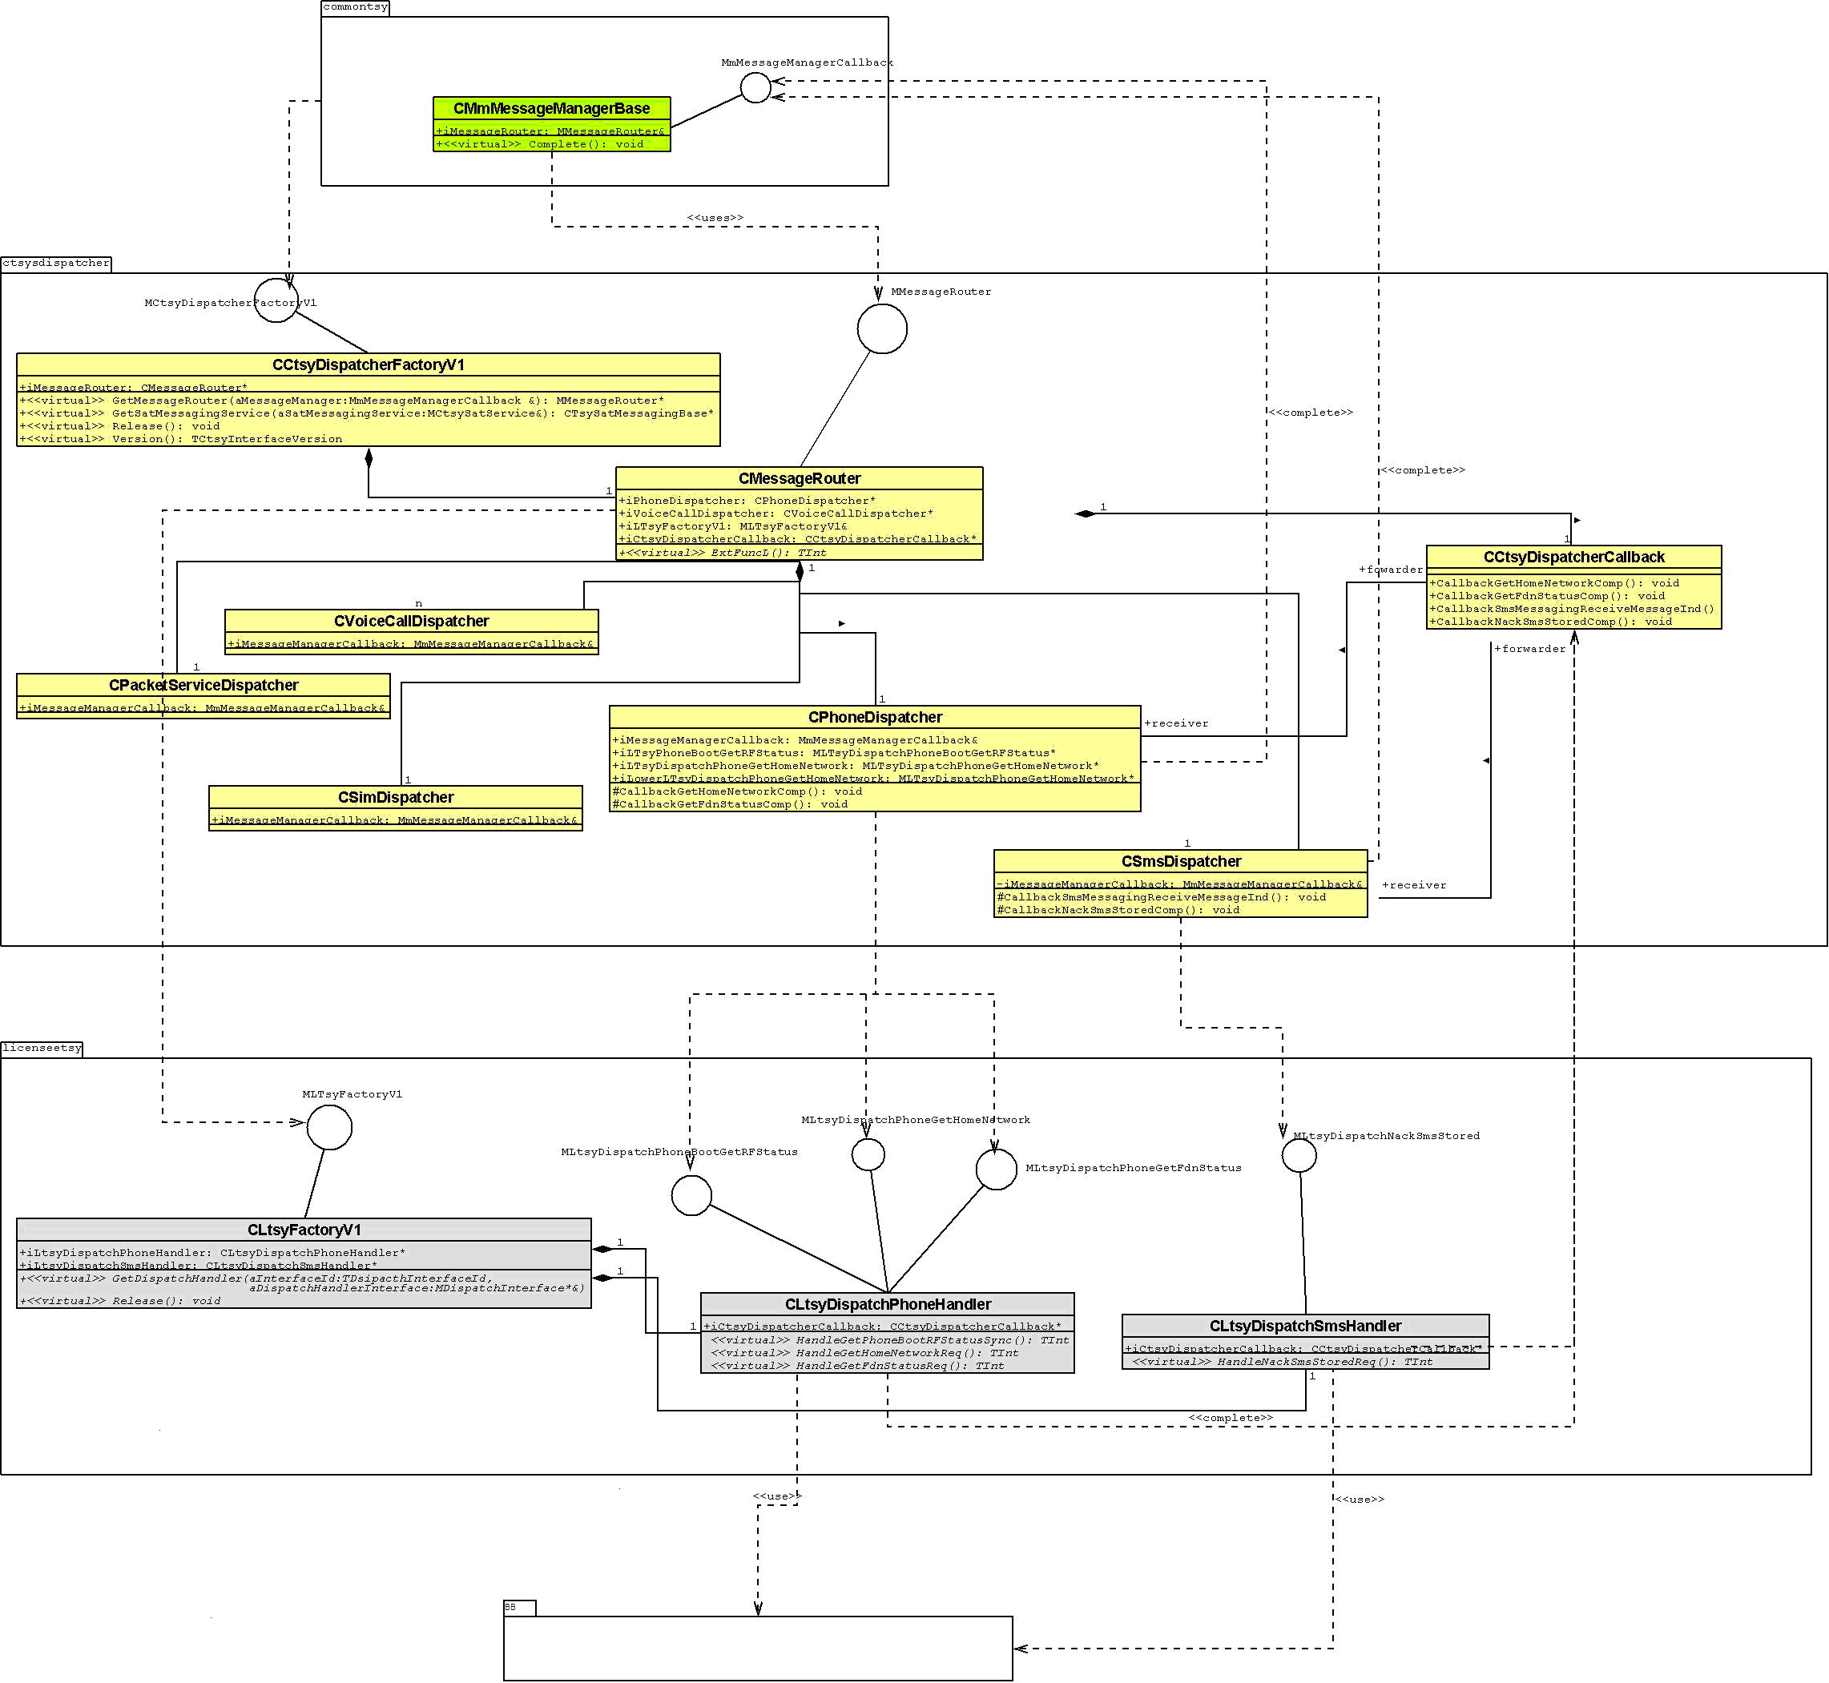
Figure 6 CtsyDispatcher and LTSY class view

Figure 6 above depicts the key classes that would be present in the new interface.

Class | Layer | Role
CMmMessageManagerBase | CTSY | Manages message passing between CTSY and CtsyDispatcher. Implements the CTSY callback interface MmMessageManagerCallback
CLtsyFactoryV1 | CtsyDispatcher | Factory class that is responsible for creation of interfaces when requested by the CTSY.  Implements the MLTsyFactoryV1 interface.
CMessageRouter | CtsyDispatcher | This is the top level class for receiving messages from the CTSY. It implements the ExtFunc method that is invoked by the CTSY when sending a message to the CtsyDispatcher.  Implements the MMessageRouter interface.
CLtsyXXXDispatcher | CtsyDispatcher | Examples: CPacketServiceDispatcher, CVoiceCallDispatcher, CSmsDispatcher.  These are called dispatcher classes and have the responsibility of handling messages (forwarded from CMessageRouter) and doing the unpacking (from CMmDataPackage) before invoking the relevant API call down to the LTSY.  Second responsibility is to handle the callbacks from the LTSY resulting from either request completions or event indications. The LTSY uses the methods available from CCtsyDispatcherCallback to trigger a callback that is routed to the relevant CXXXDispatcher to handle. The dispatcher would pack the data into a CMmDataContainer and send a Complete request message to the CTSY.  Dispatcher classes would be created for each functional area e.g. SMS, packet, cell broadcast etc.
CCtsyDispatcherCallback | CtsyDispatcher | This class presents a set of methods that allow the LTSY to callback into the CtsyDispatcher as a result of either a request completion or event completion.  A pointer to this instance shall be passed down to the LTSY during construction for use.
CLtsyFactoryV1 | LTSY | This class has the responsibility to create instances of all the interfaces when requested by the CtsyDispatcher.  It implements the MLtsyfactoryV1 interface.
CLtsyDispatchXXXHandler | LTSY | Examples: CLtsyDispatchPhoneHandler, CLtsySmsHandler.  For each functional area a handler class should be provided that implements all the interface methods for that specific functional area.  It is these handler classes that form the bulk of the LTSY and translate the request made by the CtsyDispatcher to 1 or more Baseband calls.  Each instance of CLtsyDispatchXXXHandler should hold a reference to the CCtsyDispatcherCallback to enable completions and events to be passed back up to the CtsyDispatcher for processing.

The dispatcher classes are organised into functional units. In all, there are 13.
Functional Unit | Dispatcher Class
Call Control | CCallControlDispatcher
Phone | CPhoneDispatcher
Security | CSecurityDispatcher
EN Phonebook store | CPhonebookEnDispatcher
Cell Broadcast | CCellBroadcastDispatcher
ON Phonebook Store | CPhonebookOnDispatcher
Phonebook store | CPhonebookDispatcher
Sim | CSimDispatcher
Sms | CSmsDispatcher
Multiparty Call Control | CCallControlMultipartyDispatcher
Supplementary Services | CSupplementaryServicesDispatcher
Packet Services | CPacketServicesDispatcher
SAT | CSatDispatcher

The introduction of the CtsyDispatcher in effect provides a function based interface to be implemented by the LTSY. Each IPC message that is sent by the CTSY and subsequently unpacked by the CtsyDispatcher would then be mapped to the appropriate interface function call as shown in figure below.
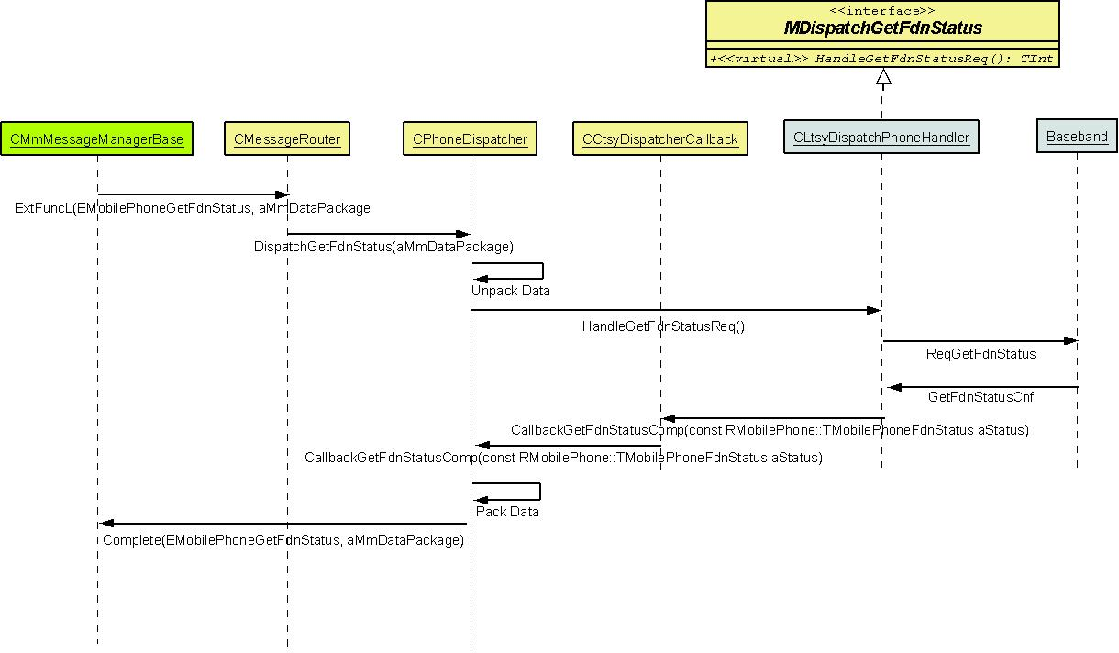

Figure 7 Sequence flow between CtsyDispatcher and LTSY

As an example the table below shows a few mappings between IPCs and the interface function to be implemented by the LTSY.
Message IPC | Interface mapping | Code snippet
EEtelCallAnswer | MLtsyDispatchCallControlAnswer | class MLtsyDispatchCallControlAnswer  {  /** Implement this interface to handle call answer requests  @param aCallId ID call to answer  @param aService service type @see RMobilePhone::TMobileService  @return TInt KErrNone on successful handling. KErrNotSupported if not supported. Or some other Symbian general error code.  */  virtual TInt HandleAnswerReqL(TInt aCalld, RMobilePhone::TMobileService aService) = 0;  };
EMobileCallHold | MLtsyDispatchCallControlHold | class MLtsyDispatchCallControlHold  {  /** Implement this interface to handle call hold request  @param aCallId ID call to put on hold.  @return TInt KErrNone on successful handling. KErrNotSupported if not supported. Or some other Symbian general error code.  */  virtual TInt HandleHoldReqL(TInt aCalld) = 0;  };
EMobilePhoneGetHomeNetwork | MLtsyDispatchPhoneGetHomeNetwork | class MLtsyDispatchPhoneGetHomeNetwork  {  /** Implement this interface to handle request to get home network  @return TInt KErrNone on successful handling. KErrNotSupported if not supported. Or some other Symbian general error code.  */  virtual TInt HandleGetHomeNetworkReqL () = 0;  };

For the callback the LTSY is provided with a pointer to CCtsyDispatcherCallback which has a method for each event or completion needing to be triggered. The unsolicited callbacks (event notifications) would then map directly to an IPC message to be completed to the CTSY as shown for an example few mappings below.
Completion Message IPC | Callback function mapping to use | Code snippet
EMobilePhoneNotifyCurrentNetworkChange | CCtsyDispatcherCallback:: CallbackPhoneNotifyCurrentNetworkChangeInd | /** Callback to be used to indicate change in network information.  @param aNewNetworkInfo Contains new network information. @see RMobilePhone::TMobilePhoneNetworkInfoV1  */  EXPORT_C void CCtsyDispatcherCallback:: CallbackPhoneNotifyCurrentNetworkChangeInd (const RMobilePhone::TMobilePhoneNetworkInfoV1& aNew NetworkInfo);
EMobilePhoneNotifyModeChange | CCtsyDispatcheCallback:: CallbackPhoneNotifyNetworkModeChangeInd | /** Callback to be used to indicate change in network mode  @param aNewNetworkMode Contains new network mode. @see RMobiePhone::TMobilePhoneNetworkMode for mode types  */  EXPORT_C void CCtsyDispatcherCallback:: CallbackPhoneNotifyNetworkModeChangeInd (RMobilePhone::TMobilePhoneNetworkMode aNew NetworkMode);
EMobilePhoneNotifySignalStrengthChange | CCtsyDispatcherCallback:: CallbackPhoneNotifySignalStrengthChangeInd | /** Callback to be used to indicate changes in signal strength  @param aSignalBars New signal strength  @param aBars New bars to display.  */  EXPORT_C void CtsyDispatcherCallback:: CallbackPhoneNotifySignalStrengthChangeInd (TUInt aNewSignalStrength, TUint8 aNewBars);

Rules and Naming Conventions

Interface Naming Conventions

LTSY interface naming conventions (CtsyDispatcher->LTSY)
Function calls into the LTSY shall have the general form

TInt Handle<FuncDesc><Type>(<arg list>);
where
return <TInt>: Typically either KErrNotSupported, KErrNone or some other error code.
<FuncDesc> = Description of what function is doing e.g. GetHomeNetwork
<Type> = one of
  - Sync : An interface method post-pended with Sync implies the request is a synchronous request where the argument list may contain [out] params as well as [in] params.
  - Req: An interface method post-pended of Req implies the request will perform some asynchronous action. All Req based methods shall require a completion with a paired callback method e.g. HandleGetHomeNetworkReq would be completed by CallbackGetHomeNetworkComp().

Examples
class MLtsyDispatchPhoneGetFdnStatus
{
virtual TInt HandleGetFdnStatusReqL ()=0;
};
class MLtsyDispatchPhoneGetHomeNetwork
{
virtual TInt HandleGetHomeNetworkReqL()=0;
};
class MLtsyDispatchPhoneGetNetworkRegistrationStatus
{
virtual TInt HandleGetNetworkRegistrationStatusReqL() = 0;
};
class MLtsyDispatchPhoneSimRefreshRegister
{
virtual TInt HandleSimRefreshRegisterSyncL()=0;
};

Callback function naming convention (LTSY->CtsyDispatcher)
Callbacks made by the LTSY to the CtsyDispatcher have the general form

void Callback<FuncDesc><Type>(<arg list>);
where
<FuncDesc> = Description of what the callback is for e.g. GetHomeNetwork
<Type> = one of
  - Comp: A callback function post-pended Comp implies that it is a callback to complete a previous request. This should be paired with the request e.g. HandleGetHomeNetworkReq is completed by CallbackGetHomeNetworkComp
  - Ind: A callback function post-pended Ind implies an unsolicited notification to be sent to the CtsyDispatcher. This would typically be some sort of event indication.

Examples
class CCtsyDispatcher : public CBase
{
public:
IMPORT_C void CallbackPhoneGetFdnStatusComp();
IMPORT_C void CallbackPhoneGetHomeNetworkComp();
IMPORT_C void CallbackPhoneGetNetworkRegistrationStatusComp();
IMPORT_C void CallbackPhoneNotifySignalStrengthChangeInd();
};

Rules of the CtsyDispatcher-LTSY interface
- No transfer of ownership of memory is implied for any arguments passed as pointers in either the down calls into the LTSY or the callbacks into the CtsyDispatcher. E.g.

TInt HandleSetFDNListReqL(RArray<TPhoneNumbers>* aFDNList);
The ownership of the RArray stays with the CtsyDispatcher and is responsible for its clean up. Likewise in the callback below ownership of the aFDNList stays with LTSY.
TInt CtsyDispatcherCallback::CallbackGetFDNListComp(RArray<TPhoneNumbers>& aFDNList);
- A corollary of point 1 is that the LTSY cannot make any assumptions about the lifetime of an argument after returning from the function scope. The reverse applies to arguments passed to the CtsyDispatcher in the callback from the LTSY. If the data needs to be kept for future use then it should be copied to memory owned by the layer. E.g. In TInt HandleSetFDNListReq(RArray<TPhoneNumbers>& aFDNList) the LTSY must not save a handle to the aFDNList for use outside of the function scope. If it is needed it must copy the list to its own array for use and then free this array independently of the CtsyDispatcher freeing the RArray passed as aFDNList.

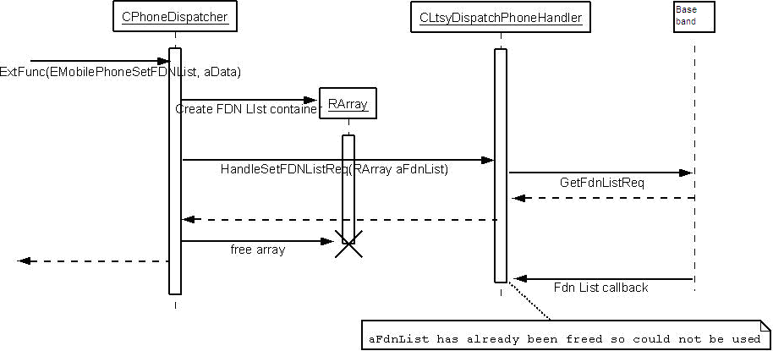

- A second corollary of point 1 and 2 is that all arguments that are not pass-by-value will be passed as const since changing the values has no meaning and should not be allowed.
- Since there is a clear division between the request and complete functions that the LTSY implements and uses it will be possible to separate the [in] argument list that will be passed in the HandleXXXX requests and the [out] argument list that is used in the callback to the CtsyDispatcher.
At present the CMmDataPackage instances have a mix of [in] and [out] parameters that are confusing to a LTSY developer. The design of the CtsyDispatcher-LTSY interface shall clean this up. For example in the class below
class TImsAuthenticateDataV5: public TMultimodeType
{
public:
IMPORT_C TImsAuthenticateDataV5();
/** holds value of network challenge AUTN */
TBuf8<KAutnLength> iAUTN;
/** holds value of network challenge RAND */
TBuf8<KRandLength> iRAND;
/** holds result RES of AUTHENTICATE command when it's successfull*/
TBuf8<KResLength> iRES;
/** holds value of session key Integrity Key */
TBuf8<KIkLength> iIK;
/** holds value of session key Cipher Key */
TBuf8<KCkLength> iCK;
/** holds value of Authentication Token when AUTHENTICATE fails*/
TBuf8<KAutsLength> iAUTS;
};

The iAUTN and iRAND are actually [in] data whilst the iRES, iIK, iCK are [out] data. In the new interface the call into the LTSY and callback to the CtsyDispatcher would reflect this by separating them E.g.

TInt HandleImsAuthenticateReq(const TDesC8& aAUTN, const TDesC8& aRAND);

void CallbackImsAuthenticateComp(const TDesC8& aRES, const TDesC8& aIK, const TDesC8& aAUTS);

Where possible structures that contain both [in] and [out] fields should be separated. For some structures that have many fields this may not be possible (e.g. QoS t-classes) and the commenting for the APIs should make it clear what is [in] and [out].
- A LTSY may choose not to support a particular interface e.g MLtsyDispatchImsAuthenticateReq in which case the initial factory request made by the CtsyDispatcher to get a handle to the interface would return a NULL handle. This would have the effect of the CTSY ExtFunc request passing the mapped IPC completing with KErrNotSupported.

Version handling between CtsyDispatcher and LTSY
Very often Etel APIs define multiple versions of T-classes e.g.

class TMobilePhoneNetworkInfoV1 : public TMultimodeType
class TMobilePhoneNetworkInfoV2 : public TMobilePhoneNetworkInfoV1
class TMobilePhoneNetworkInfoV5 : public TMobilePhoneNetworkInfoV2

Mostly inheritance is followed and a higher version is derived from an earlier version, as in the snippet above. However sometimes there are instances (see class TContextConfigGPRS : public TPacketDataConfigBase and class TContextConfigR99_R4 : public TPacketDataConfigBase for example) where inheritance has not been followed.

Multiple versions mean different entities may use or support different versions. There are three stakeholders here:
- Etel clients who will use a particular version of the T-class within an API call
- CTSY who supports 1 or more versions of the T-class when handling an API call
- LTSY who support 1 or more versions of the T-class when handling requests from the CTSY.

The rules for handling multiple versions are as follows.
- CtsyDispatcher shall create a new handler interface for each new version. E.g.

class MLtsyDispatchPhoneDoSomethingReq
{
virtual TInt HandleDoSomethingReqL(TSomeInputClassV1 aInDataV1)=0;
};

class MLtsyDispatchPhoneDoSomethingV2Req
{
virtual TInt HandleDoSomethingV2ReqL(TSomeInputClassV2 aInDataV2)=0;
};

- For request handlers being implemented by the LTSY, there is no obligation that the LTSY should support the latest (or in fact possibly any) version of the API handler, but if, for example it supports HandleDoSomethingV2ReqL then it must also support all earlier versions. E.g. HandleDoSomethingReqL as well. Note, this is actually likely to be standard anyway because typically a LTSY would support V1 and then at some point later get updated to support V2. The key point is that it should maintain support for the V1 as well.
- Where there is a need to allow for multiple versions of a T-class to be returned in a callback from LTSY to CtsyDispatcher the CtsyDispatcher callback API shall offer multiple overloads any of which may be invoked. E.g.

void CCtsyDispatcherCallback::CallbackPhoneDoSomethingComp(TSomeOutputClassV1 aOutData);
void CCtsyDispatcherCallback::CallbackPhoneDoSomethingComp(TSomeOutputClassV2 aOutData);

- A V1 request must be competed by a V1 callback and likewise for V2 etc. So, it is incorrect for a LTSY to support HandleDoSomethingV2ReqL but complete it via CallbackPhoneDoSomethingComp(TSomeOutputClassV1 aOutData).

With these rules in mind we detail the expected behaviour for fictional APIs as shown below

Etelmm.h defines the following client APIs:
class TSomeInputClassV1
{
public:
TInt iInData1;
TInt iInData2;
}
class TSomeInputClassV2 : public TSomeInputClassV1
{
public:
TInt iInData3;
}

class TSomeOutputClassV1
{
public:
TInt iOutData1;
TInt iOutData2;
}
class TSomeOutputClassV2 : public TSomeOutputClassV1
{
public:
TInt iOutData3;
}

typedef TPckg<TSomeInputClassV1> TSomeInputClassV1Pckg;
typedef TPckg<TSomeInputClassV2> TSomeInputClassV2Pckg;
typedef TPckg<TSomeOutputClassV1> TSomeOutputClassV1Pckg;
typedef TPckg<TSomeOutputClassV2> TSomeOutputClassV2Pckg;

RMobilePhone::DoSomething(const TDes8& aInputData);
RMobilePhone::NotifyOnSomethingChange(TRequestStatus, aReqStatus, TDes8& aOutputData);

Where aInputData can be either a TSomeInputClassV1Pckg or TSomeInputClassV2Pckg.
And
Where aOutputData can be either a TSomeOutputClassV1Pckg or TSomeOutputClassV2Pckg.

CtsyDispatcher requires the LTSY to service these requests and offers the following APIs:
class MLtsyDispatchPhoneDoSomethingReq
{
const TInt KLtsyDispatchPhoneDoSomethingApiId;
virtual TInt HandleDoSomethingReqL(TSomeInputClassV1 aInDataV1)=0;
};

class MLtsyDispatchPhoneDoSomethingV2Req
{
const TInt KLtsyDispatchPhoneDoSomethingV2ApiId;
virtual TInt HandleDoSomethingV2ReqL(TSomeInputClassV2 aInDataV2)=0;
};

With the corresponding callbacks being:

void CCtsyDispatcherCallback::CallbackPhoneDoSomethingComp(TSomeOutputClassV1 aOutData);
void CCtsyDispatcherCallback::CallbackPhoneDoSomethingComp(TSomeOutputClassV2 aOutData);
//indicator callbacks used to complete a pending RMobilePhone::NotifyOnSomething
void CCtsyDispatcherCallback::CallbackPhoneNotifySomethingChangeInd (TSomeOutputClassV1 aOutData);
void CCtsyDispatcherCallback::CallbackPhoneNotifySomethingChangeInd (TSomeOutputClassV2 aOutData);

Looking firstly at handling RMobilePhone::DoSomething the following scenarios are possible

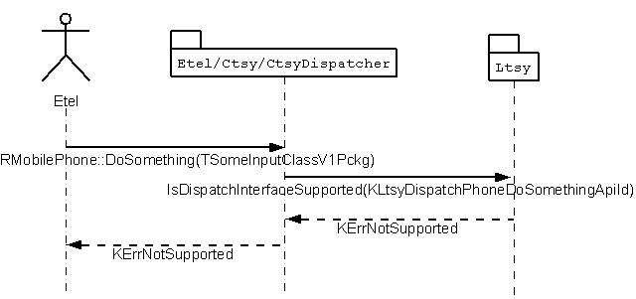
Figure 8 Client uses TSomeInputClassV1, LTSY does not support HandleDoSomethingReqL or HandleDoSomethingV2ReqL.

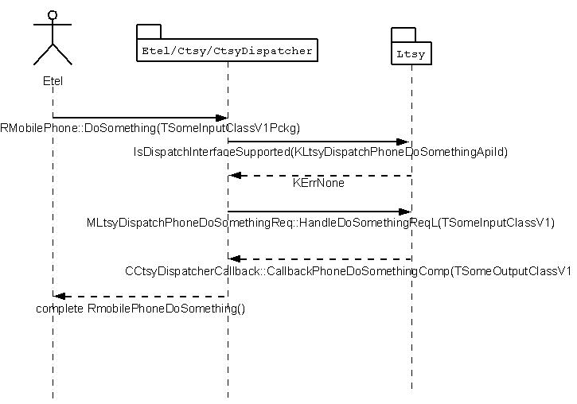
Figure 9 Client uses TSomeInputClassV1, LTSY supports HandleDoSomethingReqL .

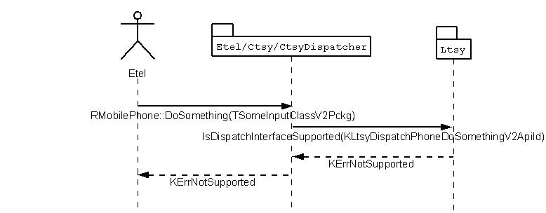
Figure 10 Client uses TSomeInputClassV2, LTSY supports HandleDoSomethingReqL.
If a client calls an API with TSomeInputClassV2 and LTSY only supports V1 then KErrNotSupported is returned. CTSY/CtsyDispatcher does not do any translation of the client request to an earlier version and invoke MLtsyDispatchPhoneDoSomethingReq::HandleDoSomethingReqL because although cast is safe the behaviour, from client perspective servicing may not be as expected. The fields in TSomeInputClassV2 (i.e. iInputData3) are lost and hence it is possible that the LTSY/modem services the request differently than client expects. It is therefore safer to return the request as KErrNotSupported.

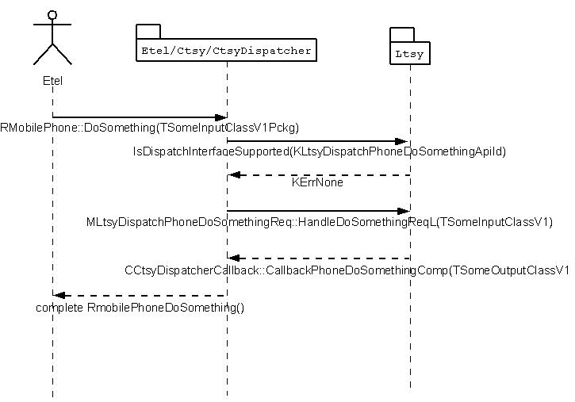

Figure 11 Client uses TSomeInputClassV1, LTSY supports HandleDoSomethingReqL and HandleDoSomethingV2ReqL.
Due to rule 2. the CTSY/CtsyDispatcher should never have to do translation from a V1 to a V2 since the LTSY should always support older versions. E.g. it should never be the case that

IsDispatchInterfaceSupported(KLtsyDispatchPhoneDoSomethingApiId) == KErrNotSupported and
IsDispatchInterfaceSupported(KLtsyDispatchPhoneDoSomethingApiId) == KErrNone
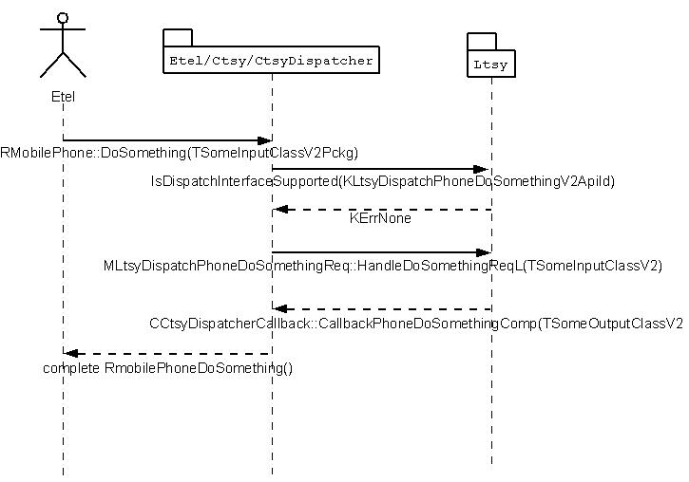
Figure 12 Client uses TSomeInputClassV2, LTSY supports HandleDoSomethingReqL and HandleDoSomethingV2ReqL

The second set of scenarios to consider is for indicator callbacks made by the LTSY to the CtsyDispatcher. In the code snippet above we had a callback API as follows

//indicator callbacks used to complete a pending RMobilePhone::NotifyOnSomething
void CCtsyDispatcherCallback::CallbackPhoneNotifySomethingChangeInd (TSomeOutputClassV1 aOutData);
void CCtsyDispatcherCallback::CallbackPhoneNotifySomethingChangeInd (TSomeOutputClassV2 aOutData);

Again a client can be an “old” client and use
RMobilePhone::NotifyOnSomethingChange(TRequestStatus, aReqStatus, TSomeOutputClassV1Pckg)
or a “new” client and use
RMobilePhone::NotifyOnSomethingChange(TRequestStatus, aReqStatus, TSomeOutputClassV2Pckg).

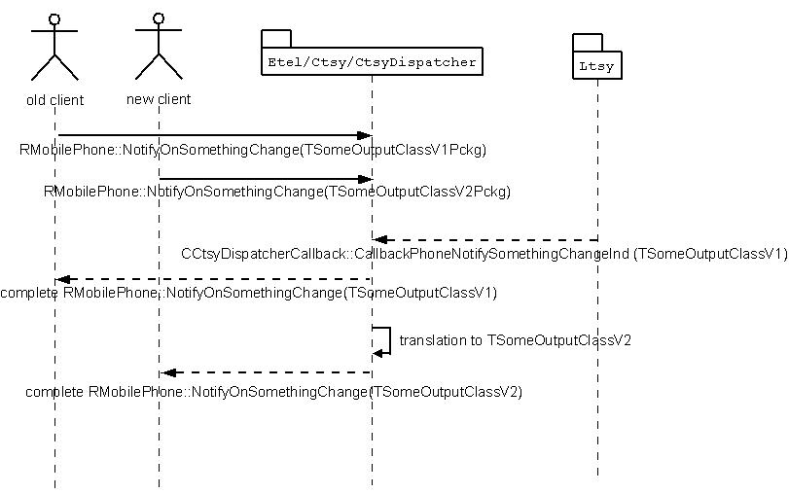

Figure 13 Two clients using different versions and LTSY supporting notification using TSomeOutputClassV1

Since it is entirely conceivable that a client is written to use a new version of API before the LTSY has updated to that version we can get the situation as in Figure 13. When completing to the “new” client the CTSY will have filled out the TSomeOutputClassV2 fields with default data since it is not provided by the LTSY. Here, translation is felt to be acceptable to provide the most flexibility to allow “new” clients to issue notifier requests when there is an “old” LTSY as opposed to returning KErrNotSupported. For the majority of T-classes it is trivial for the CTSY to populate the V2 fields with default data e.g. returning an empty string or using ExxxUnknown where enumerations are to be set.

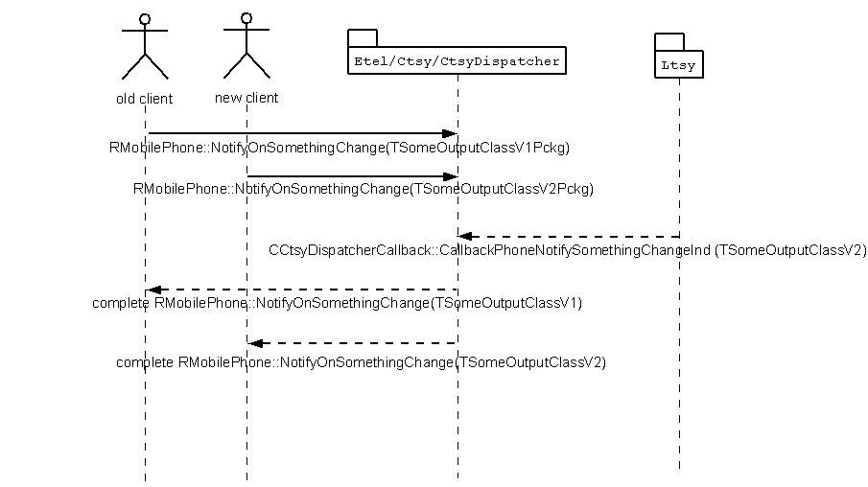

Figure 14 Two clients using different versions and LTSY supporting notification using TSomeOutputClassV2
In this situation simple casting can be used to translate the TSomeOutputClassV2 returned by the LTSY to the required TSomeOutputClassV1 to be returned to the “old” client.

LTSY Skeleton

An LTSY skeleton is provided to aid the development and speed up creation time. This can be found in the folder source folder.

../ctsydispatcher/ltsyskeleton_using_dispatcher/...

For instructions on building the LtsySkeleton see Appendix A -.

The skeleton consists of a series of source files that largely contain empty implementation, as an example,

TInt CLtsyPhonebookHandler::HandleStoreReadEntryReqL(/* TODO: Add correct parameteres here */)
/**
* This request is completed by invoking
* CCtsyDispatcherCallback::CallbackPhonebookStoreReadEntryComp
*
* @param TODO: Add parameter in-source documentation here
*
* @return KErrNone on success, KErrNotSupported if this request is not supported,
* or another error code to indicate the failure otherwise.
*/
{
TSYLOGENTRYEXIT;

TInt ret = KErrNotSupported;

// TODO: Add implementation here.......

// REMOVE this line when implementing for real LTSY
MTEST_ISSUE_MOCKLTSYENGINE_REQ(ret, KDispatchPhonebookFuncUnitId, MLtsyDispatchPhonebookStoreReadEntry::KLtsyDispatchPhonebookStoreReadEntryApiId);

return TSYLOGSETEXITERR(ret);
} // CLtsyPhonebookHandler::HandleStoreReadEntryReqL

The task of the LTSY development project is to complete the necessary functions and corresponding callbacks, either completions or indicators to the CtsyDispatcher. Of course, the skeleton is provided as an example starting point only, and depending on other factors such as baseband API design. If alternate threading models are used it may be appropriate to re-factor the structure to provide a better fit.

Class Layout
The structure of the LTSY skeleton mirrors the CtsyDispatcher structure in the sense that the LTSY is split up into the same set of functional units as listed in section 4.2. Largely it is possible to treat each unit atomically and develop the LTSY for a number of functional units in parallel. Figure 15 shows a few of classes and relationship to CtsyDispatcher interfaces

The class structure is shown below.

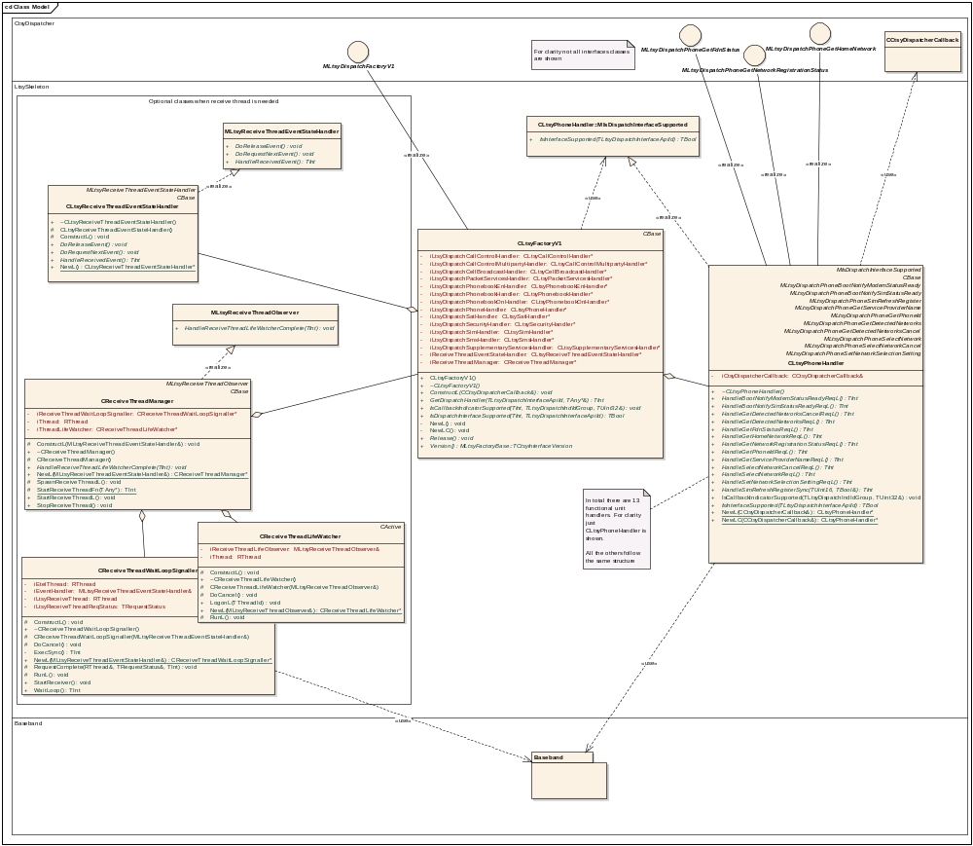

Figure 15 Ltsy Skeleton class structure

Class | Responsibility | LTSY implementation requirements
CLtsyFactoryV1 | Factory class that implements the MLtsyDispatchFactoryV1 interface. This class creates and owns all the handler classes e.g. CLtsyCallControlHandler. | There are 4 interface APIs inherited from MLtsyDispatchFactoryV1 that this class must implement. See mltsydispatchfactory.h for more information on how to implement these interface APIs. It is important to ensure that the two query interfaces  IsDispatchInterfaceSupported and IsCallbackIndicatorSupported are kept in sync such that they correctly indicate support for either a handler or an indicator callback.
CLtsyPhoneHandler CLtsyCallControlHandler, CLtsySimHandler, etc | A handler class exists for each functional unit. These are the classes that implement the handling for the dispatch API calls invoked from the CtsyDispatcher. | Each handler class inherits from the set of dispatch interface classes (e.g. MLtsyDispatchPhoneGetFdnStatus) defined for that functional unit. Each of the dispatch interface classes expose a single pure virtual handler function that should be implemented by the handler class (e.g. HandleGetFdnStatusReqL). The handling of the request should translate the request to the underlying baseband API call.  It is also expected that for each handler there would be a completion function that receives the completion event signalled from the baseband. Within this completion function the event is translated to the appropriate callback function defined in CCtsyDispatcherCallback.
CLtsyReceiveThreadEventStateHandler, CReceiveThreadManager, CReceiveThreadLifeWatcher, CReceiveThreadWaitLoopSignaller | These set of classes provide a mechanism for establishing a separate thread that may be required for some baseband architectures in order to process events being received from the baseband. | This set of classes are optional in the sense that they may be deleted from the LTSY if not needed.  See 6.2 for more information on managing a separate receive thread.

Using a separate thread for receiving events from baseband
For some baseband architectures it is possible that the handling of incoming events (i.e. from the baseband) is performed on a separate thread to the Etel thread that executes the CTSY and LTSY. This may be because the mechanism for receiving events from the baseband may use a blocking API call.
[NOTE: If this feature is not needed it can be simply removed by commenting out the lines as shown below
void CLtsyFactoryV1::ConstructL(CCtsyDispatcherCallback& aCallback)
{
...
...
//iReceiveThreadEventStateHandler = CLtsyReceiveThreadEventStateHandler::NewL();
//iReceiveThreadManager = CReceiveThreadManager::NewL(*iReceiveThreadEventStateHandler, *iReceiveThreadEventStateHandler);
//iReceiveThreadManager->StartReceiveThreadL();
]
To cater for this the LTSY skeleton provides framework classes to manage it. Figure 16 below shows the sequence of operations.
For discussion on why threading is responsibility of LTSY and not incorporated into CTSY/CtsyDispatcher see Appendix B -
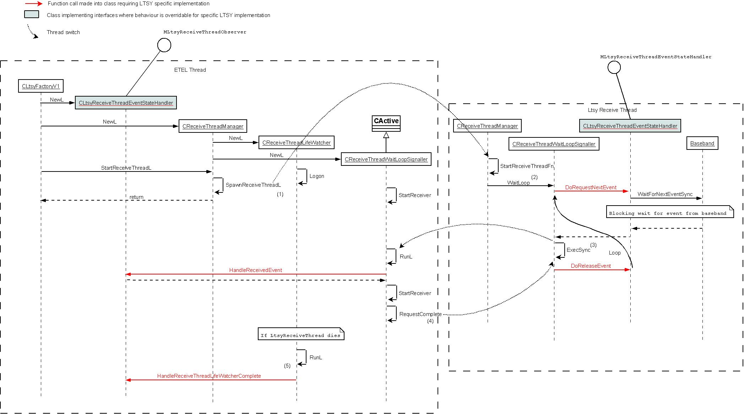
Figure 16 LTSY receive thread framework
The picture depicts the thread of execution under which each function is processed. There is only 1 actual instance of each class however at different times they may be invoked under either the Etel or the LTSY Receive thread of execution.

- SpawnReceiveThreadL launches the LtsyReceiveThread
- WaitLoop will run until either
  - Thread dies
  - Thread is killed (e.g. at shutdown)
  - RequestComplete signal from Etel->LtsyReceive thread has error status = KShutdownLtsyReceiveThread which will cause a graceful shutdown of the LTSY receive thread.
- When an event is received on the LtsyReceive thread it invokes ExecSync this causes thread switch to ETEL thread to process the event.
- ExecSync is blocking such that it will not return until signalled to do so by the Etel thread (RequestComplete)
- If the thread dies the CReceiveThreadLifeWatcher is triggered that allows an action to be performed e.g. reboot device, depending on the cause code.

Of importance to the development of the LTSY is the CLtsyReceiveThreadEventStateHandler. It is this class that needs correct implemention for the specific requirements of the LTSY. The other classes are essentially framework classes that are complete and should not need changing.

The CLtsyReceiveThreadEventStateHandler implements two interfaces
- MLtsyReceiveThreadEventStateHandler
- MLtsyReceiveThreadObserver

These interface methods are invoked during the operation of the LtsyReceive thread. The LTSY skeleton provides default behaviour for these interfaces but this should be overridden with the LTSY specific behaviour as part of development. For a description of the operation to be performed when each of the functions is invoked see mltsyreceivethreadcallbackinterfaces.h.

Removal of Symbian Test Macros
When building and running the Ltsyskeleton it will be observed that there are many places where there exist lines containing calls to macros that begin with MTEST_*. For example
TBool CLtsyPacketServicesHandler::IsInterfaceSupported(TLtsyDispatchInterfaceApiId aDispatchApiId)
/**
* Returns whether a Dispatch Interface APi is supported or not.
*
* @param aDispatchApiId Id of Dispatch interface being queried
* @return indication whether interface is supported or not
*/
{
// REMOVE this line when implementing for real LTSY
MTEST_QUERY_SUPPORT_MOCKLTSYENGINE(KDispatchPacketServicesFuncUnitId, aDispatchApiId);

switch(aDispatchApiId)
{
// Insert ApiIds when support is provided in LTSY e.g.
// case MLtsyDispatchPhoneBootNotifySimStatusReady::KLtsyDispatchPhoneBootNotifySimStatusReadyApiId: return ETrue;

default:
return EFalse;
}
}
The reason for macros is to enable us to use the same skeleton code during Symbian internal testing without polluting the empty function bodies with unnecessary code that would have to be removed. The macros themselves are designed to compile to nothing when a LTSY development project builds the Ltsyskeleton source as per the instructions in Appendix A -

These macro lines can be removed entirely from the project or left in, but compile to nothing and so do not alter built binaries in anyway. The full set of macros are defined in ltsymacros.h.

Error Code Mapping
A responsibility of the LTSY will be to map error codes returned from the baseband to those defined by Symbian. The table below provides a guide of how the 3GPP error codes map to an error code defined in a Symbian telephony header file.

3GPP Specification Error Code | Definition in Symbian
TS 24.008 Mobility Management Specific Cause Codes | EXTERROR.H starting at KErrGsmMobilityManagementBase
TS 44.018 GSM specific cause values for radio resource management | EXTERROR.H starting at KErrGsmRadioResourceBase
TS 24.008 Call Control Specific Cause Codes | EXTERROR.H starting at KErrGsmCallControlBase
TS 24.008 GPRS specific cause values for GPRS Session Management | Etelpckt.h starting at KErrGprsServicesNotAllowed
TS 04.80 Supplementary Services Network Errors | EXTERROR.H starting at KErrGsmSuppServiceBase
TS 04.11, 03.40, 07.05 SMS Errors | EXTERROR.H starting at KErrGsmSmsBase
TS 07.07 Error Codes | EXTERROR.H starting at KErrGsm0707Base
General ICC phonebook error codes | EXTERROR.H starting at KErrPhonebookBase
TS 04.80, 3.6.7section Supplementary Service Problem Codes | Gsmerror.h starting at KErrGsmSsUnrecognizedComp

Logging
The CTSY, CtsyDispatcher and LtsySkeleton all make us of commsdebugutils framework for trace logging. Within LtsySkeleton a log line can be added simply by using the LOG macro as shown below
TInt CReceiveThreadManager::StartReceiveThreadFn(TAny* aArg)
{
LOG(_L8("StartReceiveThreadFn, thread id = %d"), RThread().Id());
Also the TSYLOGENTRYEXIT macros are used to log the entry and exit from a function.
Logging is enabled at runtime via the presence of the commsdbg.ini file in c:\logs directory. Note: If running on emulator here c:\logs implies relative path within the EPOC tree e.g. if running on drive M: then full path would be M:\epoc32\winscw\c\logs.
A default version of this file should be present in every EPOC tree. However to add the specific entry to enabled TSY logging the following line should be appended
LOG TSY *
At runtime all logging will be logged to a file c:\logs\log.txt
This contains logging for many components in an interleaved manner that is useful to see the call stack. However it is also possible to separate these interleaved log lines into separate files on a per component basis. To split the log file, open a command prompt in the directory containing the log.txt file
M:\epoc32\winscw\c\logs
And type
splitlog
as shown on the diagram below:

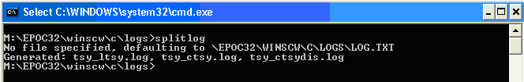

New log files will appear in the same directory and can be viewed in a text editor.

Using the SIM ATK TSY.
Although the Dispatcher fully supports the SIM ATK TSY this component is provided as a test component to validate the new HAI provided by the Dispatcher. It might be required that this functionality be disabled in favour of a Licensee’s own SAT solution. In this respect it will be necessary to disable the Dispatcher support which by default is set to on.
Disabling the Dispatcher support must be done at compile time through the use of the following pragma:
#define TEST_CODE
With this pragma undefined the responsibility of loading the SAT TSY moves from the Dispatcher back to the LTSY. The licensee developer should implement the following function to provide a pointer to the LTSY SAT implementation.

virtual CTsySatMessagingBase* GetSatMessagingService(MCtsySatService& aSatMessagingService) = 0;

With this being called as part of the Phone TSY NewSimAtk() where the SIM ATK implementation is configured.
With this arrangement, the CTSY will continue using the Dispatcher HAI but the SIM ATK will now no longer link to the Dispatcher and thus can link directly to the implementation provided by the licensee’s own LTSY.

LTSY Implementation Guidelines per Functional Area
As mentioned previously (see section 6) the development of a LTSY can be broken down into functional areas. The following sections provide information on how to write the LTSY for each functional unit. It details the main use-cases for the unit and where necessary provides further elaboration to aid development.

Call Control Functional Unit
The request handlers that must be implemented by the LTSY are declared in mltsydispatchcallcontrolinterface.h.
The callback functions used to complete the call control requests and also any indicator callbacks are declared in cctsydispatchercallback.h in the section starting with the comment:

// CallControl related callbacks

IMPORT_C void CallbackCallControlNotifyCallStatusChangeInd(TInt aError, TInt aCallId, RMobileCall::TMobileCallStatus aMobileCallStatus);
Etc....

Unless mentioned otherwise the use case descriptions below relate to voice calls.

Use Case 1: Dial call accepted then hung up
- Make a voice call, receive status change notifications, hang up

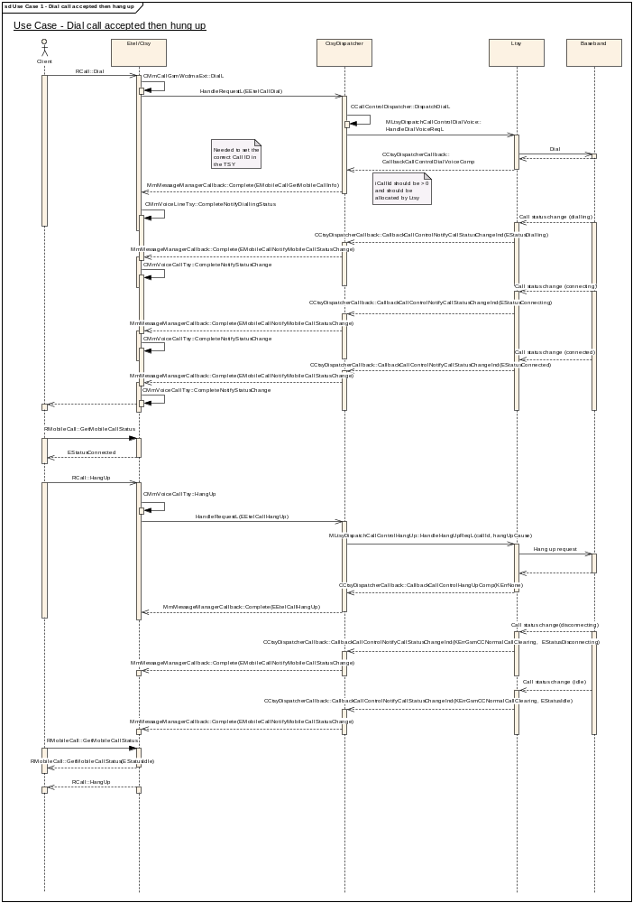

Implementation Notes:

The following interfaces and callbacks need to be implemented:

MLtsyDispatchCallControlDialVoice::HandleDialVoiceReqL

/**
* The CTSY Dispatcher shall invoke this function on receiving the EEtelCallDial
* request from the CTSY for dialling a voice call.
*
* It is a request call that is completed by invoking
* CCtsyDispatcherCallback::CallbackCallControlDialVoiceComp
*
* Implementation of this interface should
* dial the requested voice call and complete the callback to indicate
* that an attempt to dial the call has been made. The callback function is used
* to indicate the outcome of this attempt to initiate the dialling process.
*
* @param aCallLine The line to use to dial the call. This parameter can have
* one of two possible values RMobilePhone::EAlternateLinePrimary to use the
* primary voice line or RMobilePhone::EAlternateLineAuxiliary to use the
* auxiliary voice line.
*
* @param aDialledParty Details about the dialled party including the phone
* number to dial.
*
* @param aCallParamsV1 The call parameters of the call to dial. If aIsIsvCall
* is set to ETrue, only the field RMobileCall::TMobileCallParamsV1::iIdRestrict
* and RMobileCall::TMobileCallParamsV1::iAutoRedial fields are valid.
*
* @param aIsIsvCall Indicates whether the call originated from a third party
* application which would have used the CTelephony class to dial the call.
* This information is provided in case the LTSY wishes to do special handling
* for third party calls, for example, not allow third party applications to
* place emergency calls. See also
* MLtsyDispatchCallControlQueryIsEmergencyNumber::HandleQueryIsEmergencyNumberSyncL
* See also: CTelephony::DialNewCall and RMobileCall::DialISV
*
* @param aCallOrigin The origin of the dial request. e.g. Whether the dial
* came from an Etel client or the SIM or another source.
*
* @return KErrNone on success; KErrNotSupported if the LTSY does not
* support handling of this request or another error code indicating the
* failure otherwise.
*/
virtual TInt HandleDialVoiceReqL(RMobilePhone::TMobilePhoneALSLine aCallLine, RMobilePhone::TMobileAddress& aDialledParty, RMobileCall::TMobileCallParamsV1& aCallParamsV1, TBool aIsIsvCall, RMobileCall::TCallParamOrigin aCallOrigin) = 0;

EXPORT_C void CCtsyDispatcherCallback::CallbackCallControlDialVoiceComp(
TInt aError, TInt aCallId)
/**
* Callback function to be used by the Licensee LTSY to complete a pending
* MLtsyDispatchCallControlDialVoice::HandleDialVoiceReqL
*
* When a dial attempt is made via the above mentioned interface, the LTSY has the
* responsibility of allocating a unique Call ID to the call. For more
* information, see the documentation on aCallId below.
*
* @param aError The error code to be returned to the CTSY Dispatcher by the LTSY
* indicating the outcome of the attempt to dial the requested call. This should
* be KErrNone if the dialling process could be started successfully. Otherwise
* another error code to indicate the failure should be returned.
*
* @param aCallId The call ID of the call that the dial attempt refers to which
* has been allocated by the LTSY. This should be a number between 1 and
* KMaxCallIdValue and should be unique across all call modes (voice, data etc.).
* For example, if a request for a voice call is made and the LTSY allocates
* this call an ID of 1 and a request for a data call is requested, the LTSY
* should allocate a Call ID which is not the same as that already allocated for
* the first voice call.
*
*/

To indicate call status change notifications, use the following callback:

EXPORT_C void CCtsyDispatcherCallback::CallbackCallControlNotifyCallStatusChangeInd(
TInt aCauseCode, TInt aCallId, RMobileCall::TMobileCallStatus aMobileCallStatus)
/**
* Used by an LTSY to indicate to the CTSY that there has been a change in the
* status of a call. For example, if the CTSY has previously made a dial request
* to make a voice call, the LTSY can call this API to notify the CTSY
* of progress of the call through the dialling, connecting and connected states.
*
* The aCauseCode parameter should be used to indicate the reason for the change
* in status of a call.
*
* In the case of a call going idle (aMobileCallStatus = RMobileCall::EStatusIdle)
* specific cause codes need to be returned to the Common TSY to indicate
* specific causes of status changes:
*
* - To indicate that an active call has been released normally by either party,
* set aCauseCode = KErrGsmCCNormalCallClearing.
*
* - To indicate that a mobile originated call that is being dialled has gone
* idle because the remote party has rejected the call, set
* aCauseCode = KErrGsmCCCallRejected or another error code (which is != KErrNone)
* to indicate the reason for rejection.
*
* - If a mobile originated call is being dialled and the user cancels dialling,
* causing the call to go idle, set aCauseCode = KErrGsmCCNormalCallClearing.
*
* - When an incoming call goes idle because the client has rejected it
* (done using RCall::HangUp on the ringing call), set
* aCauseCode = KErrGsmCCUserBusy.
*
* @param aCauseCode The cause of the change in call status.
*
* @param aCallId The Call ID of the call whose status has changed.
*
* @param aMobileCallStatus The new status of the call refered to by aCallId.
*
* @see RMobileCall::NotifyMobileCallStatusChange
*/

Implementation of the interface MLtsyDispatchCallControlHangUp::HandleHangUpReqL allows hanging up of a call.

/**
* The CTSY Dispatcher shall invoke this function on receiving the EEtelCallHangUp
* request from the CTSY.
*
* It is a request call that is completed by invoking
* CCtsyDispatcherCallback::CallbackCallControlHangUpComp
*
* The LTSY should make a request to the modem to hang up the call specified
* in aCallId. The completion should be called to indicate the result of
* placing the hang up request with the baseband.
*
* - If aCallId refers to a connected call, the Common TSY will pass
* a hang up cause of KErrGsmReleaseByUser to indicate that the call is
* being released by the user.
*
* - If aCallId refers to a mobile terminated call which is ringing,
* the Common TSY will pass a hang up cause of KErrGsmBusyUserRequest to
* indicate that the user is rejecting the incoming call.
*
* @param aCallId The Call ID of the call to hang up.
*
* @param aHangupCause The reason for the hang up request.
*
* @return KErrNone on success, otherwise another error code indicating the
* failure.
*
* @see RCall::HangUp
*/
virtual TInt HandleHangUpReqL(TInt aCallId, TInt aHangupCause) = 0;

Completion of the hang up is done via the callback CCtsyDispatcherCallback::CallbackCallControlHangUpComp

EXPORT_C void CCtsyDispatcherCallback::CallbackCallControlHangUpComp(
TInt aError, TInt aCallId)
/**
*
* Callback function to be used by the Licensee LTSY to complete a pending
* MLtsyDispatchCallControlHangUp::HandleHangUpReqL
*
* @param aError The error code to return to the CTSY relating to the request to
* hang up. This should be KErrNone on success or another error code to indicate
* the failure otherwise.
*
* @param aCallId The Call ID of the call which has just been hung up.
*
* @see RCall::HangUp
*/

Use Case 2: Dialling call fails
- Dial a voice call, receive an error from the request to dial.
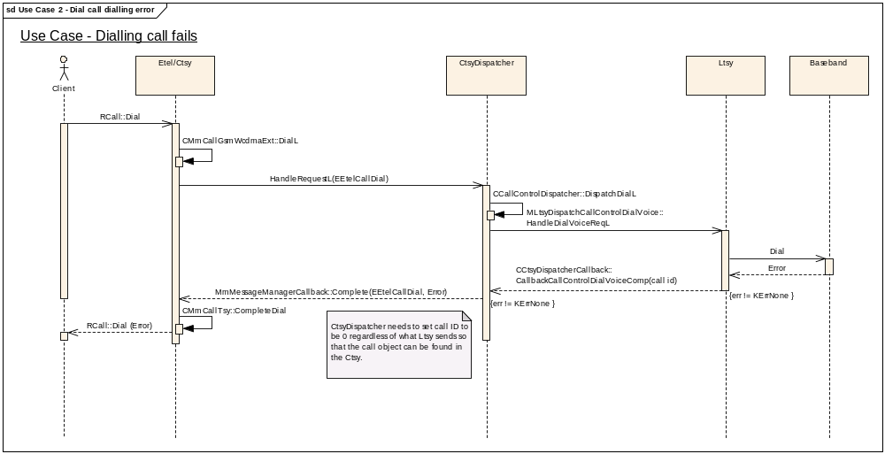

Implementation Notes:

A call to CCtsyDispatcherCallback::CallbackCallControlDialVoiceComp with aError != KErrNone indicates a failure to dial a voice call.

Use Case 3: Remote Party Reject Call
- Dial a call, remote party rejects it, receive call status notifications.

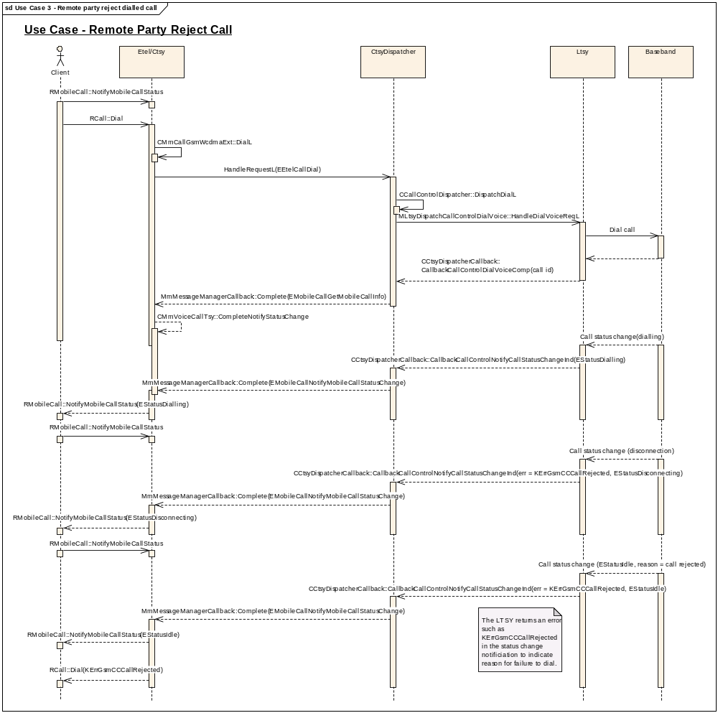

Implementation Notes:
The callback CCtsyDispatcherCallback::CallbackCallControlNotifyCallStatusChangeInd(aError = KErrGsmCCCallRejected…) indicating that the ringing call disconnects and then goes idle indicates that the remote party has rejected the call.

Use Case 4 and 5: Remote Party Hang Up With and Without Inband Info
- Dial a voice call, receive notification that the remote party has hung up with inband info.
- Dial a voice call, receive notification that the remote party has hung up without inband info.

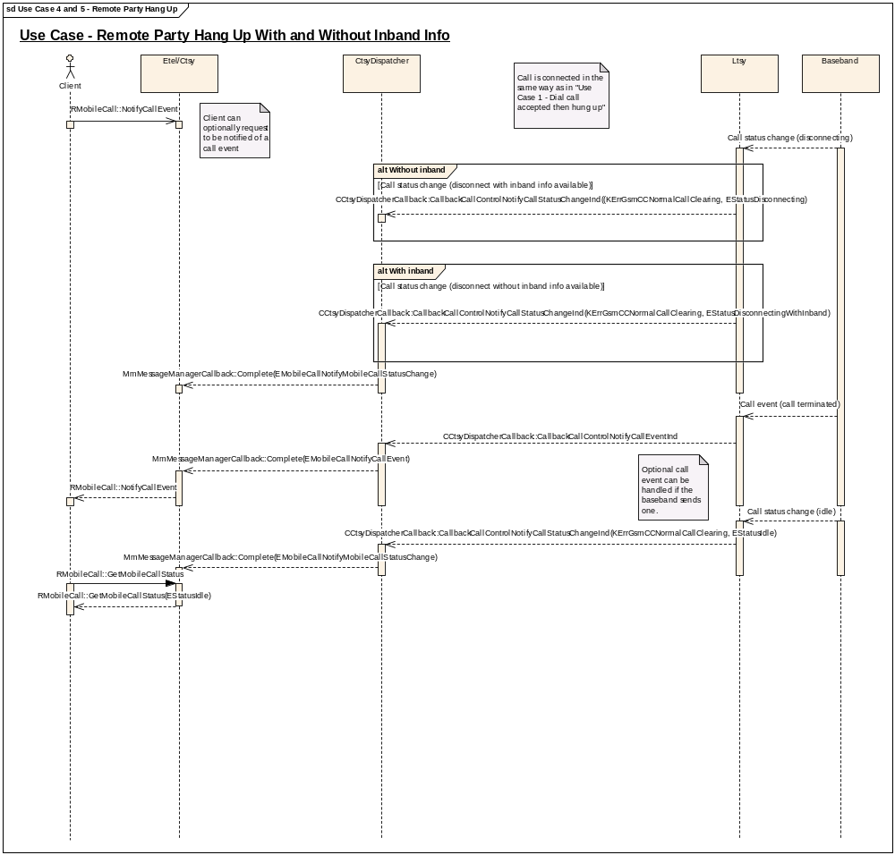

Implementation Notes:
CCtsyDispatcherCallback::CallbackCallControlNotifyCallStatusChangeInd, used to indicate a change in the call status, can be completed with a status of either RMobileCall::EStatusDisconnectingWithInband to indicate that the call is disconnecting with inband information or with RMobileCall::EStatusDisconnecting to indicate that the call is disconnecting without inband information available.

Use Case 6: Dial data call
- Dial a data call, receive notifications on the call status, call params and other call information, loan and recover the data port then hang up the call.

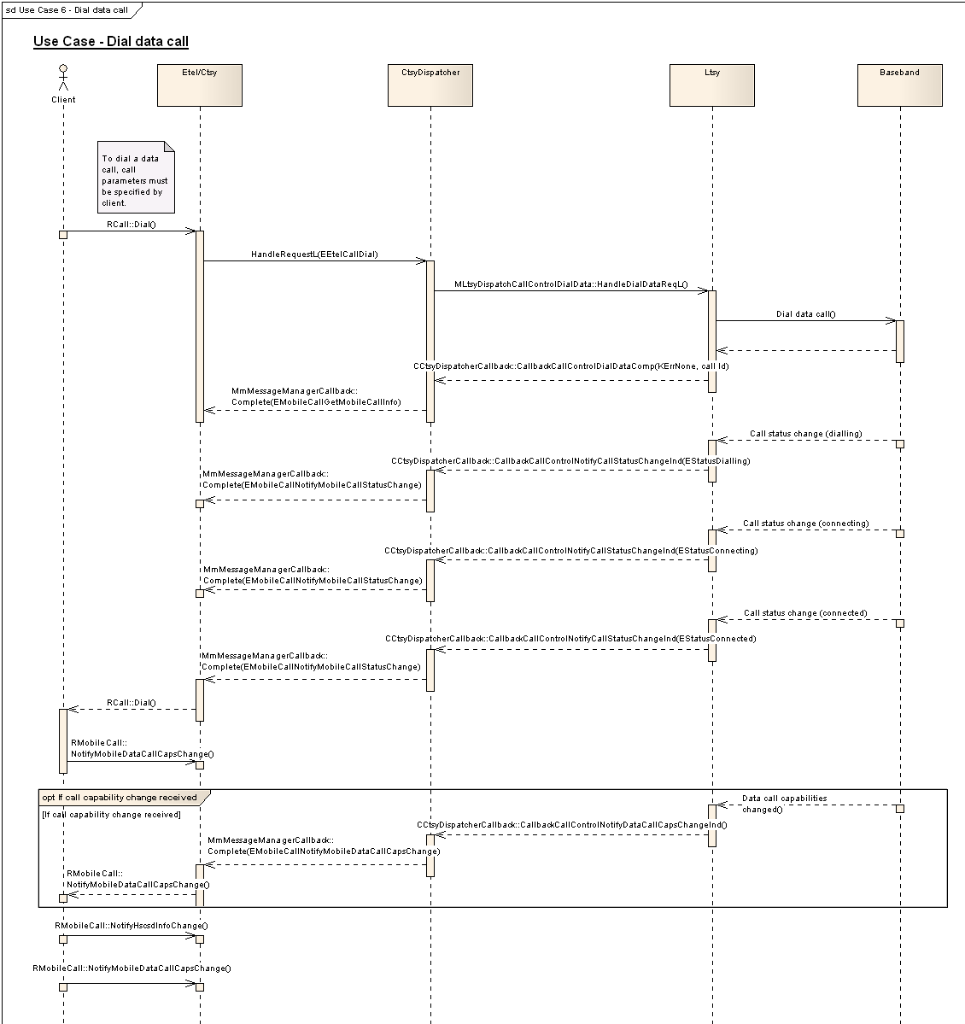

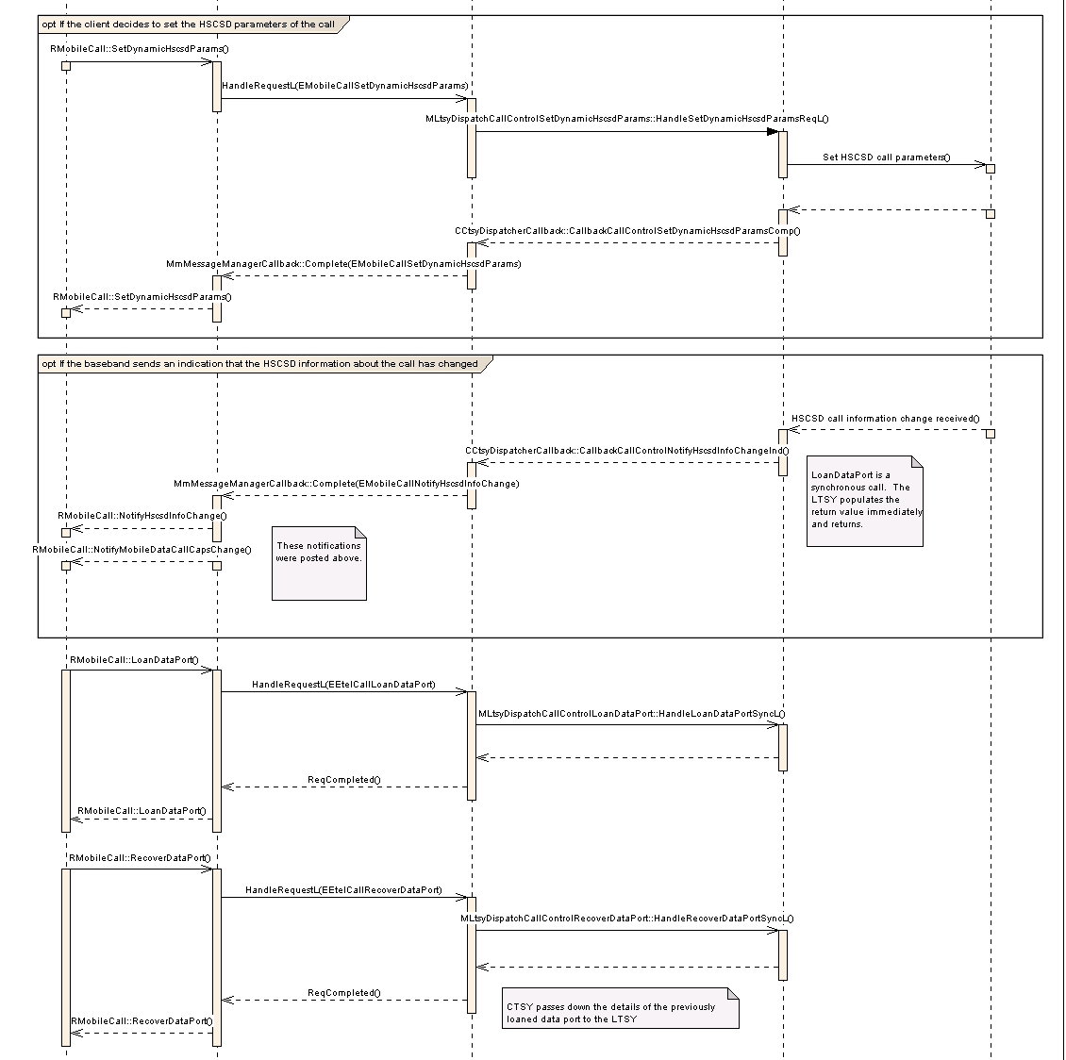

Implementation Notes:

The interface MLtsyDispatchCallControlDialData::HandleDialDataReqL should be implemented by the LTSY to allow dialling of a data call.

/**
* The CTSY Dispatcher shall invoke this function on receiving the EEtelCallDial
* request from the CTSY when a data call is requested.
*
* It is a request call that is completed by invoking
* CCtsyDispatcherCallback::CallbackCallControlDialDataComp
*
* The LTSY should dial the requested data call and complete the callback to indicate
* that an attempt to dial the call has been made. The callback function is used
* to indicate the outcome of this attempt to initiate the dialling process.
*
* @param aLine The line to use to dial the call.
*
* @param aDialledParty Details about the dialled party including the phone
* number to dial.
*
* @param aCallParamsV1 The call parameters of the call to dial.
*
* @return KErrNone on success; KErrNotSupported if the LTSY does not
* support handling of this request or another error code indicating the
* failure otherwise.
*/
virtual TInt HandleDialDataReqL(RMobilePhone::TMobileAddress& aDialledParty, RMobileCall::TMobileDataCallParamsV1& aCallParamsV1) = 0;

The following callback is used to complete the dial request:

EXPORT_C void CCtsyDispatcherCallback::CallbackCallControlDialDataComp(
TInt aError, TInt aCallId)
/**
* Callback function to be used by the Licensee LTSY to complete a pending
* MLtsyDispatchCallControlDialData::HandleDialDataReqL
*
* When a dial attempt is made via the above mentioned interface, the LTSY has the
* responsibility of allocating a unique Call ID to the call. For more
* information, see the documentation on aCallId below.
*
* For dealing with voice calls, see
* CCtsyDispatcherCallback::CallbackCallControlDialVoiceComp
*
* @param aError The error code to be returned to the CTSY Dispatcher by the LTSY
* indicating the outcome of the attempt to dial the requested call. This should
* be KErrNone if the dialling process could be started successfully. Otherwise
* another error code to indicate the failure should be returned.
*
* @param aCallId The call ID of the call that the dial attempt refers to which
* has been allocated by the LTSY. This should be a number between 1 and
* KMaxCallIdValue and should be unique across all call modes (voice, data etc.).
* For example, if a request for a voice call is made and the LTSY allocates
* this call an ID of 1 and a request for a data call is requested, the LTSY
* should allocate a Call ID which is not the same as that already allocated for
* the first voice call.
*
*/

For the LTSY to indicate a change in data call capabilities to the CTSY, the following indicator callback can be used.

EXPORT_C void CCtsyDispatcherCallback::CallbackCallControlNotifyDataCallCapsChangeInd(
TInt aError, TInt aCallId, const RMobileCall::TMobileCallDataCapsV1& aMobileCallDataCaps)
/**
* Send a notification to the Common TSY about a change in the data call
* capabilities.
*
* @param aError The error code to be returned to the CTSY Dispatcher.
*
* @param aCallId The Call ID of the call whose capabilities have changed.
*
* @param aMobileCallDataCaps The new capabilities of the data call.
*
* @see RMobileCall::NotifyMobileDataCallCapsChange
*/

Setting the call parameters of the data call can be achieved using the API:

/**
* The CTSY Dispatcher shall invoke this function on receiving the EMobileCallSetDynamicHscsdParams
* request from the CTSY.
*
* It is a request call that is completed by invoking
* CCtsyDispatcherCallback::CallbackCallControlSetDynamicHscsdParamsComp()
*
* Implementation of this interface should set the dynamic HSCSD parameters
* of the specified data call.
*
* @param aCallId The call ID of the data call.
*
* @param aHscsdParams The requested dynamic HSCSD parameters.
*
* @return KErrNone on success, otherwise another error code indicating the
* failure.
*/
virtual TInt HandleSetDynamicHscsdParamsReqL(TInt aCallId, RMobileCall::TMobileHscsdCallParamsV1& aHscsdParams) = 0;

The following is used as the call back:

EXPORT_C void CCtsyDispatcherCallback::CallbackCallControlSetDynamicHscsdParamsComp(
TInt aError, TInt aCallId)
/**
*
* Callback function to be used by the Licensee LTSY to complete a pending
* MLtsyDispatchCallControlSetDynamicHscsdParams::HandleSetDynamicHscsdParamsReqL()
*
* This callback indicates that the request to set the dynamic HSCSD parameters
* has been made (successfully or unsuccessfully. To notify the CTSY of a change
* in the HSCSD information of thecall, see the API
* CCtsyDispatcherCallback::CallbackCallControlNotifyHscsdInfoChangeInd()
*
* @param aError The error code to be returned to the CTSY Dispatcher.
*
* @see RMobileCall::SetDynamicHscsdParams()
*/

The synchronous calls:
MLtsyDispatchCallControlLoanDataPort::HandleLoanDataPortSyncL and
MLtsyDispatchCallControlRecoverDataPort::HandleRecoverDataPortSyncL
are used to loan and recover the data port if required by the baseband.

/**
* The CTSY Dispatcher shall invoke this function on receiving the EEtelCallLoanDataPort
* request from the CTSY.
*
* This API may be adaptation specific and is used for reading the port name
* from CommsDat for use in a data call.
*
* It is a sync call where the output parameters should be completed before returning
* from this function.
*
* @param aCallId Call ID of the data call requiring the data port.
*
* @param aCommPort Output parameter. The communications port information
* retrieved by a client using the RCall::LoanDataPort API.
*
* @return KErrNone on success, otherwise another error code indicating the
* failure.
*/
virtual TInt HandleLoanDataPortSyncL(TInt aCallId, RCall::TCommPort& aCommPort) = 0;

/**
* The CTSY Dispatcher shall invoke this function on receiving the EEtelCallRecoverDataPort
* request from the CTSY.
*
* This is a request to recover the data port loaned by a previous call to
* MLtsyDispatchCallControlLoanDataPort::HandleLoanDataPortSyncL
* and matches a client side call to RCall::RecoverDataPort.
*
* It is a sync call where the data arguments should be completed before returning.
*
* @param aCallId Call ID of the data call requiring the data port.
*
* @param aCommPort The data port to recover. This contains the details previously
* returned by a call to RCall::LoanDataPort
*
* @return KErrNone on success, otherwise another error code indicating the
* failure.
*/
virtual TInt HandleRecoverDataPortSyncL(TInt aCallId, RCall::TCommPort& aCommPort) = 0;

Use Case 7: Answer incoming voice call
- Receive notification of an incoming voice call, answer the call, receive call status notifications.

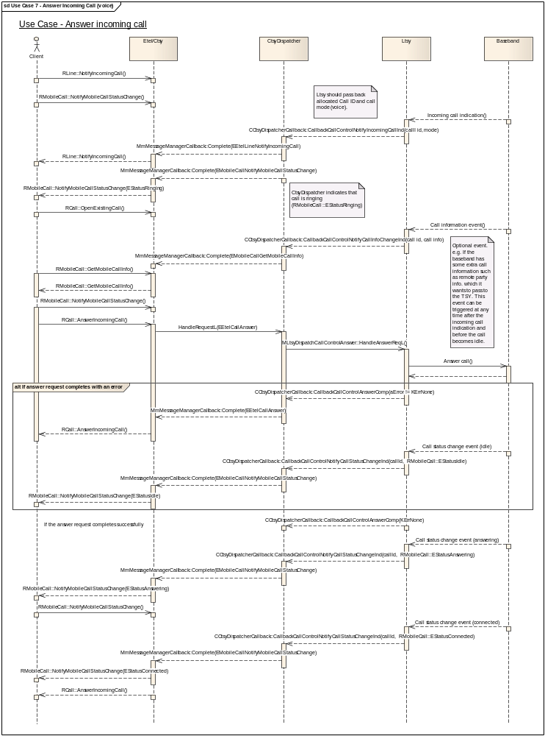

Implementation Notes:

To send an indication of an incoming call, use the following callback:

EXPORT_C void CCtsyDispatcherCallback::CallbackCallControlNotifyIncomingCallInd(
TInt aError, const RMobileCall::TMobileCallInfoV1& aCallInfo)
/**
* Notify the Common TSY about an incoming call to the phone.
*
* The aCallInfo parameter is used to provide the Common TSY with details about
* the incoming call.
*
* The field RMobileCall::TMobileCallInfoV1::iCallId is mandatory and should be
* populated with a unique Call ID allocated by the LTSY. For more details about
* how to set a valid Call ID, see the documentation on the aCallId parameter
* in CCtsyDispatcherCallback::CallbackCallControlDialVoiceComp.
*
* The field RMobileCall::TMobileCallInfoV1::iService in the aCallInfo parameter
* is mandatory
* must be populated by the LTSY to indicate to the Common TSY the type of the
* incoming call.
*
* - If there is an incoming voice call on the primary voice line,
* this field should be set to RMobilePhone::EVoiceService.
*
* - If the incoming voice call is on the auxiliary
* voice line, this parameter should be set to RMobilePhone::EAuxVoiceService.
*
* - If the incoming call is a data call, this parameter should be set to
* RMobilePhone::ECircuitDataService.
*
* The remainder of the fields in the aCallInfo parameter can be used to
* indicate other details about the incoming call. See the documentation for
* RMobileCall::TMobileCallInfoV1 for more details.
*
* @param aError The error code to be returned to the CTSY Dispatcher.
* @param aCallInfo Information about the incoming call.
*
* @see RLine::NotifyIncomingCall
*/

To answer an incoming call, the following interface needs to be implemented MLtsyDispatchCallControlAnswer::HandleAnswerReqL:

/**
* The CTSY Dispatcher shall invoke this function on receiving the EEtelCallAnswer
* request from the CTSY.
*
* It is a request call that is completed by invoking
* CCtsyDispatcherCallback::CallbackCallControlAnswerComp
*
* This request is made to the LTSY to ask it to answer an incoming call.
*
* @param aCallId The Call ID of the call to answer.
*
* @return KErrNone on success, otherwise another error code indicating the
* failure.
*
* @see RCall::AnswerIncomingCall
*/
virtual TInt HandleAnswerReqL(TInt aCallId) = 0;

Use Case 8: Reject Incoming Call
- Receive notification of an incoming voice call, reject the call, receive call status notifications as the call returns to idle.

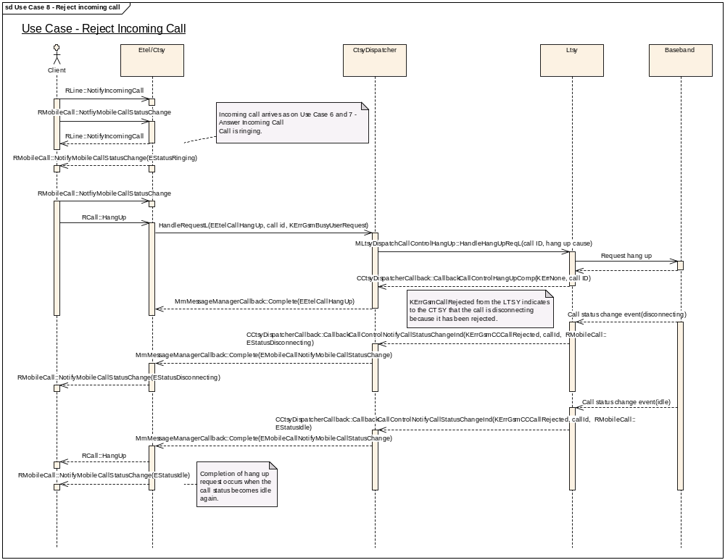

Implementation Notes:

Rejection of an incoming call is achieved by hanging up the call via the MLtsyDispatchCallControlHangUp::HandleHangUpReqL interface.
A call to CCtsyDispatcherCallback::CallbackCallControlHangUpComp with a cause of KErrGsmCallRejected by the LTSY indicates that the request for rejection has been completed successfully. Confirmation of the change in call state is achieved by calling CCtsyDispatcherCallback::CallbackCallControlNotifyCallStatusChangeInd with aError = KErrGsmCallRejected and the relevant call state (disconnecting -> idle).

Use Case 9 and 10: Cancel dialling when call is in dialling / connecting state
- Begin dialling a call, cancel dialling when the call is in the dialling state, receive call status notifications as the call returns to idle.
- Begin dialling a call, cancel dialling when the call is in the connecting (ringing) state, receive call status notifications as the call returns to idle.

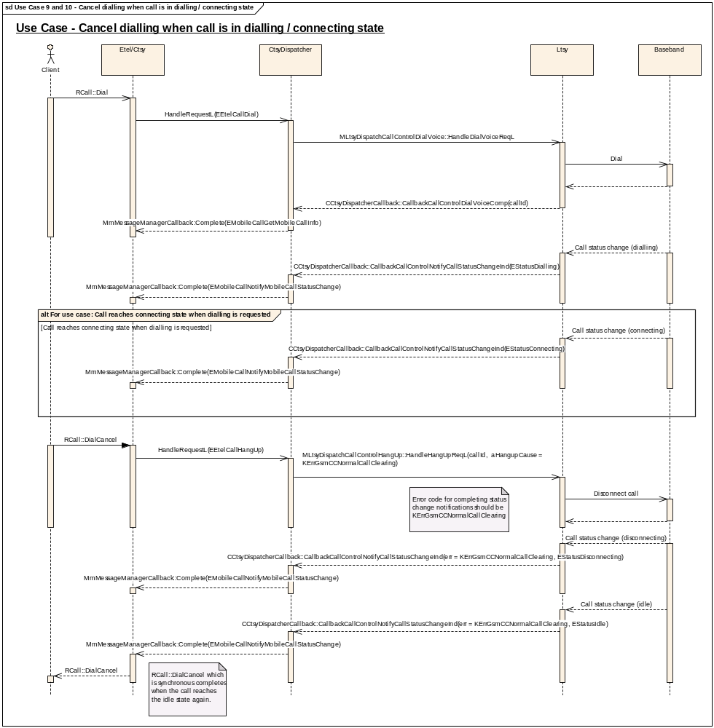

Implementation Notes:

Cancellation of a dial is request on the client application side by a call to RCall::DialCancel. The cancellation is passed to the LTSY as a hang up of the call. i.e. MLtsyDispatchCallControlHangUp::HandleHangUpReqL(callId, aHangupCause = KErrGsmCCNormalCallClearing)

Use Case 11: Missed incoming call
- Receive notification of an incoming call, call is not answered, incoming call disconnects and goes idle.
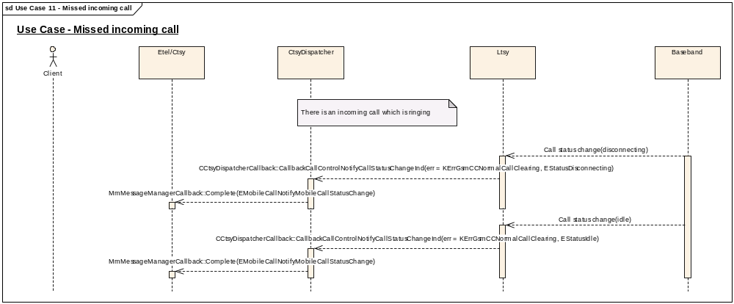

Implementation Notes:

The call status notifications via CCtsyDispatcherCallback::CallbackCallControlNotifyCallStatusChangeInd indicate to the CTSY that the remote party making the incoming call has disconnected.

Use Case 12, 13, 14, 15: Hold, resume and swap a Call
- Hold an active call, resume it, hold it again, swap the call so that it goes into the held state, swap it again so that it goes into the active state.
- Hold an active call but receive an error from the request to hold.
- Hold an active call, resume it but receive an error from the request to resume.
- Swap a call but receive an error from the request to resume.

In this use case, a single call is being swapped between the active and held states (and vice versa). It is also possible to swap two non-multiparty calls between the active and held states. There is also a swapping operation for multiparty calls, these are dealt with in the multiparty call control functional unit.
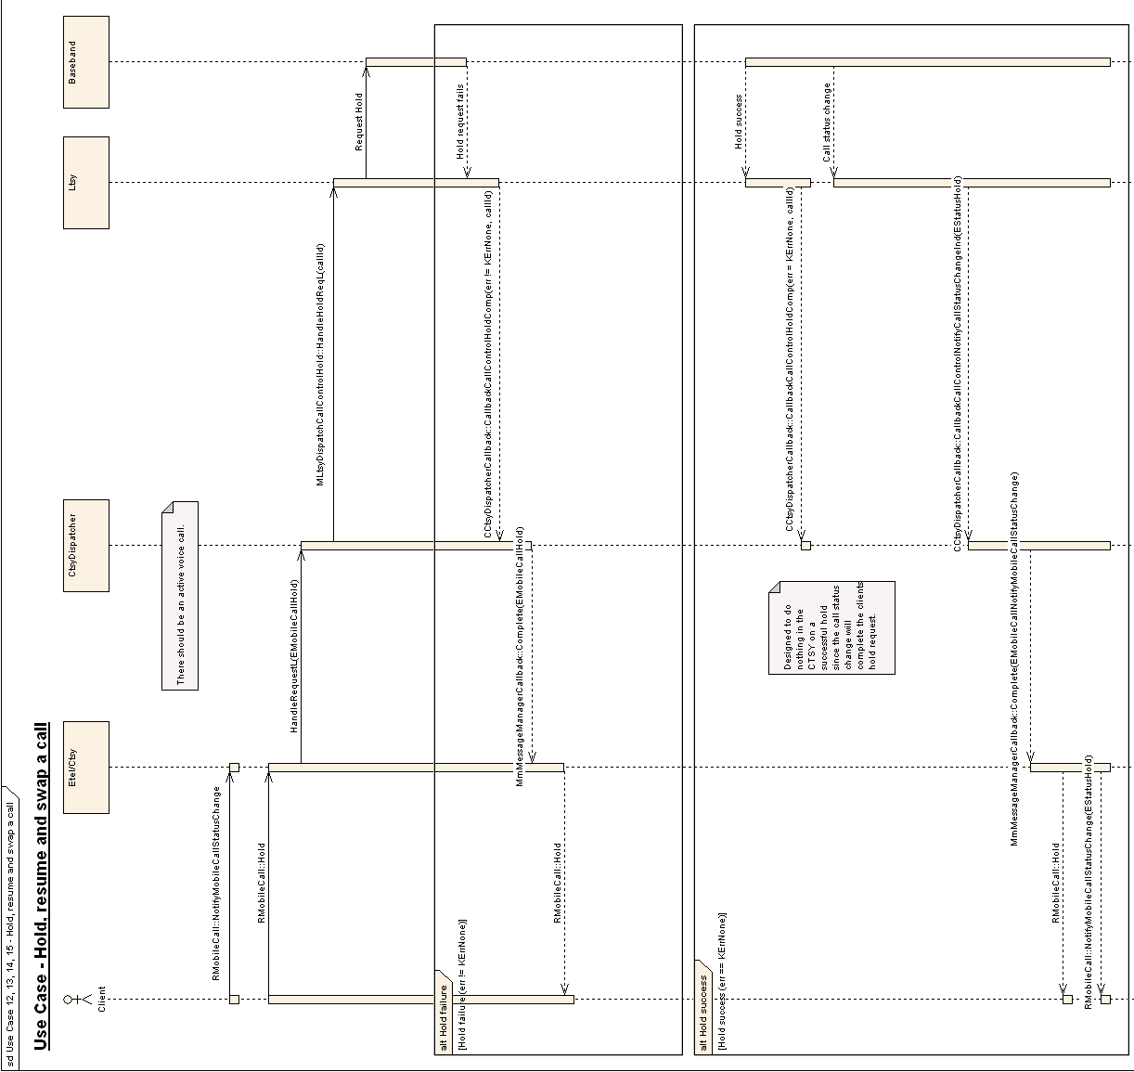
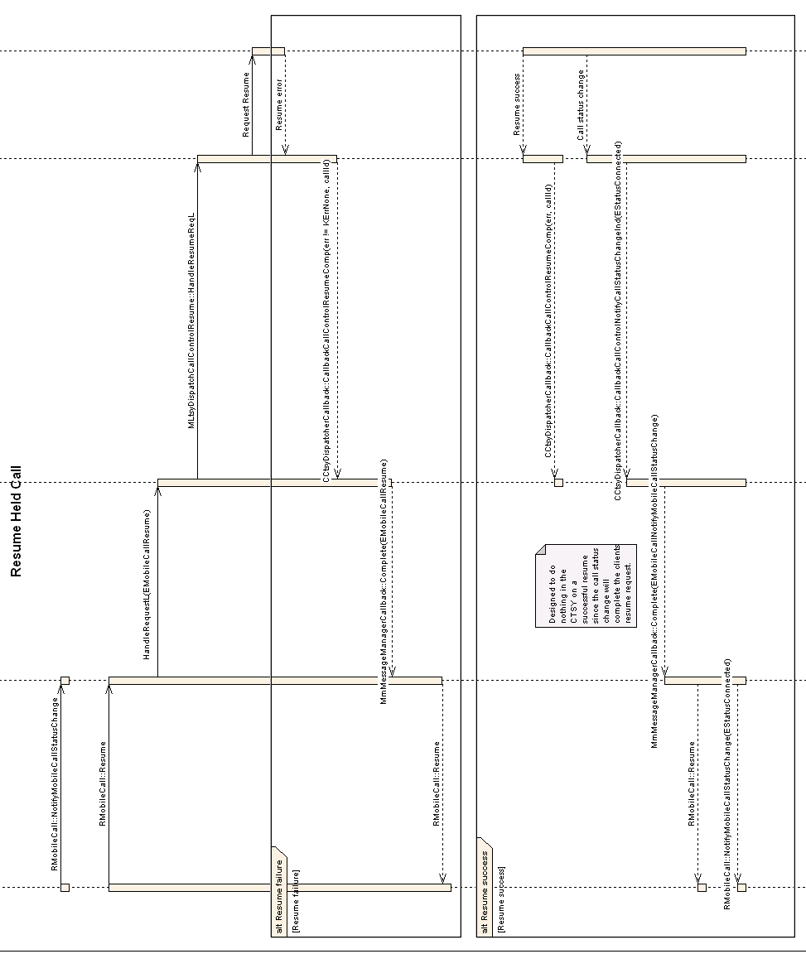
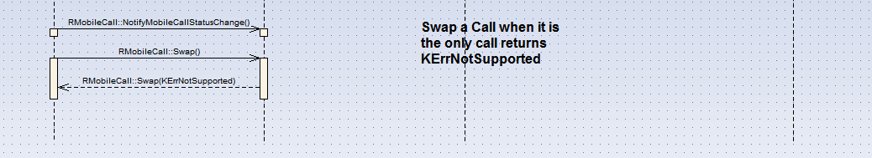

Implementation Notes:

A request to hold a call is made via the MLtsyDispatchCallControlHold::HandleHoldReqL interface:

/**
* The CTSY Dispatcher shall invoke this function on receiving the EMobileCallHold
* request from the CTSY.
*
* It is a request call that is completed by invoking
* CCtsyDispatcherCallback::CallbackCallControlHoldComp
*
* This function is called by the Common TSY to request that the Licensee TSY
* hold the specified call.
*
* @param aCallId The Call ID of the call to hold.
*
* @return KErrNone on success, otherwise another error code indicating the
* failure.
*/
virtual TInt HandleHoldReqL(TInt aCallId) = 0;

The callback from the hold request is CCtsyDispatcherCallback::CallbackCallControlHoldComp:

EXPORT_C void CCtsyDispatcherCallback::CallbackCallControlHoldComp(
TInt aError, TInt aCallId)
/**
*
* Callback function to be used by the Licensee LTSY to complete a pending
* MLtsyDispatchCallControlHold::HandleHoldReqL
*
* The result of the hold request on the call specified in aCallId is passed back
* to the Common TSY.
*
* @param aError The error code to be returned to the CTSY Dispatcher by the LTSY
* indicating the outcome of the attempt to hold the requested call. This should
* be KErrNone if the hold process could be started successfully. Otherwise
* another error code to indicate the failure should be returned.
*
* @param aCallId The Call ID of the call which was requested to be held.
*/

Call status change notifications indicated via the CCtsyDispatcherCallback::CallbackCallControlNotifyCallStatusChangeInd callback indicate that the call has been put on hold when the hold request is successful.

A request to resume a call is made via the MLtsyDispatchCallControlResume::HandleResumeReqL interface:

/**
* The CTSY Dispatcher shall invoke this function on receiving the EMobileCallResume
* request from the CTSY.
*
* It is a request call that is completed by invoking
* CCtsyDispatcherCallback::CallbackCallControlResumeComp
*
* This function is called by the Common TSY to request that the Licensee TSY
* resume the specified call.
*
* @param aCallId The Call ID of the call to resume.
*
* @return KErrNone on success, otherwise another error code indicating the
* failure.
*/
virtual TInt HandleResumeReqL(TInt aCallId) = 0;

The callback from the resume request is CCtsyDispatcherCallback::CallbackCallControlResumeComp

EXPORT_C void CCtsyDispatcherCallback::CallbackCallControlResumeComp(
TInt aError, TInt aCallId)
/**
*
* Callback function to be used by the Licensee LTSY to complete a pending
* MLtsyDispatchCallControlResume::HandleResumeReqL
*
* The result of the pending resume request on the call specified in aCallId is
* passed back to the Common TSY.
*
* @param aError The error code to be returned to the CTSY Dispatcher by the LTSY
* indicating the outcome of the attempt to resume the held call. This should
* be KErrNone if the resume process could be started successfully. Otherwise
* another error code to indicate the failure should be returned.
*
* @param aCallId The Call ID of the call which has been requested to be resumed.
*
* @see RMobileCall::Resume
*/

Call status change notifications indicated via the CCtsyDispatcherCallback::CallbackCallControlNotifyCallStatusChangeInd callback indicate that the call has been resumed when the resume request is successful.

Use Case 16: Hold a call and dial another and swap them
- Hold an active call, dial another voice call and receive notifications on the call status as it gets connected.

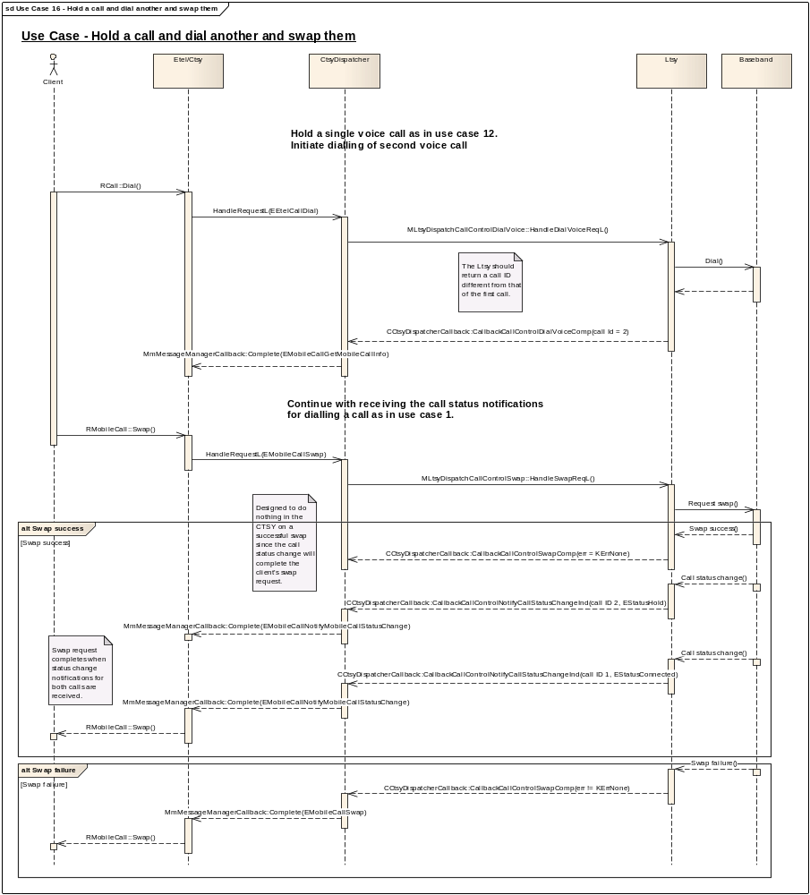

Implementation Notes:
Each call should have a unique call ID.

A request to swap a call is made via the MLtsyDispatchCallControlSwap::HandleSwapReqL interface:

/**
* The CTSY Dispatcher shall invoke this function on receiving the EMobileCallSwap
* request from the CTSY.
*
* It is a request call that is completed by invoking
* CCtsyDispatcherCallback::CallbackCallControlSwapComp()
*
* This request should be completed when the request to swap the call has
* been placed.
*
* Implementation of this interface should request that the Licensee TSY
* swap the specified calls. Swapping requires two calls to be active,
* one held and one connected. It involves switching the states of the
* two call such that the held call becomes connected (RMobileCall::EStatusConnected)
* and the connected call becomes held (RMobileCall::EStatusHold).
*
* @param aHeldCallId The Call ID of the held call to swap.
*
* @param aConnectedCallId The Call ID of the connected call to swap with
* aHeldCallId.
*
* @return KErrNone on success, otherwise another error code indicating the
* failure.
*
* @see RMobileCall::Swap()
*/
virtual TInt HandleSwapReqL(TInt aHeldCallId, TInt aConnectedCallId) = 0;

The callback from the resume request is CCtsyDispatcherCallback::CallbackCallControlSwapComp

EXPORT_C void CCtsyDispatcherCallback::CallbackCallControlSwapComp(
TInt aError)
/**
*
* Callback function to be used by the Licensee LTSY to complete a pending
* MLtsyDispatchCallControlSwap::HandleSwapReqL()
*
*
* @param aError The error code to be returned to the CTSY Dispatcher by the LTSY
* indicating the outcome of the attempt to swap the requested calls. This should
* be KErrNone if the swap process could be started successfully. Otherwise
* another error code to indicate the failure should be returned.
*
* @see RMobileCall::Swap()
*/

Call status change notifications indicated via the CCtsyDispatcherCallback::CallbackCallControlNotifyCallStatusChangeInd callback indicate that the call has been swapped when the hold request is successful. Status change notifications on the other active/held call with which this was swapped should also be received.

Use Case 17: Dialling an ISV call

It is possible for a third party application to place a voice call using the APIs offered by the CTelephony class.

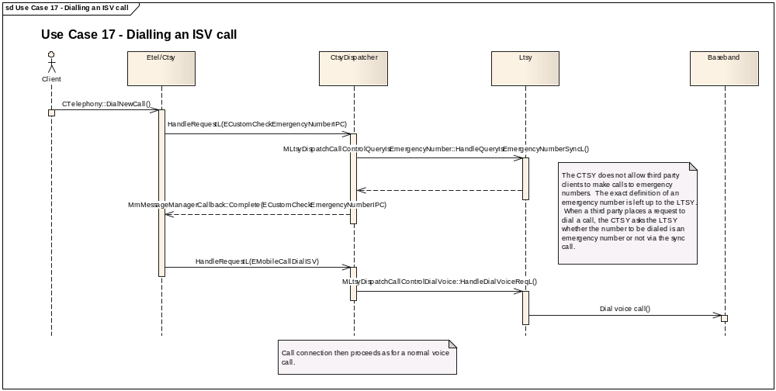

Implementation Notes

/**
* The CTSY Dispatcher shall invoke this function on receiving the
* ECustomCheckEmergencyNumberIPC request from the CTSY.
*
* It is a sync call where the output data arguments should be completed
* before returning.
*
* Implementation of this interface should check whether the specified
* number is an emergency number and return the result back to the caller
* via the output parameter.
*
* @param aNumber Input parameter. The phone number being queried to see
* if it is an emergency number or not.
*
* @param aIsEmergencyNumber Output parameter used to indicate whether the
* aNumber parameter is an emergency number. ETrue if it is, EFalse otherwise.
*
* @return KErrNone if the LTSY was successful in determining whether the
* queried number is an emergency one; KErrNotSupported if the LTSY does not
* support handling of this request or another error code indicating the
* failure otherwise.
*/
virtual TInt HandleQueryIsEmergencyNumberSyncL(const TDesC& aNumber, TBool& aIsEmergencyNumber) = 0;

The IPC ECustomCheckEmergencyNumberIPC which is implemented by the above interface is part of the
RMmCustomAPI subsession, therefore the client must have an open RMmCustomAPI subsession open before dialling an ISV call to ensure that the Custom TSY object in the Common TSY has been created.

Use Case 18: Answering an incoming call from an ISV client

Implementation Notes

A client can be notified of an incoming call using the CTelephony::NotifyChange() API. When the line is ringing, it can answer the incoming call using the CTelephony::AnswerIncomingCall() API. MLtsyDispatchCallControlAnswer:: HandleAnswerReqL() is used to request to answer the incoming call. The aIsIsvCall parameter in this API is used to indicate that the request to answer originated from a third party client. The LTSY can then optionally handle the request differently from a normal answer.

Use Case 19, 20: Dialling an Emergency Call (success and immediate failure scenarios)
- Dial an emergency call, receive the call status change notifications as the call is connected.
- Dial an emergency call, receive an immediate error from the request to dial.

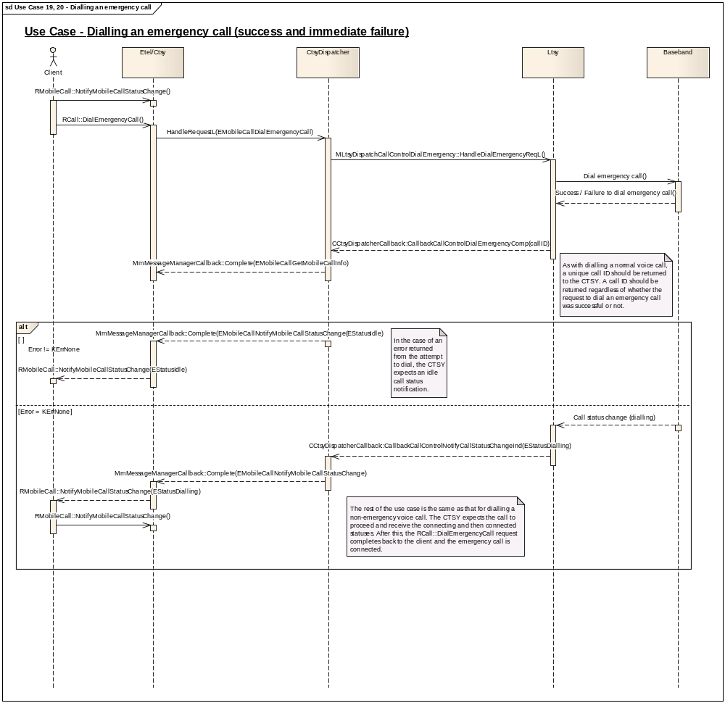

Implementation Notes

MLtsyDispatchCallControlDialEmergency::HandleDialEmergencyReqL() is used to request for an emergency call to be dialled.

/**
* The CTSY Dispatcher shall invoke this function on receiving the EMobileCallDialEmergencyCall
* request from the CTSY.
*
* It is a request call that is completed by invoking
* CCtsyDispatcherCallback::CallbackCallControlDialEmergencyComp()
*
* Implementation of this interface should dial an emergency call to the specified
* number.
*
* @param aEmergencyNumber The emergency phone number to dial. The descriptor
* should be of type RMobileENStore::TEmergencyNumber.
*
* @return KErrNone on success, otherwise another error code indicating the
* failure.
*/
virtual TInt HandleDialEmergencyReqL(const TDes& aEmergencyNumber) = 0;

The callback for this is:

EXPORT_C void CCtsyDispatcherCallback::CallbackCallControlDialEmergencyComp(
TInt aError, TInt aCallId)
/**
*
* Callback function to be used by the Licensee LTSY to complete a pending
* MLtsyDispatchCallControlDialEmergency::HandleDialEmergencyReqL()
*
* This callback is used to inform the CTSY of the outcome of the request to
* initiate the dialling process to dial an emergency call.
*
* This callback is similar to CCtsyDispatcherCallback::CallbackCallControlDialVoiceComp
* but refers specifically to the diallinf of an emergency call.
*
* @param aError The error code to be returned to the CTSY Dispatcher.
* @param aCallId The call ID of the call that the dial attempt refers to which
* has been allocated by the LTSY. The call ID needs to be unique across all
* calls and modes(emergency and non-emergency included). See the documentation for
* CCtsyDispatcherCallback::CallbackCallControlDialVoiceComp for precise details
* on how to allocate a valid call ID.
*
* @see RMobileCall::DialEmergencyCall()
*/

If there is an immediate failure to dial the emergency call, CCtsyDispatcherCallback::CallbackCallControlDialEmergencyComp() should be completed with aError != KErrNone. The CTSY dispatcher will then complete the relevant call status notification indicating that the call has gone idle and an error will be returned to the client.

Use Case 21, 22: Transferring a call (success and failure)
- There are two calls, one held call (call 1) and one active call (call 2). The calls are transferred connecting call 1 and call 2 together while the party doing the transferring drops out of the call.

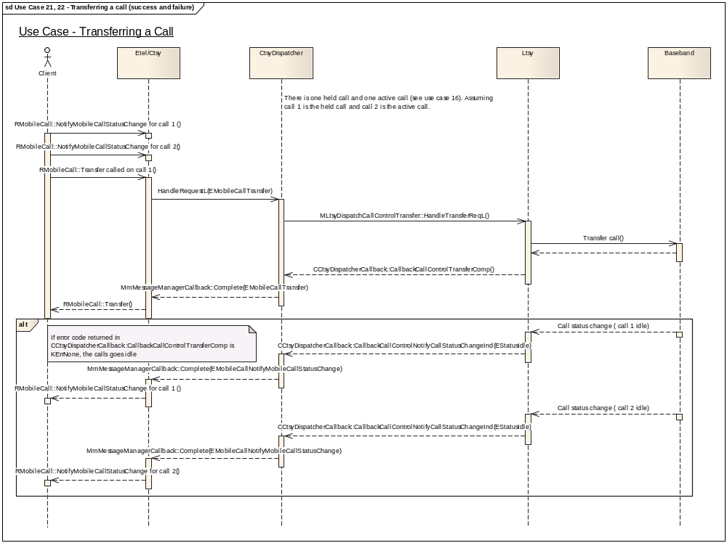

Implementation Notes

To transfer a call use:

/**
* The CTSY Dispatcher shall invoke this function on receiving the EMobileCallTransfer
* request from the CTSY.
*
* It is a request call that is completed by invoking
* CCtsyDispatcherCallback::CallbackCallControlTransferComp()
*
* This request should be completed when the request to transfer the call has
* been placed.
*
* Implementation of this interface should transfer the specified held call.
* Transferring a call can be requested when there is one held call and another
* call either connected or in the ringing state. When the two remote parties
* are transferred to each other, the party requesting this operation (us)
* drops out of the call.
*
* @param aHeldCallId Call ID of the call held call to transfer.
*
* @param aOtherCallId Call ID of the other call to transfer the held call to.
* This call is either an incoming call in the ringing state or a connected call.
*
* @return KErrNone on success, otherwise another error code indicating the
* failure.
*
* @see RMobileCall::Transfer()
*/
virtual TInt HandleTransferReqL(TInt aHeldCallId, TInt aOtherCallId) = 0;

The callback for this is:

EXPORT_C void CCtsyDispatcherCallback::CallbackCallControlTransferComp(TInt aError)
/**
*
* Callback function to be used by the Licensee LTSY to complete a pending
* MLtsyDispatchCallControlTransfer::HandleTransferReqL()
*
* Informs the CTSY of the outcome of initiating the transfer process.
*
* Successful completion of the transfer process is indicated by a change
* in the call status of the calls which were transferred.
*
* @param aError KErrNone on success, or another error code indicating the error otherwise.
*
* @see RMobileCall::Transfer()
*/

Use Case 23, 24: Sending a DTMF string

- There is an active voice call (call1). The client requests to send a DTMF string (12345w67890wABCD). The ‘w’ characters are stop (also known as ‘wait’) characters. The CTSY first sends 12345 and stops at the wait character and notifies the client that a stop has been encountered. The client requests to continue sending the string and 67890 is sent. The CTSY again notifies the client of the stop and again the client requests to continue sending the string. ABCD is sent and the request to send the string completes.
- When a ‘w’ is encountered the client can also request to terminate the sending of the string.

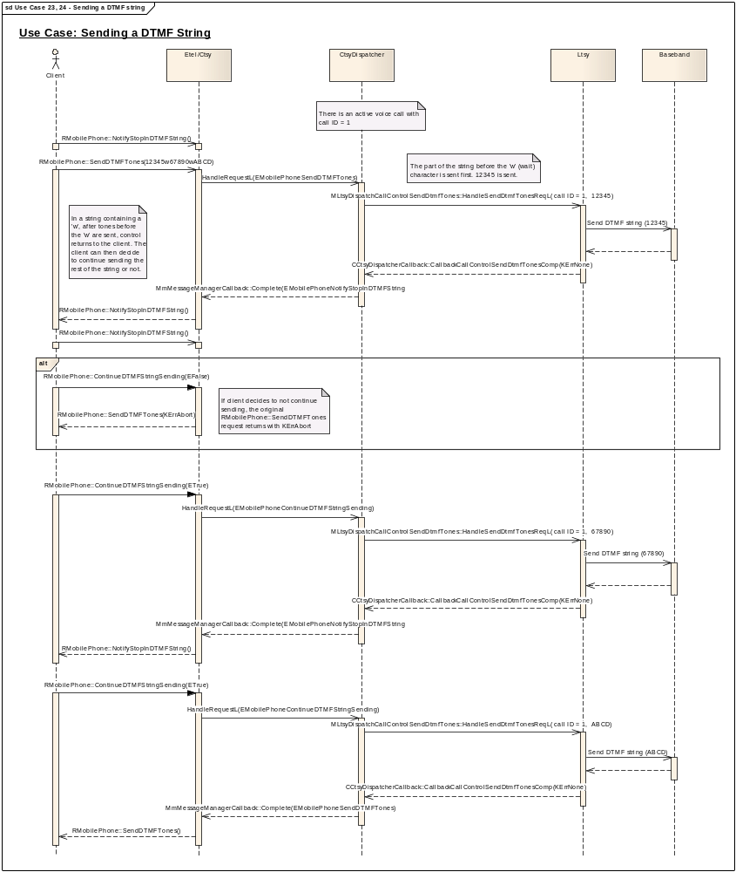

Implementation Notes
The parsing of the string to locate a ‘w’ character and notifications to the client of stops are all handled in the CTSY and the CTSY Dispatcher. The LTSY only needs to deal with the sending of the tones.
Sending of a string is achieved using the API:

/**
* The CTSY Dispatcher shall invoke this function on receiving the EMobilePhoneSendDTMFTones
* request from the CTSY.
*
* It is a request call that is completed by invoking
* CCtsyDispatcherCallback::CallbackCallControlSendDtmfTonesComp()
*
* Implementation of this interface should send the specified DTMF string through
* the currently active call.
*
* @param aCallId The Call ID of the call through which the DTMF string will be
* sent.
*
* @param aTones Tones to send through the active call.
*
* @return KErrNone on success, otherwise another error code indicating the
* failure.
*
* @see RMobilePhone::SendDTMFTones
*/
virtual TInt HandleSendDtmfTonesReqL(TInt aCallId, const TDesC &aTones) = 0;

The callback is:

EXPORT_C void CCtsyDispatcherCallback::CallbackCallControlSendDtmfTonesComp(
TInt aError)
/**
*
* Callback function to be used by the Licensee LTSY to complete a pending
* MLtsyDispatchCallControlSendDtmfTones::HandleSendDtmfTonesReqL()
*
* This callback indicates that the DTMF string has been sent.
*
* @param aError The error code to be returned to the CTSY Dispatcher.
*
* @see RMobilePhone::SendDTMFTones()
*/
Other relevant APIs:

It is also possible to cancel sending of a DTMF string during sending:

/**
* The CTSY Dispatcher shall invoke this function on receiving the EMobilePhoneSendDTMFTonesCancel
* request from the CTSY.
*
* It is a request call that is completed by invoking
* CCtsyDispatcherCallback::CallbackCallControlSendDtmfTonesCancelComp()
*
* Implementation of this interface should attempt to cancel the sending of
* a string of DTMF tones which were previously sent by
* MLtsyDispatchCallControlSendDtmfTones::HandleSendDtmfTonesReqL()
*
* @param aCallId The Call ID of the active call that the cancel request relates
* to.
*
* @return KErrNone on success, otherwise another error code indicating the
* failure.
*
* @see RMobilePhone::SendDTMFTones()
*/
virtual TInt HandleSendDtmfTonesCancelReqL(TInt aCallId) = 0;
The callback for the cancel is:

EXPORT_C void CCtsyDispatcherCallback::CallbackCallControlSendDtmfTonesCancelComp(TInt aError)
/**
*
* Callback function to be used by the Licensee LTSY to complete a pending
* MLtsyDispatchCallControlSendDtmfTonesCancel::HandleSendDtmfTonesCancelReqL()
*
*
* @param aError The error code to be returned to the CTSY Dispatcher.
*
* @see RMobilePhone::SendDTMFTones()
*/

It is also possible to send a single DTMF tone. An API (and corresponding callback) exists to start and stop the tone.

/**
* The CTSY Dispatcher shall invoke this function on receiving the EMobilePhoneStopDTMFTone
* request from the CTSY.
*
* It is a request call that is completed by invoking
* CCtsyDispatcherCallback::CallbackCallControlStopDtmfToneComp()
*
* Implementation of this interface should stop sending the DTMF tone previously
* started by MLtsyDispatchCallControlStartDtmfTone::HandleStartDtmfToneL().
*
* @param aCallId Call ID of the connected call the stop request will be sent
* through.
*
* @return KErrNone on success, otherwise another error code indicating the
* failure.
*/
virtual TInt HandleStopDtmfToneReqL(TInt aCallId) = 0;

EXPORT_C void CCtsyDispatcherCallback::CallbackCallControlStartDtmfToneComp(TInt aError)
/**
*
* Callback function to be used by the Licensee LTSY to complete a pending
* MLtsyDispatchCallControlStartDtmfTone::HandleStartDtmfToneL()
*
* @param aError The error code to be returned to the CTSY Dispatcher by the LTSY
* indicating the outcome of the request to send the DTMF tone.
*
* @see RMobilePhone::StartDTMFTone()
*/

/**
* The CTSY Dispatcher shall invoke this function on receiving the EMobilePhoneStopDTMFTone
* request from the CTSY.
*
* It is a request call that is completed by invoking
* CCtsyDispatcherCallback::CallbackCallControlStopDtmfToneComp()
*
* Implementation of this interface should stop sending the DTMF tone previously
* started by MLtsyDispatchCallControlStartDtmfTone::HandleStartDtmfToneL().
*
* @param aCallId Call ID of the connected call the stop request will be sent
* through.
*
* @return KErrNone on success, otherwise another error code indicating the
* failure.
*/
virtual TInt HandleStopDtmfToneReqL(TInt aCallId) = 0;
EXPORT_C void CCtsyDispatcherCallback::CallbackCallControlStopDtmfToneComp(TInt aError)
/**
*
* Callback function to be used by the Licensee LTSY to complete a pending
* MLtsyDispatchCallControlStopDtmfTone::HandleStopDtmfToneReqL()
*
* @param aError The error code to be returned to the CTSY Dispatcher.
*
* @see RMobilePhone::StopDTMFTone()
*/

Use Case 25: Dialling a voice call using the alternate line

Dialling a voice call using the alternate line is achieved in the same way as using the primary line. (see section 8.1.1)
The API MLtsyDispatchCallControlDialVoice::HandleDialVoiceReqL() should be used:

virtual TInt HandleDialVoiceReqL(RMobilePhone::TMobilePhoneALSLine aCallLine, RMobilePhone::TMobileAddress& aDialledParty, RMobileCall::TMobileCallParamsV1& aCallParamsV1, TBool aIsIsvCall, RMobileCall::TCallParamOrigin aCallOrigin) = 0;

with aCallLine set to RMobileCall::EAlternateLineAuxiliary

Other APIs in this functional unit:

RMobilePhone::GetIdentityServiceStatus()

/**
* The CTSY Dispatcher shall invoke this function on receiving the EMobilePhoneGetIdentityServiceStatus
* request from the CTSY.
*
* It is a request call that is completed by invoking
* CCtsyDispatcherCallback::CallbackCallControlGetIdentityServiceStatusComp()
*
* Implementation of this interface should request for the status of the
* specified identity service such as the Caller ID Presentation Service.
*
* @param aService The service whose status needs to be retrieved.
*
* @return KErrNone on success, otherwise another error code indicating the
* failure.
*
* @see RMobilePhone::GetIdentityServiceStatus()
*/
virtual TInt HandleGetIdentityServiceStatusReqL(RMobilePhone::TMobilePhoneIdService aService) = 0;

EXPORT_C void CCtsyDispatcherCallback::CallbackCallControlGetIdentityServiceStatusComp(
TInt aError, RMobilePhone::TMobilePhoneIdServiceStatus aIdentityServiceStatus)
/**
*
* Callback function to be used by the Licensee LTSY to complete a pending
* MLtsyDispatchCallControlGetIdentityServiceStatus::HandleGetIdentityServiceStatusReqL()
*
*
* @param aError The error code to be returned to the CTSY Dispatcher.
*
* @param aIdentityServiceStatus The status of the service requested in
* MLtsyDispatchCallControlGetIdentityServiceStatus::HandleGetIdentityServiceStatusReqL()
*
* @see RMobilePhone::GetIdentityServiceStatus()
*/

RMobilePhone::SetALSLine

Set the ALS (alternate line service) line.

/**
* The CTSY Dispatcher shall invoke this function on receiving the EMobilePhoneSetALSLine
* request from the CTSY.
*
* It is a request call that is completed by invoking
* CCtsyDispatcherCallback::CallbackCallControlSetActiveAlsLineComp()
*
* Implementation of this interface should set the active ALS line to that
* specified.
*
* @param aAlsLine The new active ALS line.
*
* @return KErrNone on success, otherwise another error code indicating the
* failure.
*/
virtual TInt HandleSetActiveAlsLineReqL(RMobilePhone::TMobilePhoneALSLine aAlsLine) = 0;

EXPORT_C void CCtsyDispatcherCallback::CallbackCallControlSetActiveAlsLineComp(TInt aError)
/**
*
* Callback function to be used by the Licensee LTSY to complete a pending
* MLtsyDispatchCallControlSetActiveAlsLine::HandleSetActiveAlsLineReqL()
*
* This callback indicates the outcome of the request to set the active ALS line.
*
* @param aError The error code to be returned to the CTSY Dispatcher.
*
* @see RMobilePhone::SetALSLine()
*/

RMobileCall::ReceiveUUI

Receive User-To-User signalling information.

EXPORT_C void CCtsyDispatcherCallback::CallbackCallControlReceiveUuiInd(
TInt aError, TInt aCallId, const RMobileCall::TMobileCallUUI& aCallUui)
/**
* Used by the LTSY to indicate to the CTSY that it has received a User-to-User
* Information notification.
*
* @param aError The error code to be returned to the CTSY Dispatcher.
* @param aCallId The Call ID of the call to which this signal relates.
*
* @see RMobileCall:ReceiveUUI()
*/

Phone Functional Unit
The request handlers that must be implemented by the LTSY are declared in mltsydispatchphoneinterface.h.
The callback functions used to complete the phone requests and also any indicator callbacks are declared in cctsydispatchercallback.h in the section starting with the comment

// Phone related callbacks
IMPORT_C void CallbackPhoneGetFdnStatusComp(TInt aError, RMobilePhone::TMobilePhoneFdnStatus aFdnStatus);
Etc....

Use-case 1: Boot Phone
This use-case covers:
- Loading the LTSY
- LTSY establishing communication with the baseband
- CTSY going through its boot sequence consisting of making a series of requests to the LTSY.
- Closing down the CTSY which closes (releases) the LTSY
- LTSY releasing its communication channel with the baseband

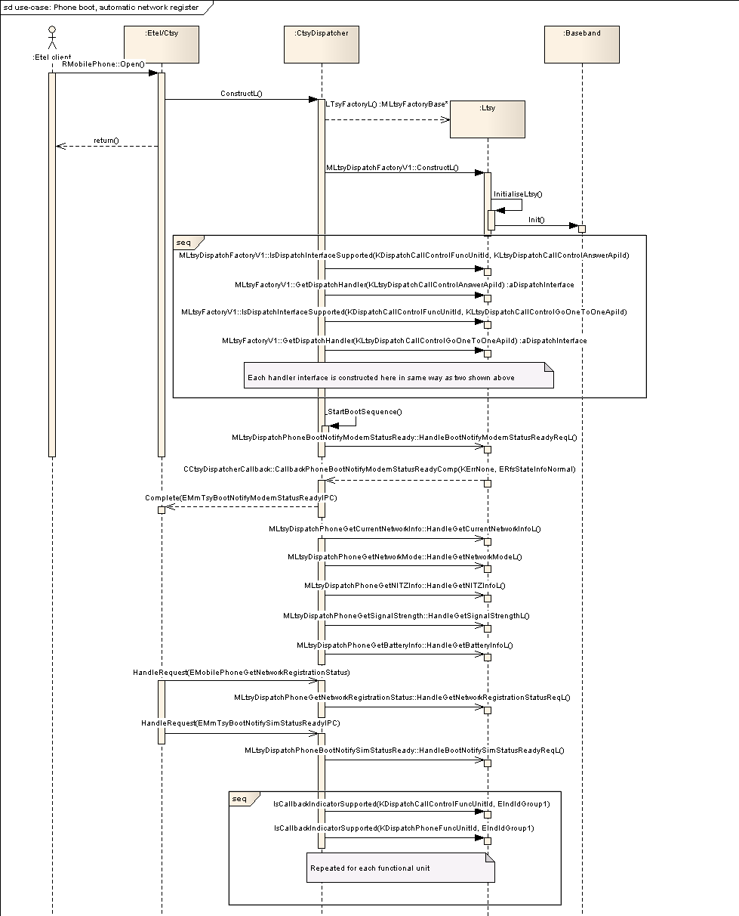

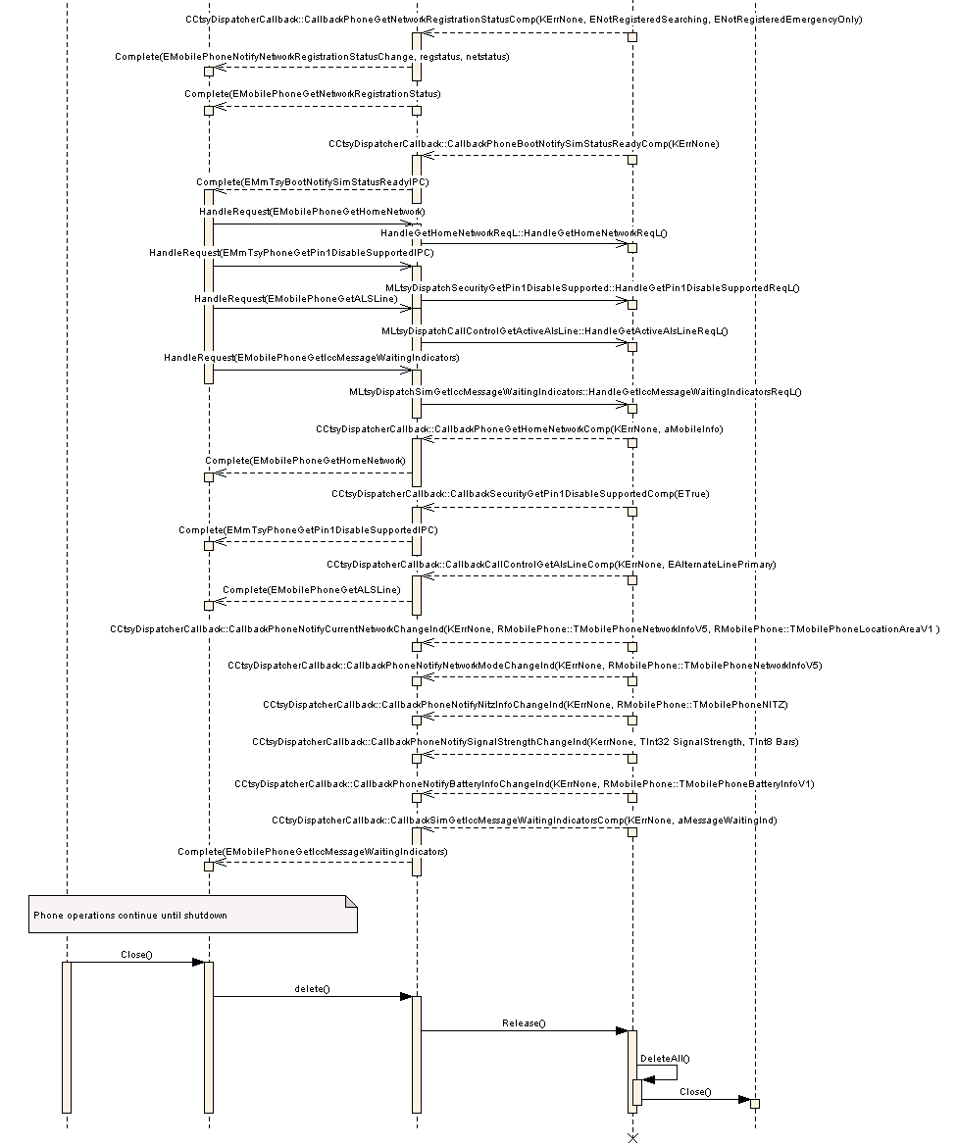

Implementation Notes
The phone boot sequence does not make any assumptions about the state of network registration after the sequence ends. Therefore if the baseband auto-registers onto the network then registration status maybe ERegisteredOnHomeNetwork but if registration is manual then status could be ENotRegisteredEmergencyOnly.

Use-case 2: Manual Network Detection and Selection
This use-case covers:
- User setting to do manual network selection
- User requesting to get the list of detected networks
- User selecting a network to register onto
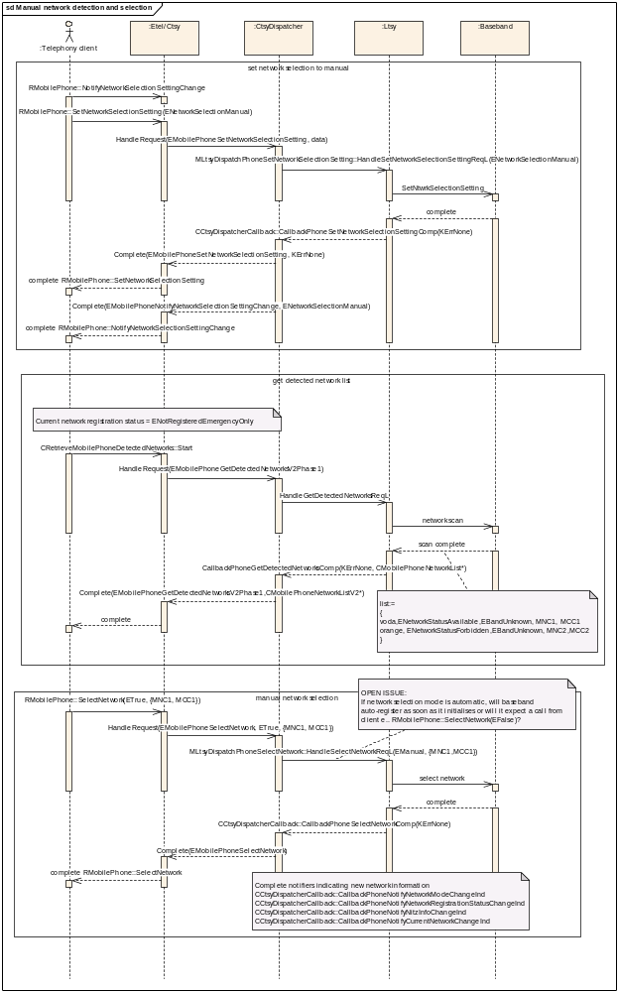

Implementation Notes
It is important to ensure that network status changes to becoming registered on a network that all the callbacks relating to notifying network information are completed. Specifically,
CCtsyDispatcherCallback::CallbackPhoneNotifyNetworkModeChangeInd
CCtsyDispatcherCallback::CallbackPhoneNotifySignalStrengthChangeInd
CCtsyDispatcherCallback::CallbackPhoneNotifyNetworkRegistrationStatusChangeInd
CCtsyDispatcherCallback::CallbackPhoneNotifyNitzInfoChangeInd

Use-case 3: Network Information Updates
This use-case covers:
- Notifying CTSY on NITZ updates
- Notifying CTSY on changes to network information
- Notifying CTSY on changes to network mode (e.g. GSM and WCDMA)
- Notifying CTSY on changes to signal strength

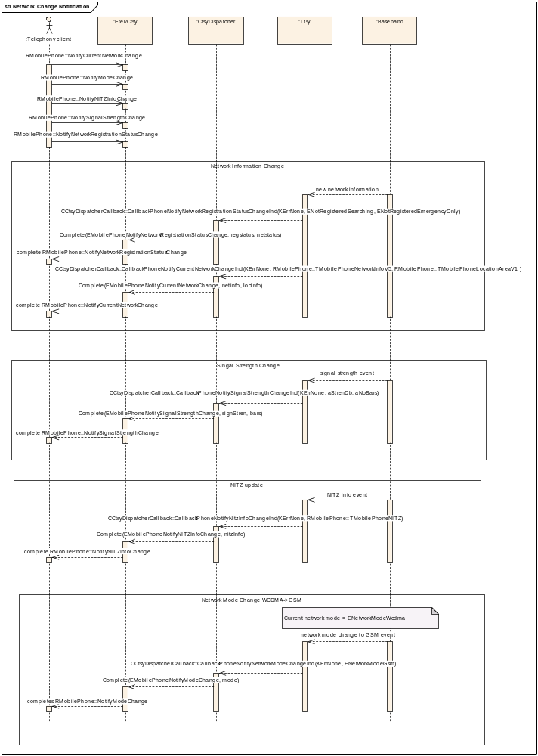

Additional Phone API’s

RMobilePhone::GetBatteryInfo
For this Etel API the following handler will need to be implemented MLtsyDispatchPhoneGetBatteryInfo::HandleGetBatteryInfoL. The HandleGetBatteryInfoL() should retrieve the current battery information.
class MLtsyDispatchPhoneGetBatteryInfo : public virtual MLtsyDispatchInterface
{
public:
virtual TInt HandleGetBatteryInfoL() = 0;
};

The request is completed by invoking CCtsyDispatcherCallback::CallbackPhoneGetBatteryInfoComp and supplying the battery information data as follows
void CCtsyDispatcherCallback::CallbackPhoneGetBatteryInfoComp(
TInt aError,
const RMobilePhone::TMobilePhoneBatteryInfoV1& aBatteryInfo)

RMobilePhone::NotifyBatteryInfoChange
The callback CallbackPhoneNotifyBatteryInfoChangeInd is used to notify a battery change event has occurred. The battery information data is to be supplied as follows
CCtsyDispatcherCallback::CallbackPhoneNotifyBatteryInfoChangeInd(
TInt aError,
const RMobilePhone::TMobilePhoneBatteryInfoV1& aBatteryInfo)

RMobilePhone::GetPhoneId
For this Etel API the following handler will need to be implemented MLtsyDispatchPhoneGetPhoneId::HandleGetPhoneIdReqL. The HandleGetPhoneIdReqL() should retrieve the phone's identity as described by the fields in RMobilePhone::TMobilePhoneIdentityV1.
class MLtsyDispatchPhoneGetPhoneId: public virtual MLtsyDispatchInterface
{
public:
virtual TInt HandleGetPhoneIdReqL() = 0;
};
The request is completed by invoking CCtsyDispatcherCallback::CallbackPhoneGetPhoneIdComp and supplying the battery information data as follows
void CCtsyDispatcherCallback::CallbackPhoneGetPhoneIdComp (
TInt aError,
const RMobilePhone::TMobilePhoneIdentityV1& aPhoneId)

RMobilePhone::GetHomeNetwork
For this Etel API the following handler will need to be implemented MLtsyDispatchPhoneGetHomeNetwork::HandleGetHomeNetworkReqL. The HandleGetHomeNetworkReqL () should retrieve the current home network as described by the fields in RMobilePhone::TMobilePhoneNetworkInfoV5.
class MLtsyDispatchPhoneGetHomeNetwork: public virtual MLtsyDispatchInterface
{
public:
virtual TInt HandleGetHomeNetworkReqL() = 0;
};
The request is completed by invoking CCtsyDispatcherCallback::CallbackPhoneGetHomeNetworkComp and supplying the network information data as follows
void CCtsyDispatcherCallback::CallbackPhoneGetHomeNetworkComp(
TInt aError,
const RMobilePhone::TMobilePhoneNetworkInfoV5& aNetworkInfo)

RMobilePhone::GetServiceProviderName
For this Etel API the following handler will need to be implemented MLtsyDispatchPhoneGetServiceProviderName::HandleGetServiceProviderNameReqL. The HandleGetServiceProviderNameReqL() should retrieve the service provider details as described by the fields in RMobilePhone::TMobilePhoneServiceProviderNameV2.
class MLtsyDispatchPhoneGetServiceProviderName: public virtual MLtsyDispatchInterface
{
public:
virtual TInt HandleGetServiceProviderNameReqL() = 0;
};
The request is completed by invoking CCtsyDispatcherCallback:: CallbackPhoneGetServiceProviderNameComp and supplying the service provider information data as follows
void CCtsyDispatcherCallback:: CallbackPhoneGetServiceProviderNameComp(
TInt aError,
const RMobilePhone:: TMobilePhoneServiceProviderNameV2& aServiceProvider)

Implementation Notes
The order of the callbacks made by LTSY to the CTSY is not important.

Security Functional Unit

Use Case 1: Set FDN Setting with Security Check
This use case covers:
- Notify Security Event request issued
- Request to set FDN
- Notify Security Event completed
- Request blocked due to requiring security check
- Security verification requested with incorrect security code.
- Notify Security Event request issued
- Request to set FDN repeated
- Notify Security Event completed
- Request blocked due to requiring security check
- Security verification requested with correct security code.
- FDN request permitted to go to LTSY
- FDN setting confirmed and notification complete.
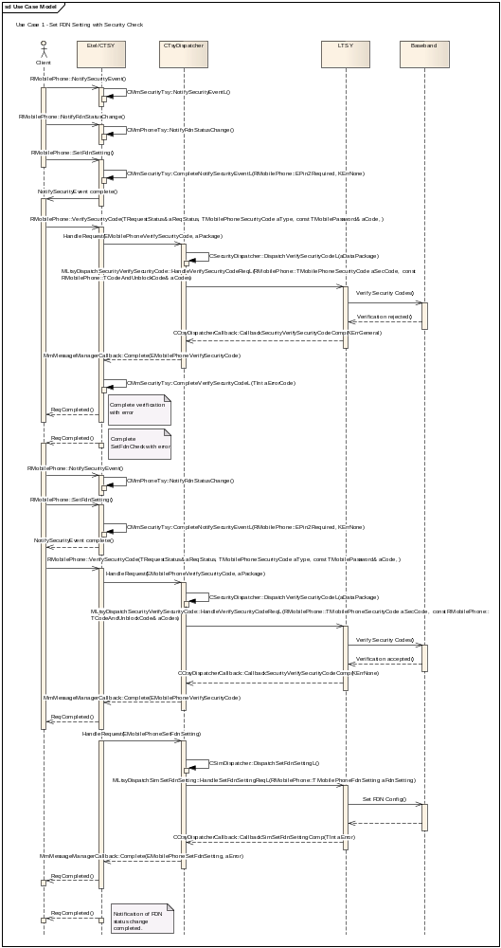
class MLtsyDispatchSecurityVerifySecurityCode : public MLtsyDispatchInterface
{
public:

static const TInt KLtsyDispatchSecurityVerifySecurityCodeApiId = KDispatchSecurityFuncUnitId + 6;

/**
* The CTSY Dispatcher shall invoke this function on receiving the EMobilePhoneVerifySecurityCode
* request from the CTSY.
*
* It is a request call that is completed by invoking
* CCtsyDispatcherCallback::CallbackSecurityVerifySecurityCodeComp()
*
* This function member sends a security code requiring verification to the phone.
*
* If the security code required is one of the unblock codes (either PUK1 or
* PUK2), then the user must supply a new PIN1 or PIN2 code as well as the associated
* unblocking code. In this case, aUnblockCode will contain the unblocking code
* and aCode will contain the new PIN1 or PIN2 value. If the security code required
* is NOT one of the unblock codes, then the user only has to supply the one
* security code. In this case, aUnblockCode will be invalid and aCode will contain
* the required security code (PIN1, PIN2 or Phone Password).
*
* @param aSecCode The type of code that is to be verified.
* @param aCodes The actual code and if a PUK1 or PUK2 is specified, the PUK code.
*
* @return KErrNone on success, otherwise another error code indicating the
* failure.
*/
virtual TInt HandleVerifySecurityCodeReqL(
RMobilePhone::TMobilePhoneSecurityCode aSecCode,
const RMobilePhone::TCodeAndUnblockCode& aCodes) = 0;

}; // class MLtsyDispatchSecurityVerifySecurityCode

EXPORT_C void CCtsyDispatcherCallback::CallbackSecurityVerifySecurityCodeComp(
TInt aError)
/**
*
* Callback function to be used by the Licensee LTSY to complete a pending
* MLtsyDispatchSecurityVerifySecurityCode::HandleVerifySecurityCodeReqL()
*
* Completion to the routine sending a security code requiring verification to the phone
*
* @param aError KErrNone on success, or another error code indicating the error otherwise.
*
* @see RMobilePhone::VerifySecurityCode()
*/

Use Case 2: Set Lock Setting
This use case covers:
- Request Set Lock Setting
- Request confirmed
- Indicate change to lock info
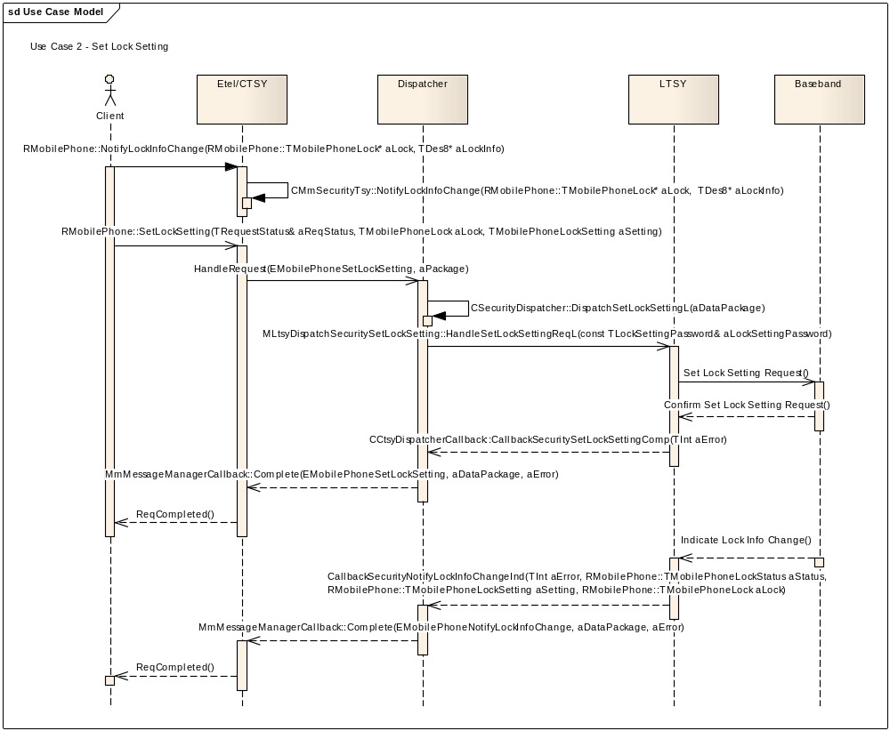

class MLtsyDispatchSecuritySetLockSetting : public MLtsyDispatchInterface
{
public:

static const TInt KLtsyDispatchSecuritySetLockSettingApiId = KDispatchSecurityFuncUnitId + 5;

/**
* The CTSY Dispatcher shall invoke this function on receiving the EMobilePhoneSetLockSetting
* request from the CTSY.
*
* It is a request call that is completed by invoking
* CCtsyDispatcherCallback::CallbackSecuritySetLockSettingComp()
*
* This function allows a client to change the current setting of a lock.
*
* @param aLockSettingPassword Struct containing the lock to change, the new settings for the lock, and password params.
*
* @return KErrNone on success, otherwise another error code indicating the
* failure.
*/
virtual TInt HandleSetLockSettingReqL(const TLockSettingPassword& aLockSettingPassword) = 0;

}; // class MLtsyDispatchSecuritySetLockSetting

EXPORT_C void CCtsyDispatcherCallback::CallbackSecuritySetLockSettingComp(TInt aError)
/**
*
* Callback function to be used by the Licensee LTSY to complete a pending
* MLtsyDispatchSecuritySetLockSetting::HandleSetLockSettingReqL()
*
* LTSY notifies about current values for lock status and lock setting.
*
* @param aError KErrNone on success, or another error code indicating the error otherwise.
*
* @see RMobilePhone::SetLockSetting()
*/

EXPORT_C void CCtsyDispatcherCallback::CallbackSecurityNotifyLockInfoChangeInd(
TInt aError, RMobilePhone::TMobilePhoneLockStatus aStatus, RMobilePhone::TMobilePhoneLockSetting aSetting, RMobilePhone::TMobilePhoneLock aLock)
/**
*
* Used by the LTSY to indicate that the phone lock information has changed. This complements
* the CCtsyDispatcherCallback::CallbackSecuritySetLockSettingComp() which indicates that the
* lock status change request has been received.
*
* Completion routine to provide the status of a phone lock and lock information back to the CTSY
*
* @param aError KErrNone on success, or another error code indicating the error otherwise.
* @param aStatus Status of the lock (unknown, locked, unlocked or blocked).
* @param aSetting Lock setting (unknown, enabled, disabled or replaced).
* @param aLock Lock type.
*
* @see RMobilePhone::NotifyLockInfoChange()
*/

Use Case 3: Set Lock Setting with Access Denied
This use case covers:
- Notify Security Event request issued
- Set Lock Setting request fails with KErrAccessDenied
- Notify Security Event completed
- Security verification fails with KErrAccessDenied
- Notify Security Event request issued
- Reposting Set Lock Setting request fails with KErrAccessDenied
- Notify Security Event completed
- Security verification accepted
- Set Lock Setting request allowed to go into LTSY
- Set Lock Setting completes OK

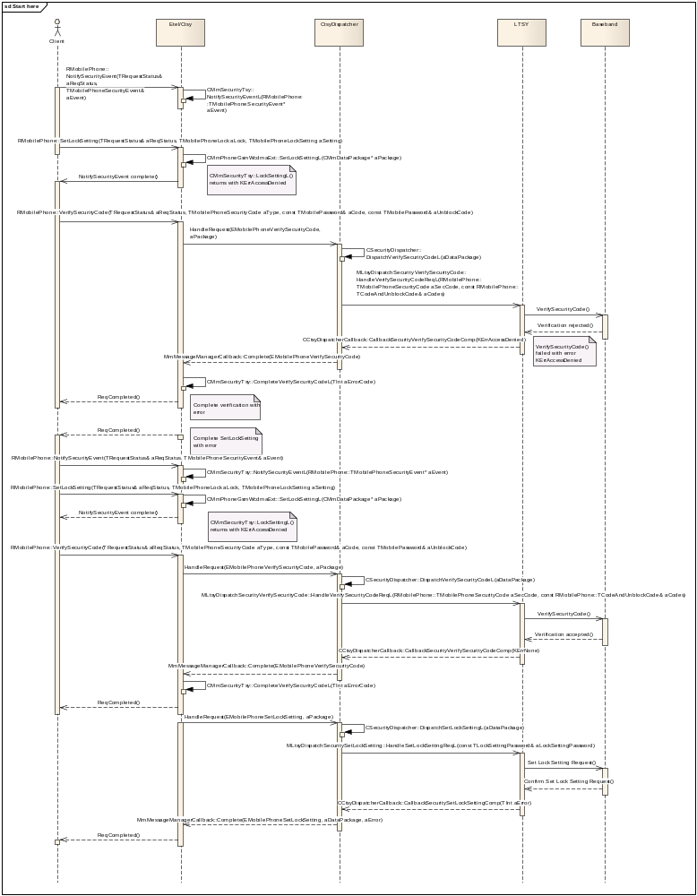
EXPORT_C void CCtsyDispatcherCallback::CallbackSecurityNotifySecurityEventInd(TInt aError, RMobilePhone::TMobilePhoneSecurityEvent aSecEvent)
/**
*
* Completion routine to provide security event identifier back to the CTSY.
*
* @param aError KErrNone on success, or another error code indicating the error otherwise.
* @param aSecEvent Notify security event.
*
* @see RMobilePhone::NotifySecurityEvent()
*/

Use Case 4: Abort Verification of Security Code
This use case covers:
- Verify Security Code request issued
- Abort Security Code synchronous request completes OK
- Verify Security Code completes with KErrAbort
- Set Lock Setting request issued
- Abort Security Code synchronous request
- Set Lock Setting completes with KErrAbort
- Set Fdn Setting request issued
- Abort Security Code synchronous request
- Set Fdn Setting completes with KErrAbort

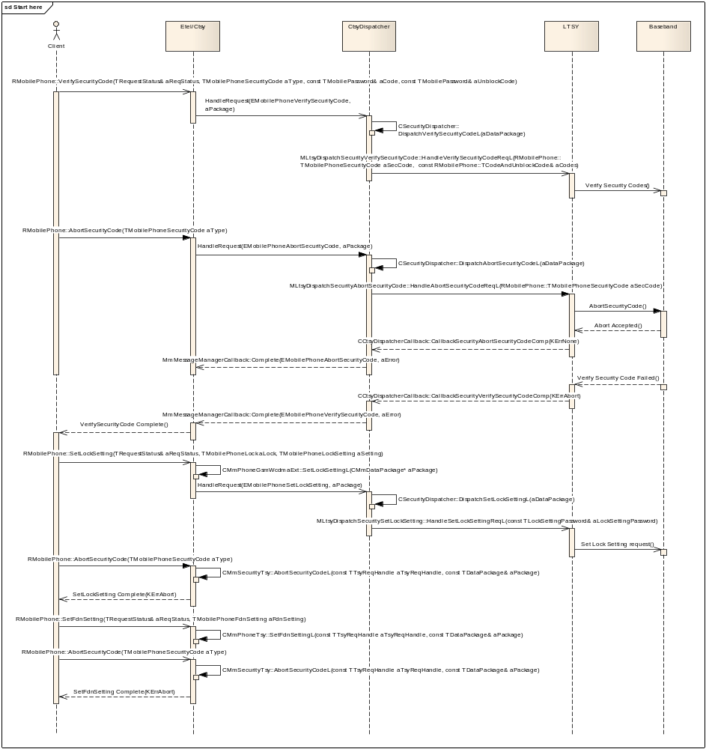
class MLtsyDispatchSecurityAbortSecurityCode : public MLtsyDispatchInterface
{
public:

static const TInt KLtsyDispatchSecurityAbortSecurityCodeApiId = KDispatchSecurityFuncUnitId + 3;

/**
* The CTSY Dispatcher shall invoke this function on receiving the EMobilePhoneAbortSecurityCode
* request from the CTSY.
*
* It is a request call that is completed by invoking
* CCtsyDispatcherCallback::CallbackSecurityAbortSecurityCodeComp()
*
* Implementation of this interface should inform the phone that the user has cancelled an outstanding
* "get security code" request.
*
* @param aSecCode Specifies which code request has been cancelled.
*
* @return KErrNone on success, otherwise another error code indicating the
* failure.
*/
virtual TInt HandleAbortSecurityCodeReqL(RMobilePhone::TMobilePhoneSecurityCode aSecCode) = 0;

}; // class MLtsyDispatchSecurityAbortSecurityCode

EXPORT_C void CCtsyDispatcherCallback::CallbackSecurityAbortSecurityCodeComp(TInt aError)
/**
*
* Callback function to be used by the Licensee LTSY to complete a pending
* MLtsyDispatchSecurityAbortSecurityCode::HandleAbortSecurityCodeReqL()
*
* Completion to the request: user has cancelled an outstanding "get security code" request.
*
* @param aError KErrNone on success, or another error code indicating the error otherwise.
*
* @see RMobilePhone::AbortSecurityCode()
*/

EN Phonebook store Functional Unit
The request handlers that must be implemented by the LTSY are declared in mltsydispatchphonebookeninterface.h.

The callback functions used to complete the EN phonebook requests and also any indicator callbacks are declared in cctsydispatchercallback.h in the section starting with the comment

// PhonebookEn related callbacks
IMPORT_C void CallbackPhonebookEnStoreGetInfoComp(TInt aError, TInt aUsedEntries);
Etc....

Use Case 1: Read All entries from the storage
This use case covers:
- Read all entries from the storage.
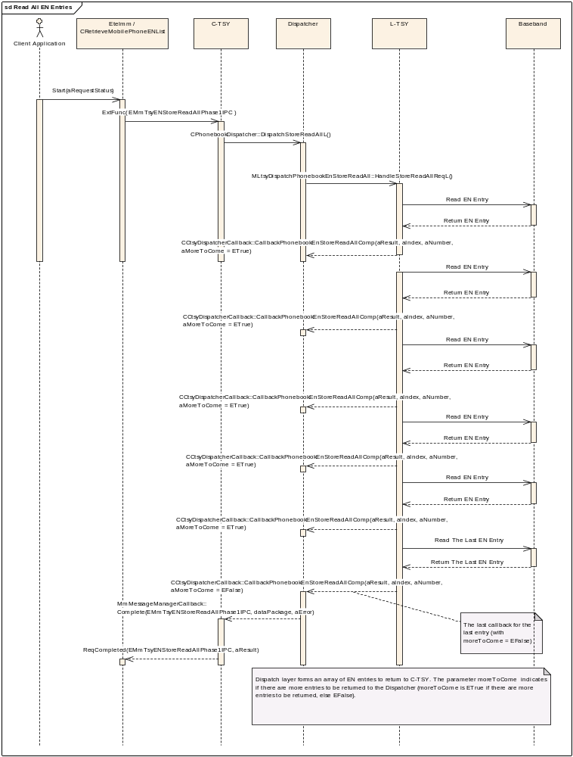
class MLtsyDispatchPhonebookEnStoreReadAll : public MLtsyDispatchInterface
{
public:

static const TInt KLtsyDispatchPhonebookEnStoreReadAllApiId = KDispatchPhonebookEnFuncUnitId + 2;

/**
* The CTSY Dispatcher shall invoke this function on receiving the EMmTsyENStoreReadAllPhase1IPC
* request from the CTSY.
*
* It is a request call that is completed by invoking
* CCtsyDispatcherCallback::CallbackPhonebookEnStoreReadAllComp()
*
* Implementation of this interface should handle reading all the entries from the EN storage.
*
*
* @return KErrNone on success, otherwise another error code indicating the
* failure.
*/
virtual TInt HandleStoreReadAllReqL() = 0;

}; // class MLtsyDispatchPhonebookEnStoreReadAll

EXPORT_C void CCtsyDispatcherCallback::CallbackPhonebookEnStoreReadAllComp(
TInt aError, TInt aIndex, const TDesC& aNumber, TBool aMoreToCome)
/**
*
* Callback function to be used by the Licensee LTSY to complete a pending
* MLtsyDispatchPhonebookEnStoreReadAll::HandleStoreReadAllReqL()
*
* @param aError KErrNone on success, or another error code indicating the error otherwise.
* @param aIndex The index of the entry.
* @param aNumber The number stored in the EN entry. The length of this should not be more than 6.
* @param aMoreToCome ETrue if there are more entries to be read, False otherwise.
*
* @see CRetrieveMobilePhoneENList::Start()
*/

Cell Broadcast Functional Unit
The request handlers that must be implemented by the LTSY are declared in mltsydispatchcellbroadcastinterface.h.

The callback functions used to complete the cell broadcast requests and also any indicator callbacks are declared in cctsydispatchercallback.h in the section starting with the comment

// CellBroadcast related callbacks
IMPORT_C void CallbackCellBroadcastGsmBroadcastNotifyMessageReceivedInd(TInt aError, const TDesC8& aCbsMsg);
Etc....

Use Case 1: ReceiveMessage – completing with GSM broadcast message
This use case covers:
- ReceiveMessage() request and completion.
- Receiving GSM broadcast message.
- Retrieving broadcast filter setting by GetFilterSetting() (EBroadcastAcceptAll).
- Setting broadcast filter setting to EBroadcastAcceptNone by SetFilterSetting().
- Retrieving new broadcast filter setting by GetFilterSetting().
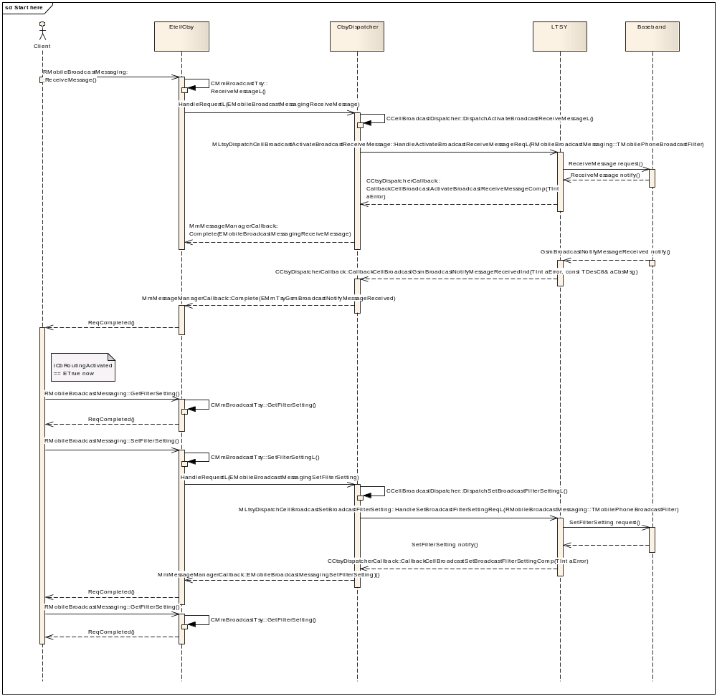

class MLtsyDispatchCellBroadcastActivateBroadcastReceiveMessage : public virtual MLtsyDispatchInterface
{
public:

static const TInt KLtsyDispatchCellBroadcastActivateBroadcastReceiveMessageApiId = KDispatchCellBroadcastFuncUnitId + 2;
/**
* The CTSY Dispatcher shall invoke this function on receiving the EMobileBroadcastMessagingReceiveMessage request from the CTSY.
*
* It is a request call that is completed by invoking
* CCtsyDispatcherCallback::CallbackCellBroadcastActivateBroadcastReceiveMessageComp()
* Implementation of this interface will complete when a new incoming broadcast message has been received
* @param aFilterSetting struct settings for a filter to accept/reject messages
*
* @return KErrNone on success, otherwise another error code indicating the
* failure.
*/
virtual TInt HandleActivateBroadcastReceiveMessageReqL(RMobileBroadcastMessaging::TMobilePhoneBroadcastFilter aFilterSetting) = 0;

}; // class MLtsyDispatchCellBroadcastActivateBroadcastReceiveMessage

EXPORT_C void CCtsyDispatcherCallback::CallbackCellBroadcastGsmBroadcastNotifyMessageReceivedInd(
TInt aError, const TDesC8& aCbsMsg)
/**
*
* Function will be called by LTSY to pass GSM cell broadcast message. It may be used as a completion of ReceiveMessage() request or by usolicited completion.
*
* @param aError The error code to be returned to the CTSY Dispatcher
* @param aCbsMsg GSM cell broadcast message
*
* @see RMobileBroadcastMessaging::ReceiveMessage()
*/

class MLtsyDispatchCellBroadcastSetBroadcastFilterSetting : public virtual MLtsyDispatchInterface
{
public:

static const TInt KLtsyDispatchCellBroadcastSetBroadcastFilterSettingApiId = KDispatchCellBroadcastFuncUnitId + 1;

/**
* The CTSY Dispatcher shall invoke this function on receiving the EMobileBroadcastMessagingSetFilterSetting
* request from the CTSY.
*
* It is a request call that is completed by invoking
* CCtsyDispatcherCallback::CallbackCellBroadcastSetBroadcastFilterSettingComp()
* Implementation of this interface sets a new value for the filter setting.
* The filter specifies which broadcast messages are accepted and which are rejected
*
*
* @param aFilterSetting struct settings for a filter to accept/reject messages
*
* @return KErrNone on success, otherwise another error code indicating the
* failure.
*/
virtual TInt HandleSetBroadcastFilterSettingReqL(RMobileBroadcastMessaging::TMobilePhoneBroadcastFilter aFilterSetting) = 0;

}; // class MLtsyDispatchCellBroadcastSetBroadcastFilterSetting

Use Case 2: ReceiveMessage – completing with WCDMA broadcast message
This use case covers:
- ReceiveMessage() request and completion.
- Receiving WCDMA broadcast message.
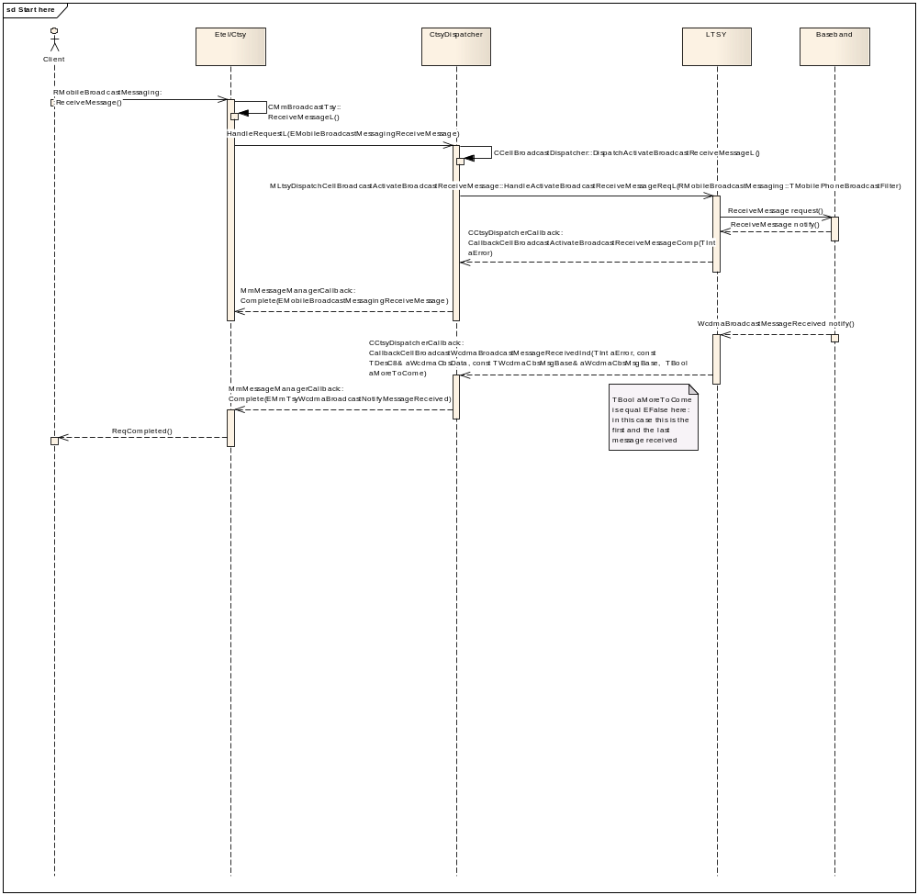
EXPORT_C void CCtsyDispatcherCallback::CallbackCellBroadcastWcdmaBroadcastMessageReceivedInd(
TInt aError, const TDesC8& aWcdmaCbsData, const TWcdmaCbsMsgBase& aWcdmaCbsMsgBase, TBool aMoreToCome )
/**
*
* Function will be called by LTSY to pass array of WCDMA cell broadcast messages. It may be used as a completion
* of ReceiveMessage() request or by usolicited completion.
*
* @param aError KErrNone on success, or another error code indicating the error otherwise.
* @param aWcdmaCbsData Broadcast message WCDMA.
* @param aWcdmaCbsMsgBase base wcdma cbs data structure.
* @param aMoreToCome Are there more WCDMA messages to come.
*
* @see RMobileBroadcastMessaging::ReceiveMessage()
*/

ON Phonebook Store Functional Unit
The request handlers that must be implemented by the LTSY are declared in mltsydispatchphonebookinterface.h.

The callback functions used to complete the ON phonebook requests and also any indicator callbacks are declared in cctsydispatchercallback.h in the section starting with the comment

// PhonebookOn related callbacks
IMPORT_C void CallbackPhonebookOnStoreReadAllInd(TInt aError);
Etc....

Use Case 1: GetInfo, StoreAll entries, ReadAll entries, DeleteAll entries
This use case covers:
- Get information of the storage.
- Store all entries.
- Read all entries.
- Delete all entries.
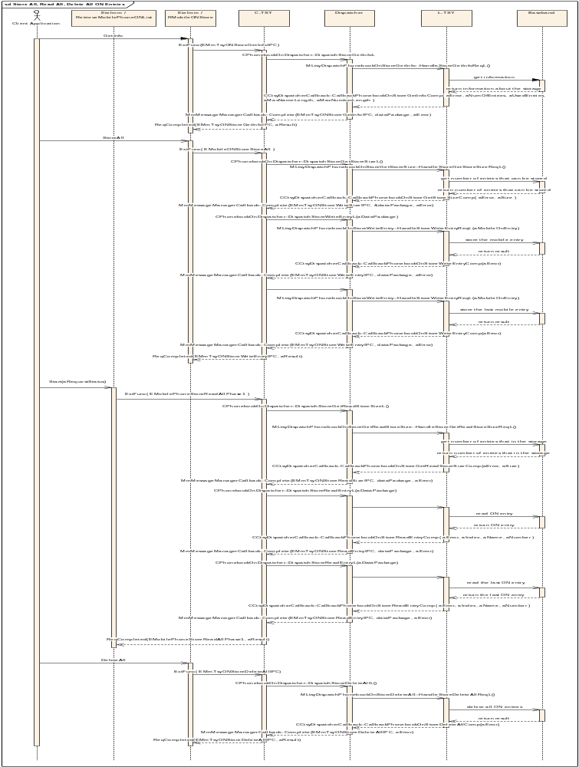

Implementation Notes
Get information of the storage
class MLtsyDispatchPhonebookOnStoreGetInfo : public MLtsyDispatchInterface
{
public:

static const TInt KLtsyDispatchPhonebookOnStoreGetInfoApiId = KDispatchPhonebookOnFuncUnitId + 4;

/**
* The CTSY Dispatcher shall invoke this function on receiving the EMmTsyONStoreGetInfoIPC
* request from the CTSY.
*
* It is a request call that is completed by invoking
* CCtsyDispatcherCallback::CallbackPhonebookOnStoreGetInfoComp()
*
* Implementation of this interface should request to get the information of a given storage. The
* callback should be completed with the information.
*
*
* @return KErrNone on success, otherwise another error code indicating the
* failure.
*/
virtual TInt HandleStoreGetInfoReqL() = 0;

}; // class MLtsyDispatchPhonebookOnStoreGetInfo

EXPORT_C void CCtsyDispatcherCallback::CallbackPhonebookOnStoreGetInfoComp(
TInt aError, TInt aNumOfEntries, TInt aUsedEntries, TInt aMaxNameLength, TInt aMaxNumberLength)
/**
*
* Callback function to be used by the Licensee LTSY to complete a pending
* MLtsyDispatchPhonebookOnStoreGetInfo::HandleStoreGetInfoReqL()
*
* @param aError KErrNone on success, or another error code indicating the error otherwise.
* @param aNumOfEntries The number of entries.
* @param aUsedEntries The number of used entries.
* @param aMaxNameLength The maximum length of name.
* @param aMaxNumberLength The maximum length of number.
*
* @see RMobileONStore::GetInfo()
*/

Store all entries
class MLtsyDispatchPhonebookOnStoreGetStoreSize : public MLtsyDispatchInterface
{
public:

static const TInt KLtsyDispatchPhonebookOnStoreGetStoreSizeApiId = KDispatchPhonebookOnFuncUnitId + 9;

/**
* The CTSY Dispatcher shall invoke this function on receiving the EMmTsyONStoreWriteSizeIPC
* request from the CTSY.
*
* It is a request call that is completed by invoking
* CCtsyDispatcherCallback::CallbackPhonebookOnStoreGetStoreSizeComp()
*
* Implementation of this interface should handle retrieving of the size of the storage.
*
*
* @return KErrNone on success, otherwise another error code indicating the
* failure.
*/
virtual TInt HandleStoreGetStoreSizeReqL() = 0;

}; // class MLtsyDispatchPhonebookOnStoreGetStoreSize

EXPORT_C void CCtsyDispatcherCallback::CallbackPhonebookOnStoreGetStoreSizeComp(
TInt aError, TInt aSize)
/**
*
* Callback function to be used by the Licensee LTSY to complete a pending
* MLtsyDispatchPhonebookOnStoreGetStoreSize::HandleStoreGetStoreSizeReqL()
*
*
* @param aError KErrNone on success, or another error code indicating the error otherwise.
* @param aSize The number of entries that can be stored in the storage.
*
* @see RMobileONStore::StoreAll()
*/

class MLtsyDispatchPhonebookOnStoreWriteEntry : public MLtsyDispatchInterface
{
public:

static const TInt KLtsyDispatchPhonebookOnStoreWriteEntryApiId = KDispatchPhonebookOnFuncUnitId + 7;

/**
* The CTSY Dispatcher shall invoke this function on receiving the EMmTsyONStoreWriteEntryIPC
* request from the CTSY.
*
* It is a request call that is completed by invoking
* CCtsyDispatcherCallback::CallbackPhonebookOnStoreWriteEntryComp()
*
* Implementation of this interface should handle storing of a ON entry as one step of storing of all entries in the ON storage.
*
*
* @param aMobileOnEntry defines contents of a fixed-size ON entry to be stored.
*
*
* @return KErrNone on success, otherwise another error code indicating the
* failure.
*/
virtual TInt HandleStoreWriteEntryReqL(const RMobileONStore::TMobileONEntryV1& aMobileOnEntry) = 0;

}; // class MLtsyDispatchPhonebookOnStoreWriteEntry

EXPORT_C void CCtsyDispatcherCallback::CallbackPhonebookOnStoreWriteEntryComp(TInt aError)
/**
*
* Callback function to be used by the Licensee LTSY to complete a pending
* MLtsyDispatchPhonebookOnStoreWriteEntry::HandleStoreWriteEntryReqL()
*
*
* @param aError KErrNone on success, or another error code indicating the error otherwise.
*
* @see RMobileONStore::StoreAllL()
*/

Read all entries
class MLtsyDispatchPhonebookOnStoreGetReadStoreSize : public MLtsyDispatchInterface
{
public:

static const TInt KLtsyDispatchPhonebookOnStoreGetReadStoreSizeApiId = KDispatchPhonebookOnFuncUnitId + 5;

/**
* The CTSY Dispatcher shall invoke this function on receiving the EMmTsyONStoreReadSizeIPC
* request from the CTSY.
*
* It is a request call that is completed by invoking
* CCtsyDispatcherCallback::CallbackPhonebookOnStoreGetReadStoreSizeComp()
*
* Implementation of this interface should handle retrieving the size of the storage for read all operation.
*
*
* @return KErrNone on success, otherwise another error code indicating the
* failure.
*/
virtual TInt HandleStoreGetReadStoreSizeReqL() = 0;

}; // class MLtsyDispatchPhonebookOnStoreGetReadStoreSize

EXPORT_C void CCtsyDispatcherCallback::CallbackPhonebookOnStoreGetReadStoreSizeComp(TInt aError, TInt aSize)
/**
*
* Callback function to be used by the Licensee LTSY to complete a pending
* MLtsyDispatchPhonebookOnStoreGetReadStoreSize::HandleStoreGetReadStoreSizeReqL()
*
*
* @param aError KErrNone on success, or another error code indicating the error otherwise.
* @param aSize The number of entries stored in the storage.
*
* @see CRetrieveMobilePhoneONList::Start()
*/

class MLtsyDispatchPhonebookOnStoreReadEntry : public MLtsyDispatchInterface
{
public:

static const TInt KLtsyDispatchPhonebookOnStoreReadEntryApiId = KDispatchPhonebookOnFuncUnitId + 3;

/**
* The CTSY Dispatcher shall invoke this function on receiving the EMmTsyONStoreReadEntryIPC
* request from the CTSY.
*
* It is a request call that is completed by invoking
* CCtsyDispatcherCallback::CallbackPhonebookOnStoreReadEntryComp()
*
* Implementation of this interface should handle reading an entry from ON storage as one step of reading of all entries.
*
*
* @param aIndex index of the entry,
*
*
* @return KErrNone on success, otherwise another error code indicating the
* failure.
*/
virtual TInt HandleStoreReadEntryReqL(TInt aIndex) = 0;

}; // class MLtsyDispatchPhonebookOnStoreReadEntry

EXPORT_C void CCtsyDispatcherCallback::CallbackPhonebookOnStoreReadEntryComp(
TInt aError, TInt aIndex, const TDesC& aName, const TDesC& aNumber)
/**
*
* Callback function to be used by the Licensee LTSY to complete a pending
* MLtsyDispatchPhonebookOnStoreReadEntry::HandleStoreReadEntryReqL()
*
*
* @param aError KErrNone on success, or another error code indicating the error otherwise.
* @param aIndex The index of the entry.
* @param aName The name stored in the entry. The length of this should not be more than 20.
* @param aNumber The number stored in the ON entry. The length of this should not be more than 100.
*
* @see CRetrieveMobilePhoneONList::Start()
*/

Delete all entries
class MLtsyDispatchPhonebookOnStoreDeleteAll : public MLtsyDispatchInterface
{
public:

static const TInt KLtsyDispatchPhonebookOnStoreDeleteAllApiId = KDispatchPhonebookOnFuncUnitId + 2;

/**
* The CTSY Dispatcher shall invoke this function on receiving the EMmTsyONStoreDeleteAllIPC
* request from the CTSY.
*
* It is a request call that is completed by invoking
* CCtsyDispatcherCallback::CallbackPhonebookOnStoreDeleteAllComp()
*
* Implementation of this interface should handle deletion of all entries of the storage.
*
*
* @return KErrNone on success, otherwise another error code indicating the
* failure.
*/
virtual TInt HandleStoreDeleteAllReqL() = 0;

}; // class MLtsyDispatchPhonebookOnStoreDeleteAll

EXPORT_C void CCtsyDispatcherCallback::CallbackPhonebookOnStoreDeleteAllComp(TInt aError)
/**
*
* Callback function to be used by the Licensee LTSY to complete a pending
* MLtsyDispatchPhonebookOnStoreDeleteAll::HandleStoreDeleteAllReqL()
*
*
* @param aError KErrNone on success, or another error code indicating the error otherwise.
*
* @see RMobileONStore::DeleteAll()
*/
{
TSYLOGENTRYEXITARGS(_L8("aError=%d"), aError);

// Forward completion to correct dispatcher object to handle
__ASSERT_DEBUG(iDispatcherHolder, CtsyDispatcherPanic(EInvalidNullPtr));
iDispatcherHolder->GetPhonebookOnDispatcher().CallbackStoreDeleteAll(aError);

} // CCtsyDispatcherCallback::CallbackPhonebookOnStoreDeleteAllComp

Phonebook Store Functional Unit
The request handlers that must be implemented by the LTSY are declared in mltsydispatchphonebookinterface.h.
The callback functions used to complete the phonebook and sms store requests and also any indicator callbacks are declared in cctsydispatchercallback.h in the section starting with the comment

// Phonebook related callbacks
IMPORT_C void CallbackPhonebookStoreResetCacheInd(TInt aError, MLtsyDispatchPhonebookStoreTypes::TPhonebook aPhonebook);
Etc....

Use-case 1,2: Phonebook Store - Open
This use case covers the opening of a phonebook store (see CCTsyPhonebookFU::TestUseCase0001L() and CCTsyPhonebookFU::TestUseCase0002L().
The main phases of opening a phonebook store are
- Initialisation
- Retrieving the cache (Fdn and And phonebooks are cached in the CTSY)

Initialisation
The first time a phonebook store is opened on a RMobilePhone session causes the phonebook store initialisation IPC, this IPC is used to both inform the LTSY to do any initialisation required (on the request) and retrieve information regarding the different stores and return them to the CTSY (on the complete).

Initialisation is only done for FDN, AND, VMB and MBDN phonebooks, if initialisation has already been completed is it not done again until either a SIM refresh is requested or there is a new RMobilePhone session (i.e. the existing one has been closed).

class MLtsyDispatchPhonebookStoreInitialise : public virtual MLtsyDispatchInterface
{
public:

static const TInt KLtsyDispatchPhonebookStoreInitialiseApiId = KDispatchPhonebookFuncUnitId + 6;

/**
* The CTSY Dispatcher shall invoke this function on receiving the EMmTsyPhoneBookStoreInitIPC
* request from the CTSY.
*
* It is a request call that is completed by invoking
* CCtsyDispatcherCallback::CallbackPhonebookStoreInitialiseComp()
*
* Implementation of this interface should request to initialise the phonebook store, the callback should
* be completed when store initialisation is completed.
*
*
* @return KErrNone on success, otherwise another error code indicating the
* failure.
*/
virtual TInt HandleStoreInitialiseReqL() = 0;

}; // class MLtsyDispatchPhonebookStoreInitialise

EXPORT_C void CCtsyDispatcherCallback::CallbackPhonebookStoreInitialiseComp(
TInt aError, const DispatcherPhonebook::TPhonebookStoreInfoV1& aPhonebookStoreInfo)
/**
*
* Callback function to be used by the Licensee LTSY to complete a pending
* MLtsyDispatchPhonebookStoreInitialise::HandleStoreInitialiseReqL()
*
*
* @param aError KErrNone on success, or another error code indicating the error otherwise.
* @param aPhonebookStoreInfo The information relating to the whole phonebook store.
*
*/

Retrieving the cache
FDN and ADN phonebooks cache the entries within the CTSY, on opening one of there phonebooks the cache needs to be populated. A request is made to cache a given phonebook, and the request is completed with a TLV containing the entire phonebook. Once the callback is complete the phonebook is fully open and can be used for Read, Writes etc.
class MLtsyDispatchPhonebookStoreCache : public virtual MLtsyDispatchInterface
{
public:

static const TInt KLtsyDispatchPhonebookStoreCacheApiId = KDispatchPhonebookFuncUnitId + 3;

/**
* The CTSY Dispatcher shall invoke this function on receiving the EMmTsyPhoneBookStoreCacheIPC
* request from the CTSY.
*
* It is a request call that is completed by invoking
* CCtsyDispatcherCallback::CallbackPhonebookStoreCacheComp()
*
* Implementation of this interface should request to cache a given phonebook, the entire
* phonebook entries are returned in the callback.
*
*
* @param aPhonebook The phonebook to cache.
*
*
* @return KErrNone on success, otherwise another error code indicating the
* failure.
*/
virtual TInt HandleStoreCacheReqL(DispatcherPhonebook::TPhonebook aPhonebook) = 0;

}; // class MLtsyDispatchPhonebookStoreCache

EXPORT_C void CCtsyDispatcherCallback::CallbackPhonebookStoreCacheComp(
TInt aError, DispatcherPhonebook::TPhonebook aPhonebook, const TDesC8& aPhonebookEntries)
/**
*
* Callback function to be used by the Licensee LTSY to complete a pending
* MLtsyDispatchPhonebookStoreCache::HandleStoreCacheReqL()
*
* @param aError KErrNone on success, or another error code indicating the error otherwise.
* @param aPhonebook The phonebook of which the cache entries are for (and the request was made from).
* @param aPhonebookEntries All entries from the phonebook encoded in a TLV, this can either be encoded directly
* via a CPhoneBookBuffer() or via the CPhoneBookEntry::ExternalizeToTlvEntry() utility.
*
*/

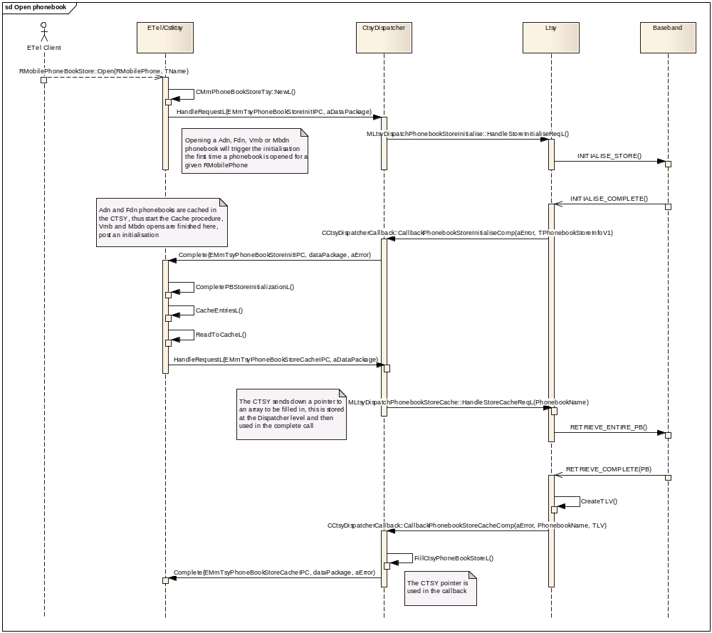

Implementation Notes
The phonebook entries are returned by the LTSY in the callback @param aPhonebookEntries in TLV format. This is the same TLV format as used in the Etel calls RMobilePhoneStore::Read() and RMobilePhoneStore::Write(). The TLV can be encoded directly via the CPhoneBookBuffer() class or via the utility class provided in the dispatcher CPhoneBookEntry().
To use the CPhoneBookEntry() the LTSY will create an instance then fill in the entry details SetFirstName(), SetDiallingNumber() etc, once completed a call to CPhoneBookEntry::ExternalizeToTlvEntry() will write the data to a descriptor via a CPhoneBookEntry().
The CPhoneBookEntry::TlvSize() calculates the size of the buffer required for the current data held in the CPhoneBookEntry, (note the size will be 3 more than required due to the CPhoneBookBuffer() implantation.
The below example shows creating the TLV from an array of CPhoneBookEntry’s, however the TLV could be created with a single CPhoneBookEntry() if reset, populated and Externalised for each entry.
The same TLV process can be used for returning entry data in a Read request.
The rational behind sending a TLV rather than a CPhoneBookEntry (or similar) directly is that it future proofs the dispatcher interface and is consistent with the Etel APIs.

Void CreateTlvFromPhonebookL(const RPointerArray<CPhoneBookEntry>& aPhonebook, RBuf8& aBuf)
{
TInt tlvSize = 0;
for(TInt i = 0; i < aPhonebook.Count(); ++i)
{
tlvSize += aPhonebook[i]->TlvSize();
}

aBuf.ReAllocL(tlvSize);

CPhoneBookBuffer* pbBuffer = new (ELeave) CPhoneBookBuffer();
CleanupStack::PushL(pbBuffer);

pbBuffer->Set(&aBuf);

for(TInt i = 0; i < aPhonebook.Count(); ++i)
{
aPhonebook[i]->ExternalizeToTlvEntry(*pbBuffer);
}

CleanupStack::PopAndDestroy(pbBuffer);
}

Use-case 3,4: Phonebook Store - Read Entry
This use case covers the reading from a phonebook store (see CCTsyPhonebookFU::TestUseCase0003L() and CCTsyPhonebookFU::TestUseCase0004L().
Once the phonebook store has been successfully opened entries maybe read.
FDN and ADN reads with reading more than one entry come from the CTSY cache; otherwise the request is propagated to the LTSY.
class MLtsyDispatchPhonebookStoreReadEntry : public virtual MLtsyDispatchInterface
{
public:

static const TInt KLtsyDispatchPhonebookStoreReadEntryApiId = KDispatchPhonebookFuncUnitId + 1;

/**
* The CTSY Dispatcher shall invoke this function on receiving the EMmTsyPhoneBookStoreReadIPC
* request from the CTSY.
*
* It is a request call that is completed by invoking
* CCtsyDispatcherCallback::CallbackPhonebookStoreReadEntryComp()
*
* Implementation of this interface should request to read a number of entries from a given phonebook.
* The entries are returned in the callback.
*
*
* @param aPhonebook The phonebook to read entries from.
* @param aIndex Specifies the index to start reading from, must be >= 1.
* @param aNumSlots Specifies the number of slots to read, must be >= 1 and <= total number of slots.
*
*
* @return KErrNone on success, otherwise another error code indicating the
* failure.
*
* @see RMobilePhoneBookStore::Read()
*/
virtual TInt HandleStoreReadEntryReqL(DispatcherPhonebook::TPhonebook aPhonebook, TInt aIndex, TInt aNumberOfSlots) = 0;

}; // class MLtsyDispatchPhonebookStoreReadEntry

EXPORT_C void CCtsyDispatcherCallback::CallbackPhonebookStoreReadEntryComp(
TInt aError, DispatcherPhonebook::TPhonebook aPhonebook, const TDesC8& aPhonebookEntries)
/**
*
* Callback function to be used by the Licensee LTSY to complete a pending
* MLtsyDispatchPhonebookStoreReadEntry::HandleStoreReadEntryReqL()
*
*
* @param aError KErrNone on success, or another error code indicating the error otherwise.
* @param aPhonebook The phonebook of which the read request was made and which the enties are for
* @param aPhonebookEntries The read entries from the phonebook encoded in a TLV, this can either be encoded directly
* via a CPhoneBookBuffer() or via the CPhoneBookEntry::ExternalizeToTlvEntry() utility.
*
* @see RMobilePhoneBookStore::Read()
*/

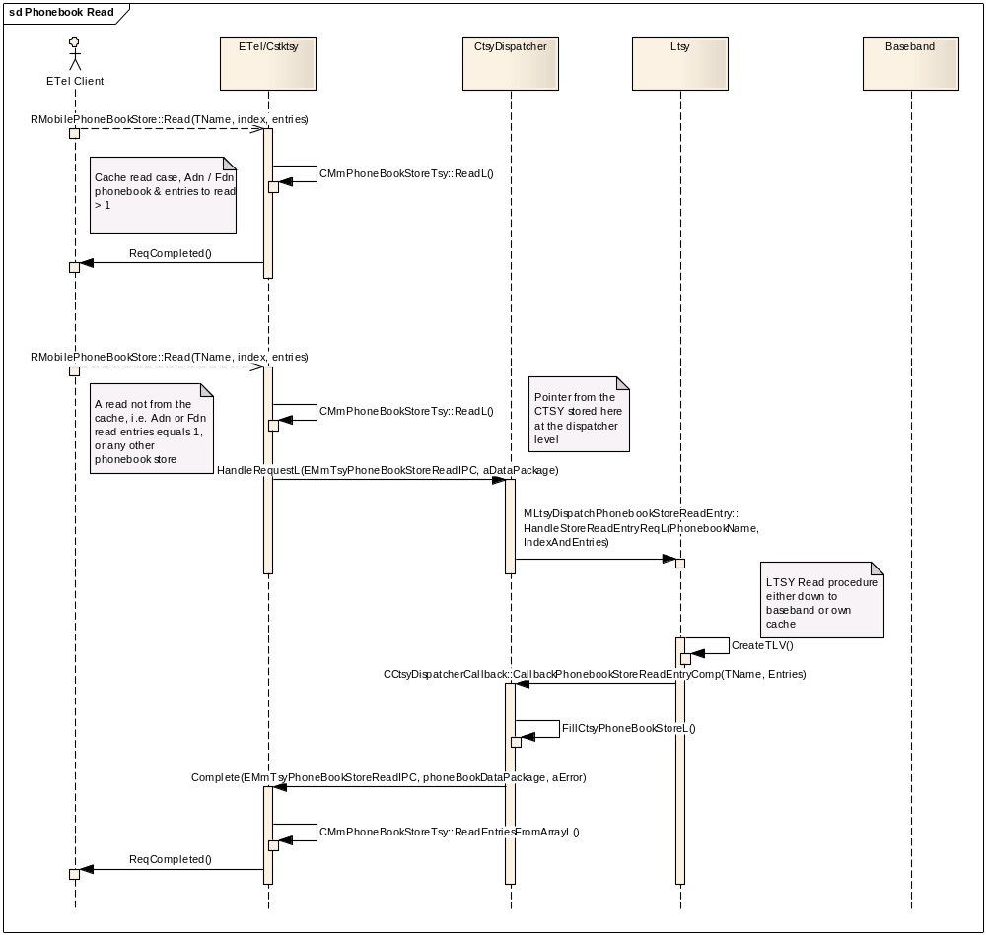

Implementation Notes
The TLV process is exactly the same as the one described in the completion of the phonebook cache from the LTSY.

Use-case 5: Phonebook Store - Delete Entry
This use case covers the deleting an and entry from a phonebook store (see CCTsyPhonebookFU::TestUseCase0005L()
Once the phonebook store has been successfully opened entries maybe deleted (given the capabilities).
All delete requests are propagated to the LTSY, with the CTSY cache being updated to reflect the change in the success case.
No sequence diagram is included due to this being a simple request complete process.
class MLtsyDispatchPhonebookStoreDeleteEntry : public virtual MLtsyDispatchInterface
{
public:

static const TInt KLtsyDispatchPhonebookStoreDeleteEntryApiId = KDispatchPhonebookFuncUnitId + 2;

/**
* The CTSY Dispatcher shall invoke this function on receiving the EMmTsyPhoneBookStoreDeleteIPC
* request from the CTSY.
*
* It is a request call that is completed by invoking
* CCtsyDispatcherCallback::CallbackPhonebookStoreDeleteEntryComp()
*
* Implementation of this interface should request to delete an entry from a given phonebook, the
* callback indicates when the operation has been completed.
*
*
* @param aPhonebook The phonebook to delete an entry from.
* @param aIndex The entry index in the phonebook to delete.
*
*
* @return KErrNone on success, otherwise another error code indicating the
* failure.
*
* @see RMobilePhoneBookStore::Delete()
*
*/
virtual TInt HandleStoreDeleteEntryReqL(DispatcherPhonebook::TPhonebook aPhonebook, TInt aIndex) = 0;

}; // class MLtsyDispatchPhonebookStoreDeleteEntry

EXPORT_C void CCtsyDispatcherCallback::CallbackPhonebookStoreDeleteEntryComp(
TInt aError, DispatcherPhonebook::TPhonebook aPhonebook, TInt aMaxNumberLength)
/**
*
* Callback function to be used by the Licensee LTSY to complete a pending
* MLtsyDispatchPhonebookStoreDeleteEntry::HandleStoreDeleteEntryReqL()
*
*
* @param aError KErrNone on success, or another error code indicating the error otherwise.
* @param aPhonebook The phonebook of which the delete request was made.
* @param aMaxNumberLength The new maximum number length possible in the phonebook, this field is
* only relevant to FDN, ADN and VMB phonebooks.
*
* @see RMobilePhoneBookStore::Delete()
*/

Use-case 6: Phonebook Store – Delete All
This use case covers deleting all entries from a phonebook store (see CCTsyPhonebookFU::TestUseCase0006L()
Once the phonebook store has been successfully opened all entries maybe deleted (given the capabilities).
All delete requests are propagated to the LTSY, with the CTSY cache being updated to reflect the change in the success case.
No sequence diagram is included due to this being a simple request complete process.

class MLtsyDispatchPhonebookStoreDeleteAll : public virtual MLtsyDispatchInterface
{
public:

static const TInt KLtsyDispatchPhonebookStoreDeleteAllApiId = KDispatchPhonebookFuncUnitId + 7;

/**
* The CTSY Dispatcher shall invoke this function on receiving the EMmTsyPhoneBookStoreDeleteAllIPC
* request from the CTSY.
*
* It is a request call that is completed by invoking
* CCtsyDispatcherCallback::CallbackPhonebookStoreDeleteAllComp()
*
* Implementation of this interface should request to delete all entries from a given phonebook, the
* callback indicates when the operation is completed.
*
*
* @param aPhonebook The phonebook to delete all entries from.
*
*
* @return KErrNone on success, otherwise another error code indicating the
* failure.
*
* @see RMobilePhoneBookStore::DeleteAll()
*
*/
virtual TInt HandleStoreDeleteAllReqL(DispatcherPhonebook::TPhonebook aPhonebook) = 0;

}; // class MLtsyDispatchPhonebookStoreDeleteAll

EXPORT_C void CCtsyDispatcherCallback::CallbackPhonebookStoreDeleteAllComp(
TInt aError, DispatcherPhonebook::TPhonebook aPhonebook, TInt aMaxNumberLength)
/**
*
* Callback function to be used by the Licensee LTSY to complete a pending
* MLtsyDispatchPhonebookStoreDeleteAll::HandleStoreDeleteAllReqL()
*
*
* @param aError KErrNone on success, or another error code indicating the error otherwise.
* @param aPhonebook The phonebook name for which the delete all request was made.
* @param aMaxNumberLength The new maximum number length possible in the phonebook, this field is
* only relevant to Fdn, Adn and Vmb phonebooks.
*
* @see RMobilePhoneBookStore::DeleteAll()
*/

Use-case 7: Phonebook Store – Write
This use case covers writing an entry to the phonebook store (see CCTsyPhonebookFU::TestUseCase0007L()
Once the phonebook store has been successfully opened entries maybe written deleted (given the capabilities).
All write requests are propagated to the LTSY, with the CTSY cache being updated to reflect the change in the success case.
No sequence diagram is included due to this being a simple request complete process.

class MLtsyDispatchPhonebookStoreWriteEntry : public virtual MLtsyDispatchInterface
{
public:

static const TInt KLtsyDispatchPhonebookStoreWriteEntryApiId = KDispatchPhonebookFuncUnitId + 8;

/**
* The CTSY Dispatcher shall invoke this function on receiving the EMmTsyPhoneBookStoreWriteIPC
* request from the CTSY.
*
* It is a request call that is completed by invoking
* CCtsyDispatcherCallback::CallbackPhonebookStoreWriteEntryComp()
*
* Implementation of this interface should request to write an entry to a given phonebook.
* The callback indicates when the operation is complete.
*
*
* @param aPhonebook The phonebook to be written to.
* @param aEntry The entry to be written, this is coded as a TLV, this can be decoded either
* directly via a CPhoneBookBuffer() or via the CPhoneBookEntry::InternalizeFromTlvEntry() utility.
*
*
* @return KErrNone on success, otherwise another error code indicating the
* failure.
*
* @see RMobilePhoneBookStore::Write()
*
*/
virtual TInt HandleStoreWriteEntryReqL(DispatcherPhonebook::TPhonebook aPhonebook, const TDesC8& aEntry) = 0;

}; // class MLtsyDispatchPhonebookStoreWriteEntry

EXPORT_C void CCtsyDispatcherCallback::CallbackPhonebookStoreWriteEntryComp(
TInt aError, DispatcherPhonebook::TPhonebook aPhonebook, TUint16 aIndex, TInt aMaxNumberLength)
/**
*
* Callback function to be used by the Licensee LTSY to complete a pending
* MLtsyDispatchPhonebookStoreWriteEntry::HandleStoreWriteEntryReqL()
*
* @param aError KErrNone on success, or another error code indicating the error otherwise.
* KErrGsmSimServSneFull, KErrGsmSimServAnrFull, or KErrGsmSimServEmailFull indicates one of the
* services is full and the field of the entry (e.g. Email) could not be written.
* In the cache case the field (e.g. Email) is not written to the cache but the other
* fields are written, the request is then completed with the error code. In the non-cache case
* the request is completed with the error code.
* @param aPhonebook The phonebook name for which the write request was made.
* @param aIndex The index to which the entry was written in the phonebook.
* @param aMaxNumberLength The new maximum number length possible in the phonebook, this field is
* only relevant to Fdn, Adn and Vmb phonebooks.
*
* @see RMobilePhoneBookStore::Write()
* */

Implementation Notes
The request presents the entry to be written to the LTSY is TLV format, again this maybe decoded via the CPhoneBookBuffer() class or via the utility class provided in the dispatcher CPhoneBookEntry(). The InternalizeFromTlvEntry() internalises the CPhoneBookEntry from the TLV.
The below example shows how to decode the TLV using the CPhoneBookEntry. The entry fields can then be read using the getters.
Void FillPhonebookEntry(const TDesC8& aTlvEntry, CPhoneBookEntry& aPhonebookEntry)
{
CPhoneBookBuffer* pbBuffer = new (ELeave) CPhoneBookBuffer();
CleanupStack::PushL(pbBuffer);

RBuf8 buf;
CleanupClosePushL(buf);

buf.CreateL(aTlvEntry);

pbBuffer->Set(&buf);
pbBuffer->StartRead();

User::LeaveIfError(aPhonebookEntry.InternalizeFromTlvEntry(*pbBuffer));

CleanupStack::PopAndDestroy(&buf);
CleanupStack::PopAndDestroy(pbBuffer);
}

Use-case 10: Phonebook Store – Get Phonebook Store Information
This use case covers getting the information for a given phonebook store (see CCTsyPhonebookFU::TestUseCase0010L().
Once the phonebook store has been successfully opened the details may be retrieved.
For caching phonebooks (ADN and FDN) the information required is completely held in the CTSY, for non caching phonebooks the number of used entries needs to be retrieved via a LTSY call.
No sequence diagram is included due to this being a simple request complete process.

class MLtsyDispatchPhonebookStoreGetPhonebookInfo : public virtual MLtsyDispatchInterface
{
public:

static const TInt KLtsyDispatchPhonebookStoreGetPhonebookInfoApiId = KDispatchPhonebookFuncUnitId + 5;

/**
* The CTSY Dispatcher shall invoke this function on receiving the EMmTsyPhoneBookStoreGetInfoIPC
* request from the CTSY.
*
* It is a request call that is completed by invoking
* CCtsyDispatcherCallback::CallbackPhonebookStoreGetPhonebookInfoComp()
*
* Implementation of this interface should request to get the information of a given phonebook. The
* callback should be completed with the information.
*
* This call to the LTSY is only used when the CTSY requires the information about the number of used entries
* in a phonebook, thus calls to RMobilePhoneBookStore::GetInfo() on cached phonebooks can be completed immediately
* as the CTSY will already hold this information.
*
*
* @param aPhonebook The phonebook to retrieve the information from.
*
*
* @return KErrNone on success, otherwise another error code indicating the
* failure.
*
* @see RMobilePhoneBookStore::GetInfo()
*
*/
virtual TInt HandleStoreGetPhonebookInfoReqL(DispatcherPhonebook::TPhonebook aPhonebook) = 0;

}; // class MLtsyDispatchPhonebookStoreGetPhonebookInfo

EXPORT_C void CCtsyDispatcherCallback::CallbackPhonebookStoreGetPhonebookInfoComp(
TInt aError, DispatcherPhonebook::TPhonebook aPhonebook, TInt aUsedEntries)
/**
*
* Callback function to be used by the Licensee LTSY to complete a pending
* MLtsyDispatchPhonebookStoreGetPhonebookInfo::HandleStoreGetPhonebookInfoReqL()
*
*
* @param aError KErrNone on success, or another error code indicating the error otherwise.
* @param aPhonebook The phonebook name of which the phonebook information is for.
* @param aUsedEntries The number of used entries in the phonebook.
*
* @see RMobilePhoneBookStore::GetInfo()
*/
{
TSYLOGENTRYEXITARGS(_L8("aError=%d,aPhonebook=%d,aUsedEntries=%d"), aError, aUsedEntries, aPhonebook);

// Forward completion to correct dispatcher object to handle
__ASSERT_DEBUG(iDispatcherHolder, CtsyDispatcherPanic(EInvalidNullPtr));
iDispatcherHolder->GetPhonebookDispatcher().CallbackStoreGetPhonebookInfo(aError,aPhonebook,aUsedEntries);

} // CCtsyDispatcherCallback::CallbackPhonebookStoreGetPhonebookInfoComp

Use-case 11: Phonebook Store – Get Store Information
This use case covers getting the information for a given store (see CCTsyPhonebookFU::TestUseCase0011L().
Once the phonebook store has been successfully opened the details may be retrieved.
No sequence diagram is included due to this being a simple request complete process.

class MLtsyDispatchPhonebookGetPhoneStoreInfo : public virtual MLtsyDispatchInterface
{
public:

static const TInt KLtsyDispatchPhonebookGetPhoneStoreInfoApiId = KDispatchPhonebookFuncUnitId + 9;

/**
* The CTSY Dispatcher shall invoke this function on receiving the EMobilePhoneGetPhoneStoreInfo
* request from the CTSY.
*
* It is a request call that is completed by invoking
* CCtsyDispatcherCallback::CallbackPhonebookGetPhoneStoreInfoComp()
*
* Implementation of this interface should request to get the information of a given store. The
* callback should be completed with the information.
*
*
* @param aStoreName The name of the store to retrieve the information from (e.g. KETelIccFdnPhoneBook).
*
*
* @return KErrNone on success, otherwise another error code indicating the
* failure.
*
* @see RMobilePhone::GetPhoneStoreInfo()
*/
virtual TInt HandleGetPhoneStoreInfoReqL(const TDesC& aStoreName) = 0;

}; // class MLtsyDispatchPhonebookGetPhoneStoreInfo

EXPORT_C void CCtsyDispatcherCallback::CallbackPhonebookGetPhoneStoreInfoComp(
TInt aError, const RMobilePhoneStore::TMobilePhoneStoreInfoV1& aPhoneStoreInfo)
/**
*
* Callback function to be used by the Licensee LTSY to complete a pending
* MLtsyDispatchPhonebookGetPhoneStoreInfo::HandleGetPhoneStoreInfoReqL()
*
*
* @param aError KErrNone on success, or another error code indicating the error otherwise.
* @param aPhoneStoreInfo The phone store information.
*
* @see RMobilePhone::GetPhoneStoreInfo()
*/

Use-case 12: Phonebook Store – Refresh
This use case covers the refresh of the cached phonebooks (see CCTsyPhonebookFU::TestUseCase0012L().
The SIM may indicate a refresh of the cache is required, (via the CallbackSimRefreshSimFilesInd).
This process following the indicator is similar to opening a phonebook, the initialise process is completed followed by the retrieval of the cached phonebooks listed in the refresh list.
(See SIM refresh)
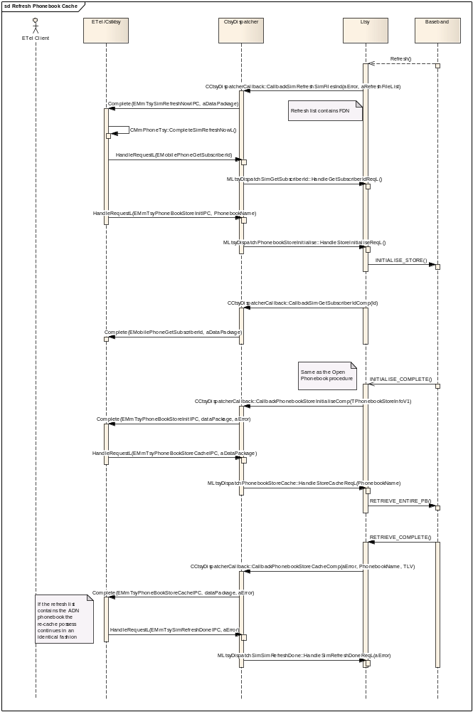

Use-case 13: Read SMS Entry
This use case covers how a SMS entry can be read.
- Read SMS entry.
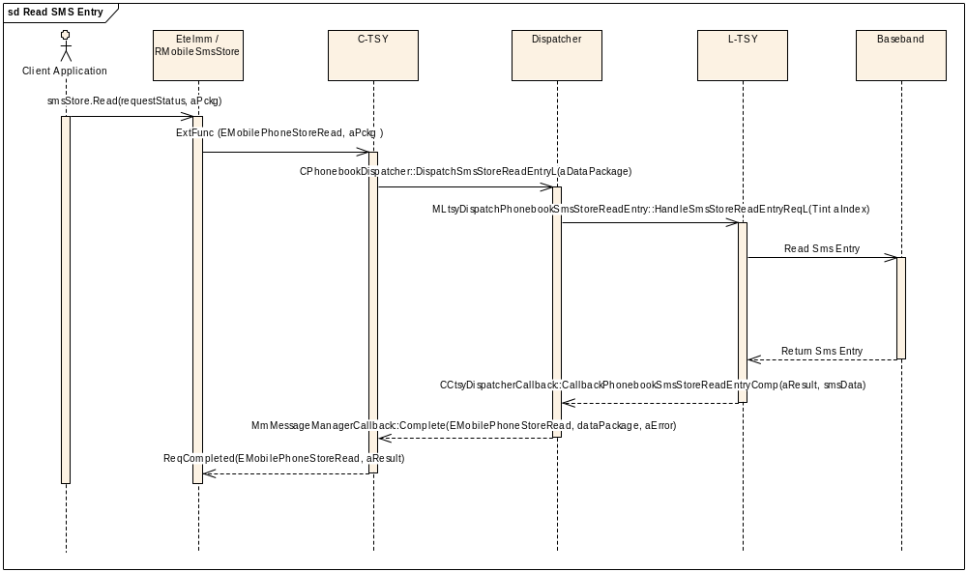
class MLtsyDispatchPhonebookSmsStoreReadEntry : public virtual MLtsyDispatchInterface
{
public:

static const TInt KLtsyDispatchPhonebookSmsStoreReadEntryApiId = KDispatchPhonebookFuncUnitId + 14;

/**
* The CTSY Dispatcher shall invoke this function on receiving the EMobilePhoneStoreRead
* request from the CTSY.
*
* It is a request call that is completed by invoking
* CCtsyDispatcherCallback::CallbackPhonebookSmsStoreReadEntryComp()
*
* Implementation of this interface should handle reading of an entry in the SMS storage.
*
* @param aIndex the index of the entry to read from.
*
*
* @return KErrNone on success, otherwise another error code indicating the
* failure.
*/
virtual TInt HandleSmsStoreReadEntryReqL(TInt aIndex) = 0;

}; // class MLtsyDispatchPhonebookSmsStoreReadEntry };

EXPORT_C void CCtsyDispatcherCallback::CallbackPhonebookSmsStoreReadEntryComp(
TInt aError, const TSmsData& aSmsData)
/**
*
* Callback function to be used by the Licensee LTSY to complete a pending
* MLtsyDispatchPhonebookSmsStoreReadEntry::HandleSmsStoreReadEntryReqL()
*
* @param aError KErrNone on success, or another error code indicating the error otherwise.
* @param aSmsData SMS data. @see TSmsData.
*
* @see RMobileSmsStore::Read()
*/

Use-case 14: Read All SMS Entries
This use case covers how all SMS entries can be read.
- Get Information about the storage
- Read all SMS entries.

Get information about the storage should be called at least once before reading all SMS entries from the SMS storage. This allows CTSY to know if the storage has entries to be read.
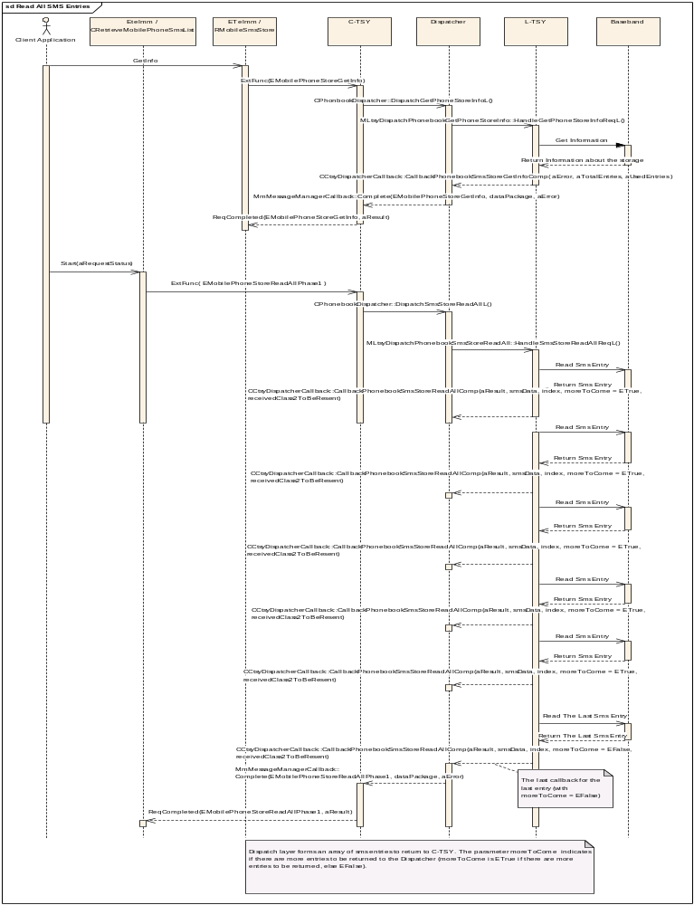
class MLtsyDispatchPhonebookGetPhoneStoreInfo : public virtual MLtsyDispatchInterface
{

public:
static const TInt KLtsyDispatchPhonebookGetPhoneStoreInfoApiId = KDispatchPhonebookFuncUnitId + 9;

/**
* The CTSY Dispatcher shall invoke this function on receiving the EMobilePhoneGetPhoneStoreInfo
* request from the CTSY.
*
* It is a request call that is completed by invoking
* CCtsyDispatcherCallback::CallbackPhonebookGetPhoneStoreInfoComp()
*
* Implementation of this interface should request to get the information of a given store. The
* callback should be completed with the information.
*
*
* @param aStoreName The name of the store to retrieve the information from (e.g. KETelIccFdnPhoneBook).
*
*
* @return KErrNone on success, otherwise another error code indicating the
* failure.
*
* @see RMobilePhone::GetPhoneStoreInfo()
*/
virtual TInt HandleGetPhoneStoreInfoReqL(const TDesC& aStoreName) = 0;

}; // class MLtsyDispatchPhonebookGetPhoneStoreInfo

EXPORT_C void CCtsyDispatcherCallback::CallbackPhonebookGetPhoneStoreInfoComp(
TInt aError, const RMobilePhoneStore::TMobilePhoneStoreInfoV1& aPhoneStoreInfo)
/**
*
* Callback function to be used by the Licensee LTSY to complete a pending
* MLtsyDispatchPhonebookGetPhoneStoreInfo::HandleGetPhoneStoreInfoReqL()
*
*
* @param aError KErrNone on success, or another error code indicating the error otherwise.
* @param aPhoneStoreInfo The phone store information.
*
* @see RMobilePhone::GetPhoneStoreInfo()
*/

class MLtsyDispatchPhonebookSmsStoreReadAll : public virtual MLtsyDispatchInterface
{
public:

static const TInt KLtsyDispatchPhonebookSmsStoreReadAllApiId = KDispatchPhonebookFuncUnitId + 10;

/**
* The CTSY Dispatcher shall invoke this function on receiving the EMobilePhoneStoreReadAllPhase1
* request from the CTSY.
*
* It is a request call that is completed by invoking
* CCtsyDispatcherCallback::CallbackPhonebookSmsStoreReadAllComp()
*
* Implementation of this interface should handle phase 1 of reading all entries in the SMS storage.
*
*
*
* @return KErrNone on success, otherwise another error code indicating the
* failure.
*/
virtual TInt HandleSmsStoreReadAllReqL() = 0;

}; // class MLtsyDispatchPhonebookSmsStoreReadAll

EXPORT_C void CCtsyDispatcherCallback::CallbackPhonebookSmsStoreReadAllComp(
TInt aError, const TSmsData& aSmsData, TInt aIndex, TBool aMoreToCome, TBool aReceivedClass2ToBeResent)
/**
*
* Callback function to be used by the Licensee LTSY to complete a pending
* MLtsyDispatchPhonebookSmsStoreReadAll::HandleSmsStoreReadAllReqL()
*
* @param aError KErrNone on success, or another error code indicating the error otherwise.
* @param aSmsData SMS data. @see TSmsData.
* @param aIndex index of the SMS entry.
* @param aMoreToCome ETrue if there will be other SMS entries, EFalse otherwise.
* @param aReceivedClass2ToBeResent ETrue if received class is to be resent, else EFalse.
*
* @see CRetrieveMobilePhoneSmsList::Start()
*/

SIM Functional Unit
The request handlers that must be implemented by the LTSY are declared in mltsydispatchsiminterface.h.

The callback functions used to complete the SIM requests and also any indicator callbacks are declared in cctsydispatchercallback.h in the section starting with the comment

// Sim related callbacks
IMPORT_C void CallbackSimNotifyIccMessageWaitingIndicatorsChangeInd(TInt aError, const RMobilePhone::TMobilePhoneMessageWaitingV1& aIndicators);
Etc....

Use-case 1: Managing Access Point Name (APN) Control List
This use case covers how the APN control list can be managed. The APN control list defines the allowed access point names stored in the UICC.
- Enabling and disabling the APN control list service
- Get notification of a change in the APN control list
- Enumerate APN control list entries
- Get an entry from the APN control list
- Delete an entry from the APN control list
- Append an entry to the APN control list

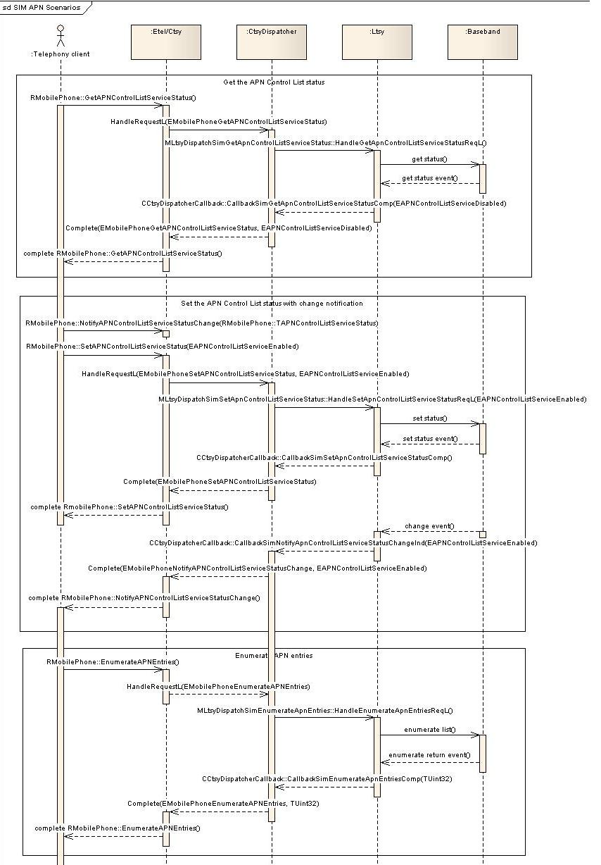
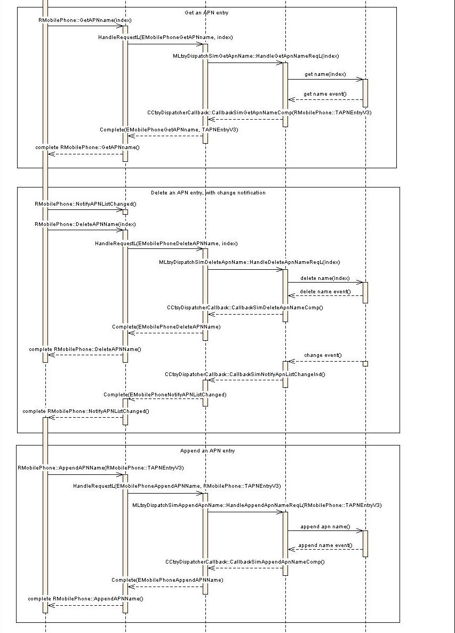
For the APN related Etel API’s the following handlers and call-back completion functions will need to be implemented:
RMobilePhone::GetAPNControlListServiceStatus
class MLtsyDispatchSimGetApnControlListServiceStatus : public virtual MLtsyDispatchInterface
{
public:
virtual TInt HandleGetApnControlListServiceStatusReqL() = 0;
};
The call-back for completion:
void CallbackSimGetApnControlListServiceStatusComp(
TInt aError,
RMobilePhone::TAPNControlListServiceStatus aStatus);

RMobilePhone::SetAPNControlListServiceStatus
class MLtsyDispatchSimSetApnControlListServiceStatus : public virtual MLtsyDispatchInterface
{
public:
virtual Tint HandleSetApnControlListServiceStatusReqL(
RMobilePhone::TAPNControlListServiceStatus aStatus) = 0;
};
The call-back for completion:
void CallbackSimSetApnControlListServiceStatusComp(TInt aError);

RMobilePhone::EnumerateAPNEntries
class MLtsyDispatchSimEnumerateApnEntries : public virtual MLtsyDispatchInterface
{
public:
virtual TInt HandleEnumerateApnEntriesReqL() = 0;
};
The call-back for completion:
void CallbackSimEnumerateApnEntriesComp(TInt aError, TUint32 aNumEntries);

RMobilePhone::AppendAPNName
class MLtsyDispatchSimAppendApnName : public virtual MLtsyDispatchInterface
{
public:
virtual TInt HandleAppendApnNameReqL(const RMobilePhone::TAPNEntryV3& aEntry) = 0;
};
The call-back for completion:
void CallbackSimAppendApnNameComp(TInt aError);

RMobilePhone::GetApnName
class MLtsyDispatchSimGetApnName : public virtual MLtsyDispatchInterface
{
public:
virtual TInt HandleGetApnNameReqL(TUint32 aIndex) = 0;
};
The call-back for completion:
void CallbackSimGetApnNameComp(
TInt aError,
const RMobilePhone::TAPNEntryV3& aEntry);

RMobilePhone::DeleteApnName
class MLtsyDispatchSimDeleteApnName : public virtual MLtsyDispatchInterface
{
public:
virtual TInt HandleDeleteApnNameReqL(TUint32 aIndex) = 0;
};
The call-back for completion:
void CallbackSimDeleteApnNameComp(TInt aError);

RMobilePhone::NotifyAPNControlListServiceStatusChange
This has just a call-back function to be implemented
void CallbackSimNotifyApnControlListServiceStatusChangeInd(
TInt aError,
RMobilePhone::TAPNControlListServiceStatus aStatus);

Use-case 2: Message Waiting Indicators
This use case covers how the client get, sets and receives updates of the MWIS from the UICC.
- Get notification of a change in the MWIS
- Get the MWIS
- Set the MWIS

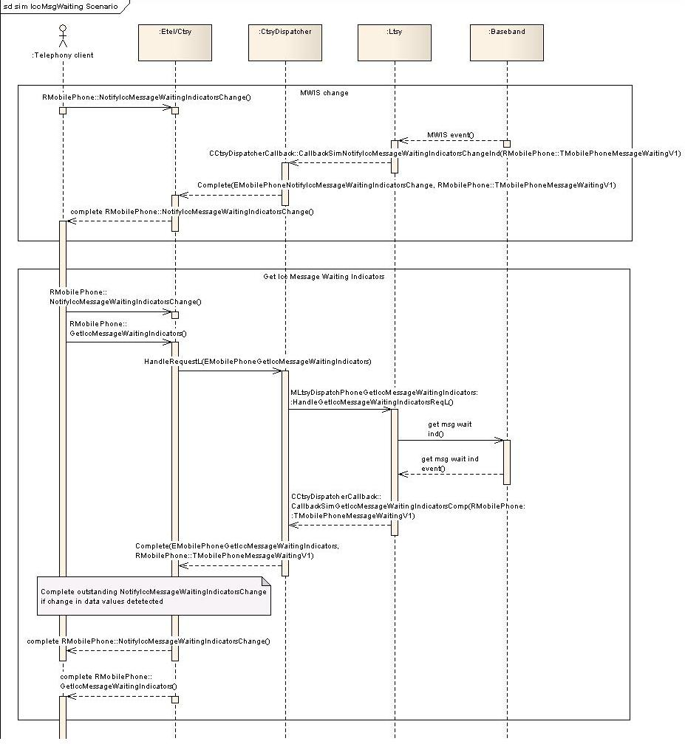

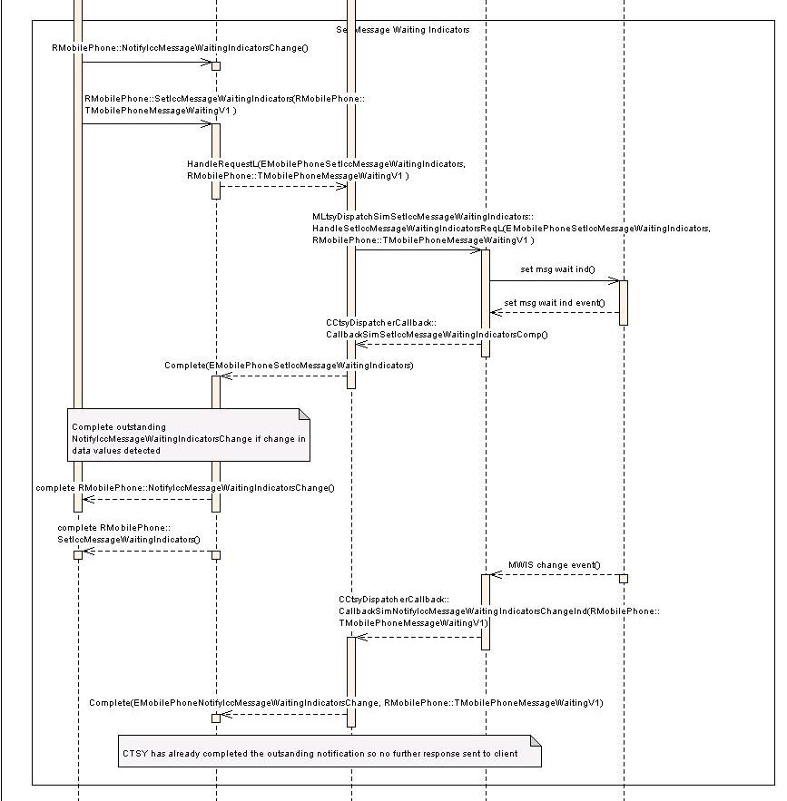

MWIS Implementation Notes
The CTSY caches the MWIS values and uses it to detect changes in MWIS values during the processing of the get and set operations. CTSY also interacts with the MWIS Central Repository (which is a component maintained within Symbian OS) to keep it updated with the current MWIS values.
It appears that by using the cached values, CTSY can still honour outstanding MWIS-change notifications even though the SIM may not support the MWIS feature. In other words, the use of the cache and the different ways in which a notification can be completed helps the CTSY in ensuring the client never misses any changes in MWIS. It is not clear what type of use-case has made this feature necessary, but it may apply to when the device needs to support hot-swappable SIMs (for example), or if the MWIS feature is suddenly disabled on the SIM from a network action (for example). This is not a statement that Symbian OS supports such features, however.
During the GetIccMessageWaitingIndicators operation if CTSY thinks the SIM does not support the MWIS feature it will not forward the request to LTSY, and will attempt to retrieve MWIS values from the MWIS Central Repository and complete the get request immediately.

The NotifyIccMessageWaitingIndicatorsChange request can be completed in 4 cases:
- By a change in the MWIS as a result of network action.
This follows the “normal” route of a notification being completed and is shown in the use-case labelled “MWIS Change”. The new values are cached and the MWIS Central Repository is updated.
- By the completion of a GetIccMessageWaitingIndicators operation when a change is detected in the MWIS. This is shown in the use-case labelled “Get Icc Message Waiting Indicators”. The change in MWIS values may occur as a result of network action. The new values are cached and the MWIS Central Repository is updated. If an error is detected in the get’s completion, MWIS values are read from the MWIS Central Repository instead. The get request is then completed back to the client.
- By the receiving of a SetIccMessageWaitingIndicators when CTSY thinks the SIM does not support the MWIS feature. In this situation, if the new values being set are different to the cached values, the cache and MWIS Central Repository are updated and then an outstanding notify request is completed. The set request is not forwarded to the LTSY but is completed back to the client immediately.
- By the completion of a SetIccMessageWaitingIndicators operation when a change is detected in the MWIS. In this situation, if the new values being set are different to the cached values, the cache and MWIS Central Repository are updated and then an outstanding notify request is completed. The set is then completed as normal.
Finally, note how an outstanding MWIS change notification can be completed to the client either by the MWIS get/set completion threads, or by the notification that is issued from the LTSY/Baseband. Which one of these makes the completion depends, in principal, on which event the LTSY/Baseband issues first (i.e. the set-event or the change-event). In either case, CTSY will not attempt to complete an already completed notification. An example is shown at the bottom of the use-case labelled “Set MWIS Indicators”.

MWIS API’s
For the MWIS related Etel API’s the following handlers and call-back completion functions will need to be implemented:
RMobilePhone::GetIccMessageWaitingIndicators
class MLtsyDispatchSimGetIccMessageWaitingIndicators : public virtual MLtsyDispatchInterface
{
public:
virtual TInt HandleGetIccMessageWaitingIndicatorsReqL() = 0;
};

The call-back for completion:
void CallbackSimGetIccMessageWaitingIndicatorsComp(
TInt aError,
const RMobilePhone::TMobilePhoneMessageWaitingV1& aMessageWaiting);

RMobilePhone::SetIccMessageWaitingIndicators
class MLtsyDispatchSimSetIccMessageWaitingIndicators : public virtual MLtsyDispatchInterface
{
public:
virtual TInt HandleSetIccMessageWaitingIndicatorsReqL(
const RMobilePhone::TMobilePhoneMessageWaitingV1& aIndicators) = 0;

};

The call-back for completion:
void CallbackSimSetIccMessageWaitingIndicatorsComp(TInt aError);

RMobilePhone::NotifyIccMessageWaitingIndicatorsChange
This has just a call-back function to be implemented
void CallbackSimNotifyIccMessageWaitingIndicatorsChangeInd(
TInt aError,
const RMobilePhone::TMobilePhoneMessageWaitingV1& aIndicators);

Other SIM FU API’s

RMobilePhone::GetSubscriberId
For this Etel API the following handler will need to be implemented MLtsyDispatchSimGetSubscriberId::HandleGetSubscriberIdReqL. This should retrieve the subscriber's identity as described by its IMSI from the LTSY.
class MLtsyDispatchSimGetSubscriberId : public virtual MLtsyDispatchInterface
{
public:
virtual TInt HandleGetSubscriberIdReqL() = 0;

};

The request is completed by invoking CCtsyDispatcherCallback::CallbackSimGetSubscriberIdComp and supplying the subscriber identity data as follows
void CCtsyDispatcherCallback::CallbackSimGetSubscriberIdComp(
TInt aError,
TBuf8<RMobilePhone::KIMSISize> aId)

RMobilePhone::GetServiceTable
For this Etel API the following handler will need to be implemented MLtsyDispatchSimGetServiceTable::HandleGetServiceTableReqL. This should retrieve the contents of a service table file that is stored on the ICC.
class MLtsyDispatchSimGetServiceTable : public virtual MLtsyDispatchInterface
{
public:
virtual TInt HandleGetServiceTableReqL(RMobilePhone::TMobilePhoneServiceTable aServiceTable) = 0;
};

The request is completed by invoking CCtsyDispatcherCallback::CallbackSimGetServiceTableComp and supplying the contents of the specified Service Table as follows
void CCtsyDispatcherCallback::CallbackSimGetServiceTableComp(
TInt aError,
const RMobilePhone::TMobilePhoneServiceTableV1& aServiceTable)

Open Issue on RMobilePhone::GetServiceTable
A part of the test for this IPC (test CCTsySimFU::TestUnit0001L()) is currently failing when run on hardware, but passes when run under emulation. Specifically the part of the test which tests for the cancellation of a GetServiceTable request. The affected portion of the test is conditionally not compiled. The user may compile this portion for testing under emulation by commenting out the #ifdef and #endif macros within the test.

RMobilePhone::GetCustomerServiceProfile
For this Etel API the following handler will need to be implemented MLtsyDispatchSimGetCustomerServiceProfile::HandleGetCustomerServiceProfileReqL. This should retrieve the contents of the Customer Service Profile file that is stored on the SIM.
class MLtsyDispatchSimGetCustomerServiceProfile : public virtual MLtsyDispatchInterface
{
public:
virtual TInt HandleGetCustomerServiceProfileReqL() = 0;
};

The request is completed by invoking CCtsyDispatcherCallback::CallbackSimGetCustomerServiceProfileComp and supplying the contents of the CSP as follows
void CCtsyDispatcherCallback::CallbackSimGetCustomerServiceProfileComp(
TInt aError,
const RMobilePhone::TMobilePhoneCspFileV1& aCsp)

RMobilePhone::ChangeSecurityCode
For this Etel API the following handler will need to be implemented MLtsyDispatchSimChangeSecurityCode::HandleChangeSecurityCodeReqL. This should allow a client to change a security code on the SIM.
class MLtsyDispatchSimChangeSecurityCode : public virtual MLtsyDispatchInterface
{
public:
virtual TInt HandleChangeSecurityCodeReqL(RMobilePhone::TMobilePhoneSecurityCode aSecCode,
const RMobilePhone::TMobilePhonePasswordChangeV1& aPasswds) = 0;
};

The request is completed by invoking CCtsyDispatcherCallback::CallbackSimGetCustomerServiceProfileComp and supplying the contents of the CSP as follows
void CCtsyDispatcherCallback::CallbackSimChangeSecurityCodeComp(TInt aError)

Internal Sim IPC (EMmTsySimRefreshNowIPC)

The SIM may indicate that certain cached data in the CTSY needs to be refreshed. This can be done using the CallbackSimRefreshSimFilesInd indicator. This supplies a list of the cached data to be updated (and FDN phonebooks, service table or ALS line)(see Phonebook Refresh Use Case for phonebook refresh).
The subscriber Id is always requested this is done via a standard request complete HandleGetSubscriberIdReqL, CallbackSimGetSubscriberIdComp
The service table is refreshed on request this is done via a standard request complete HandleGetServiceTableReqL, CallbackSimGetServiceTableComp
Once the process is completed a refresh done request is sent to the LTSY (this request has no associated complete).

cass MLtsyDispatchSimSimRefreshDone : public virtual MLtsyDispatchInterface
{
public:

static const TInt KLtsyDispatchSimSimRefreshDoneApiId = KDispatchSimFuncUnitId + 13;

/**
* The CTSY Dispatcher shall invoke this function on receiving the EMmTsySimRefreshDoneIPC
* request from the CTSY.
*
* It is a request call that has no complete.
*
*
* Implementation of this interface indicates to the LTSY the SIM refresh has finished.
*
*
* @param aError An error code relating to the result of the refresh.
*
* @return KErrNone on success, otherwise another error code indicating the
* failure.
*/
virtual TInt HandleSimRefreshDoneReqL(TInt aError) = 0;

}; // class MLtsyDispatchSimSimRefreshDone

Sms Functional Unit
The request handlers that must be implemented by the LTSY are declared in mltsydispatchsmsinterface.h.

The callback functions used to complete the sms requests and also any indicator callbacks are declared in cctsydispatchercallback.h in the section starting with the comment

// Sms related callbacks
IMPORT_C void CallbackSmsNotifyReceiveSmsMessageInd(TInt aError, TBool aInd, const
TSmsMsg& aSmsMsgPtr);
Etc....

Use Case 1: ReceiveMessage
This use case covers:
- Activate SMS routing as a result of ReceiveMessage().
- Receiving message on completion of ReceiveMessage().
- Notifying about failure to store/decode message.
- Receiving message on completion of ReceiveMessage().
- Positive acknowledgment, that SMS was successfully decoded and stored.

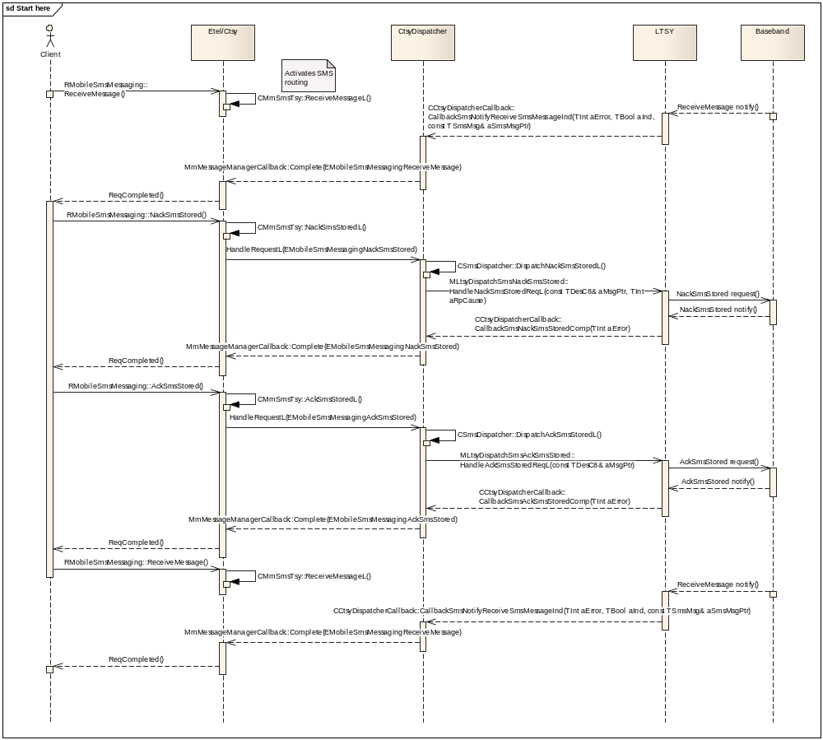
class MLtsyDispatchSmsNackSmsStored : public virtual MLtsyDispatchInterface
{
public:

static const TInt KLtsyDispatchSmsNackSmsStoredApiId = KDispatchSmsFuncUnitId + 4;

/**
* The CTSY Dispatcher shall invoke this function on receiving the
* EMobileSmsMessagingNackSmsStored request from the CTSY.
*
* It is a request call that is completed by invoking
* CCtsyDispatcherCallback::CallbackSmsNackSmsStoredComp()
* Implementation of this interface should accept this negative acknowledgment: when the
client receives an unstored SMS,
* it will use this member function to return a negative acknowledgment if it fails to decode and/or store that SMS.
* This TPDU will contain the TP error cause that prevents the client from acknowledging the SMS.
* The client should also provide the RP error cause by placing it in the aRpCause parameter.
*
* @param aMsgPtr Holds the TPDU defined for a SMS-DELIVER-REPORT (for RP-ERROR) in GSM 03.40.
* @param aRpCause Contain one of the MS related extended error codes.
*
*
* @return KErrNone on success, otherwise another error code indicating the
* failure.
*/
virtual TInt HandleNackSmsStoredReqL(const TDesC8& aMsgPtr, TInt aRpCause) = 0;

}; // class MLtsyDispatchSmsNackSmsStored

class MLtsyDispatchSmsAckSmsStored : public virtual MLtsyDispatchInterface
{
public:

static const TInt KLtsyDispatchSmsAckSmsStoredApiId = KDispatchSmsFuncUnitId + 5;

/**
* The CTSY Dispatcher shall invoke this function on receiving the EMobileSmsMessagingAckSmsStored
* request from the CTSY.
*
* It is a request call that is completed by invoking
* CCtsyDispatcherCallback::CallbackSmsAckSmsStoredComp()
* Implementation of this interface should accept the acknowledgment: when the client receives an unstored SMS,
* it will trigger this function to return a positive acknowledgment if it manages to successfully decode and store that SMS.
* If the client wishes to send a SMS-DELIVER-REPORT in response to the received SMS-DELIVER ,
* than the aMsgData parameter will be used to hold the TPDU defined for a SMS-DELIVER-REPORT (for RP-ACK) in GSM 03.40.
*
* @param aMsgPtr Holds the TPDU defined for a SMS-DELIVER-REPORT (for RP-ACK) in GSM 03.40.
*
* @return KErrNone on success, otherwise another error code indicating the
* failure.
*/
virtual TInt HandleAckSmsStoredReqL(const TDesC8& aMsgPtr) = 0;

}; // class MLtsyDispatchSmsAckSmsStored

EXPORT_C void CCtsyDispatcherCallback::CallbackSmsNotifyReceiveSmsMessageInd(TInt aError, TBool aInd, const TSmsMsg& aSmsMsgPtr )
/**
*
* Callback function to be used by the Licensee LTSY to complete a pending
* RMobileSmsMessaging::ReceiveMessage() or as unsolicited completion
*
* @param aError KErrNone on success, or another error code indicating the error otherwise.
* @param aInd Set routing activity on/off.
* @param aSmsMsgPtr Used to buffer incoming SMSes to the TSY.
*
* @see RMobileSmsMessaging::ReceiveMessage()
*/

Use Case 2: SendMessage
This use case covers:
- Successful sending SMS message down to LTSY.
- Notify about successful SMS send operation.

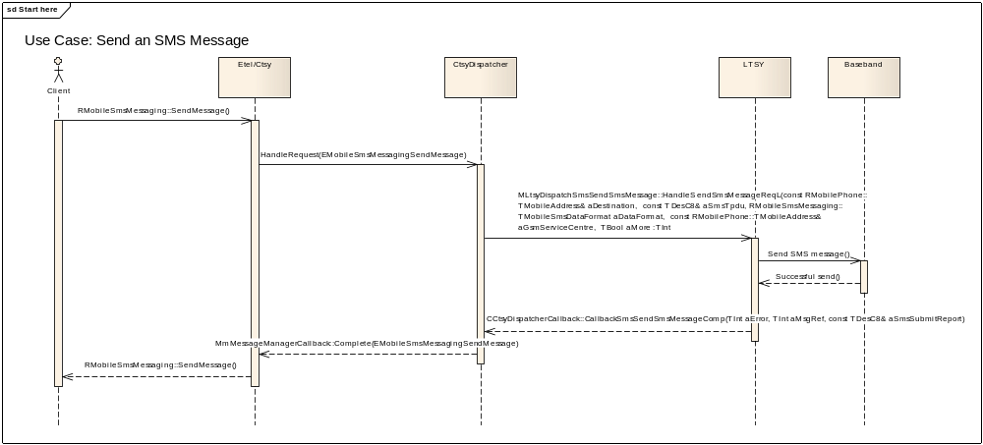

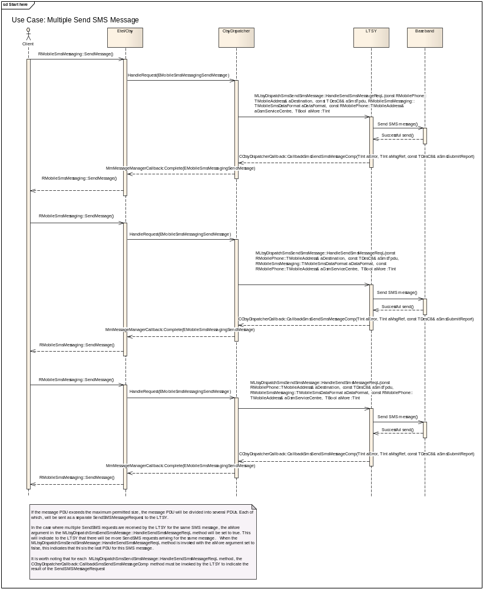

class MLtsyDispatchSmsSendSmsMessage : public virtual MLtsyDispatchInterface
{
public:

static const TInt KLtsyDispatchSmsSendSmsMessageApiId = KDispatchSmsFuncUnitId + 7;

/**
* The CTSY Dispatcher shall invoke this function on receiving the EMobileSmsMessagingSendMessage
* request from the CTSY.
*
* It is a request call that is completed by invoking
* CCtsyDispatcherCallback::CallbackSmsSendSmsMessageComp()
*
* Implementation of this interface should allow a client to send a SMS message
*
* @param aDestination The mobile telephone number.
* @param aSmsTpdu The SMS TPDU.
* @param aDataFormat The SMS data format.
* @param aGsmServiceCentre The service centre number.
* @param aMore This indicates whether the client is going to send another SMS immediately
after this one.
*
* @return KErrNone on success, otherwise another error code indicating the
* failure.
*/
virtual TInt HandleSendSmsMessageReqL( const RMobilePhone::TMobileAddress& aDestination,
const TDesC8& aSmsTpdu,
RMobileSmsMessaging::TMobileSmsDataFormat aDataFormat,
const RMobilePhone::TMobileAddress& aGsmServiceCentre,
TBool aMoreMessages) = 0;
}; // class MLtsyDispatchSmsSendSmsMessage
EXPORT_C void CCtsyDispatcherCallback::CallbackSmsSendSmsMessageComp(
TInt aError, TInt aMsgRef, const TDesC8& aSmsSubmitReport)
/**
*
* Callback function to be used by the Licensee LTSY to complete a pending
* MLtsyDispatchSmsSendSmsMessage::HandleSendSmsMessageReqL()
*
*
* @param aError The error code to be returned to the CTSY Dispatcher.
* @param aMsgRef the message reference assigned to a sent message.
* @param aSmsSubmitReport The message string, which is expected to be a buffer with
* a maximum size of RMobileSmsMessaging::KGsmTpduSize
* @see RMobileSmsMessaging::SendMessage()
*/

Multiparty Call Control Functional Unit
The request handlers that must be implemented by the LTSY are declared in mltsydispatchcallcontrolmultipartyinterface.h.

The callback functions used to complete the sms requests and also any indicator callbacks are declared in cctsydispatchercallback.h in the section starting with the comment

// CallControlMultiparty related callbacks
IMPORT_C void CallbackCallControlMultipartyConferenceHangUpComp(TInt aError);
Etc....

Use Case 1, 2, 3 - Create and hang up a multiparty conference call (including failure cases)

Use Case 1: creates a conference call with two remote parties and hangs it up
- Dial a voice call
- Hold it
- Dial a second voice call
- Create a conference call with them
- Receive conference call related notifications
- Hang up the conference
- Receive conference call related notifications

Use Case 2: failure to create a conference call
- Have one active voice call and one call on hold
- Attempt to create a conference call
- Receive an error from LTSY
- One call remains connected and the other one on hold

Use Case 3: failure to hang up a conference call
- Create a conference call with two remote parties
- Attempt to hang up the conference
- Receive error from LTSY for hang up failure
- Both calls remain connected

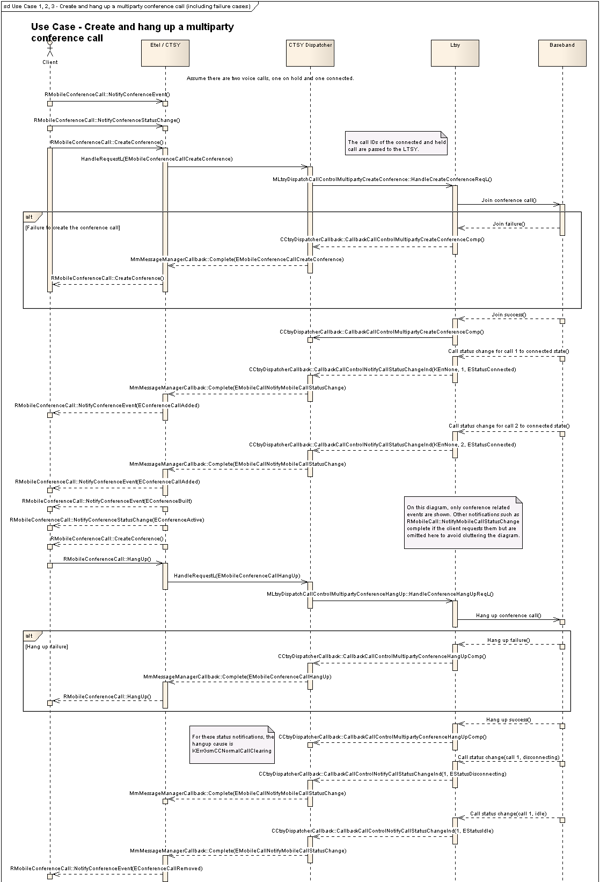
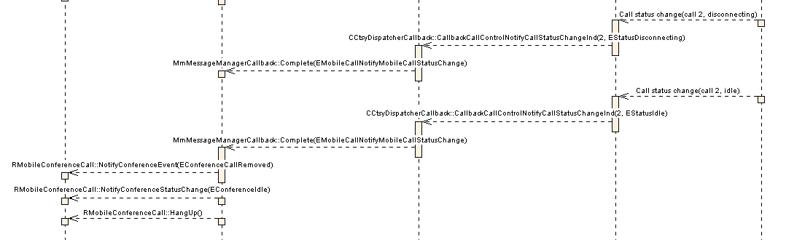

class MLtsyDispatchCallControlMultipartyCreateConference : public virtual MLtsyDispatchInterface
{
public:

static const TInt KLtsyDispatchCallControlMultipartyCreateConferenceApiId = KDispatchCallControlMultipartyFuncUnitId + 3;

/**
* The CTSY Dispatcher shall invoke this function on receiving the EMobileConferenceCallCreateConference
* request from the CTSY.
*
* It is a request call that is completed by invoking
* CCtsyDispatcherCallback::CallbackCallControlMultipartyCreateConferenceComp()
*
* Implementation of this interface should join the two specified calls into a
* multiparty (conference) call.
*
*
* @param aHeldCallId The Call ID of the held call which will be one of the calls
* joined to the conference.
*
* @param aSecondCallId The Call ID of the active / alerting call which will be
* the other call joined to the conference.
*
* @return KErrNone on success, otherwise another error code indicating the
* failure.
*
* @see RMobileConferenceCall::CreateConference()
*/
virtual TInt HandleCreateConferenceReqL(TInt aHeldCallId, TInt aSecondCallId) = 0;

}; // class MLtsyDispatchCallControlMultipartyCreateConference

class MLtsyDispatchCallControlMultipartyConferenceHangUp : public virtual MLtsyDispatchInterface
{
public:

static const TInt KLtsyDispatchCallControlMultipartyConferenceHangUpApiId = KDispatchCallControlMultipartyFuncUnitId + 1;

/**
* The CTSY Dispatcher shall invoke this function on receiving the EMobileConferenceCallHangUp
* request from the CTSY.
*
* It is a request call that is completed by invoking
* CCtsyDispatcherCallback::CallbackCallControlMultipartyConferenceHangUpComp()
*
* Implementation of this interface should terminate the active conference call.
*
* @return KErrNone on success, otherwise another error code indicating the
* failure.
*
* @see RMobileConferenceCall::HangUp()
*/
virtual TInt HandleConferenceHangUpReqL() = 0;

}; // class MLtsyDispatchCallControlMultipartyConferenceHangUp

Use Case 4: hang up of remote party in conference call
- Create a conference call with two remote parties
- Receive remote hang up from one of the parties in the conference
- Conference call goes idle as this party drops out

When one of the remote parties hangs up, call status notifications are received. The CTSY contains logic which works out that the number of remote parties in the conference has now dropped to 1 and hence the conference has gone idle. The CTSY completes the conference call status notification informing the client of this change in status.

Use Case 5: swap a conference call, add a call to an existing conference
- Set up a conference call with two remote parties
- Swap the conference call (when it is the only active call)
- The conference call goes on hold
- Dial a third call and add it to the conference
- The conference gets connected again with all three calls being a part of it
- Swap the conference call to put it back on hold
- Dial a fourth call
- Swap the conference call making it active and the fourth call on hold
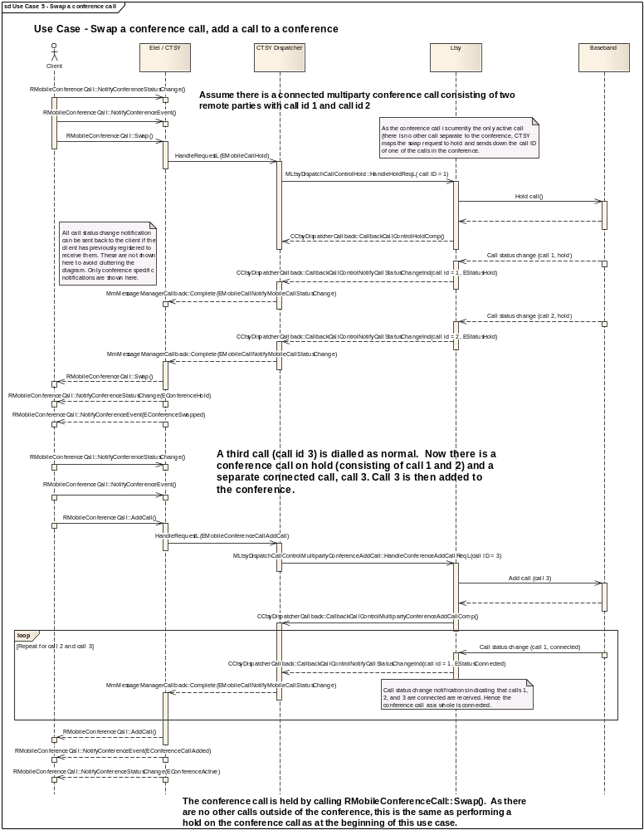
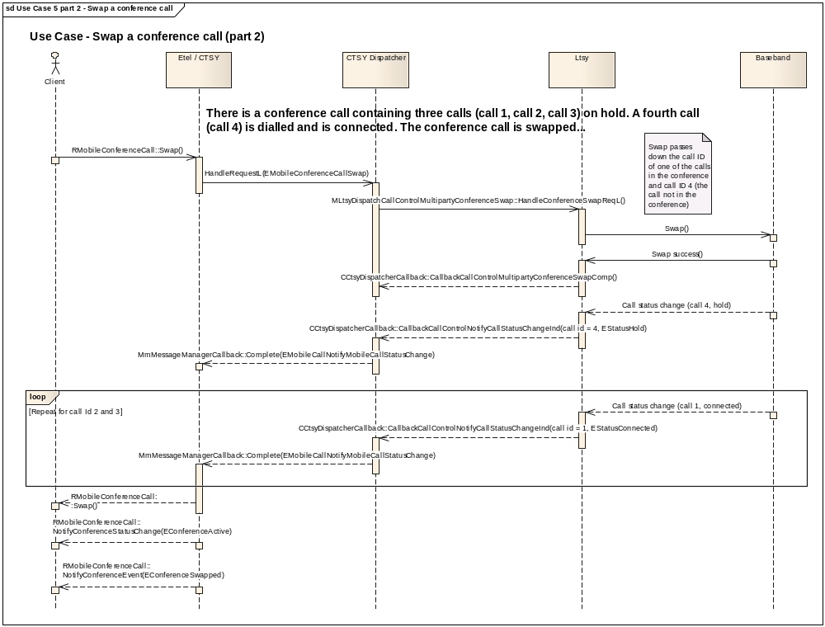

class MLtsyDispatchCallControlMultipartyConferenceAddCall : public virtual MLtsyDispatchInterface
{
public:

static const TInt KLtsyDispatchCallControlMultipartyConferenceAddCallApiId = KDispatchCallControlMultipartyFuncUnitId + 2;

/**
* The CTSY Dispatcher shall invoke this function on receiving the EMobileConferenceCallAddCall
* request from the CTSY.
*
* It is a request call that is completed by invoking
* CCtsyDispatcherCallback::CallbackCallControlMultipartyConferenceAddCallComp()
*
* Implementation of this interface should add the specified call to the conference
* call. Typically, there will be an ongoing conference call containing at least
* 2 remote parties. The conference call gets swapped into the held state and
* either a new call is dialled or an incoming call is answered. This call can
* the be added to the conference call using this API.
*
*
* @param aCallId The Call ID of the connected call to be added to the multiparty (conference) call.
*
* @return KErrNone on success, otherwise another error code indicating the
* failure.
*
* @see RMobileconferenceCall::AddCall()
*/
virtual TInt HandleConferenceAddCallReqL(TInt aCallId) = 0;

}; // class MLtsyDispatchCallControlMultipartyConferenceAddCall

Use Case 6: failure to swap a conference call
- Create a conference call with two remote parties and swap it (which puts it on hold).
- Dial a third call.
- Attempt to swap the conference call.
- Receive a failure for the swap request from the LTSY.
- The conference remains on hold and the third call remains connected.

Use Case 7: failure to add a call to a conference
- Create a conference call with two remote parties and swap it (which puts it on hold).
- Dial a third call.
- Attempt to add the third call to the conference.
- Receive failure for the add request from the LTSY.
- The conference remains on hold and the third call remains connected. There are two (remote) parties in the conference.

Use Case 8, 10 Going one to one in a conference call with two remote parties (success and failure)
“Going one to one” refers to setting up a private communication with a parties in a conference.

- Create a conference call with two remote parties.
- Go one-to-one with one of the participants.
- This call is connected, the other call gets put on hold and the conference gets split.
- The CTSY manages the conference notifications and notifies the client that the two calls have been removed from the conference and it has been split.

In the case of failure to go one-to-one, the calls remain in their original state.

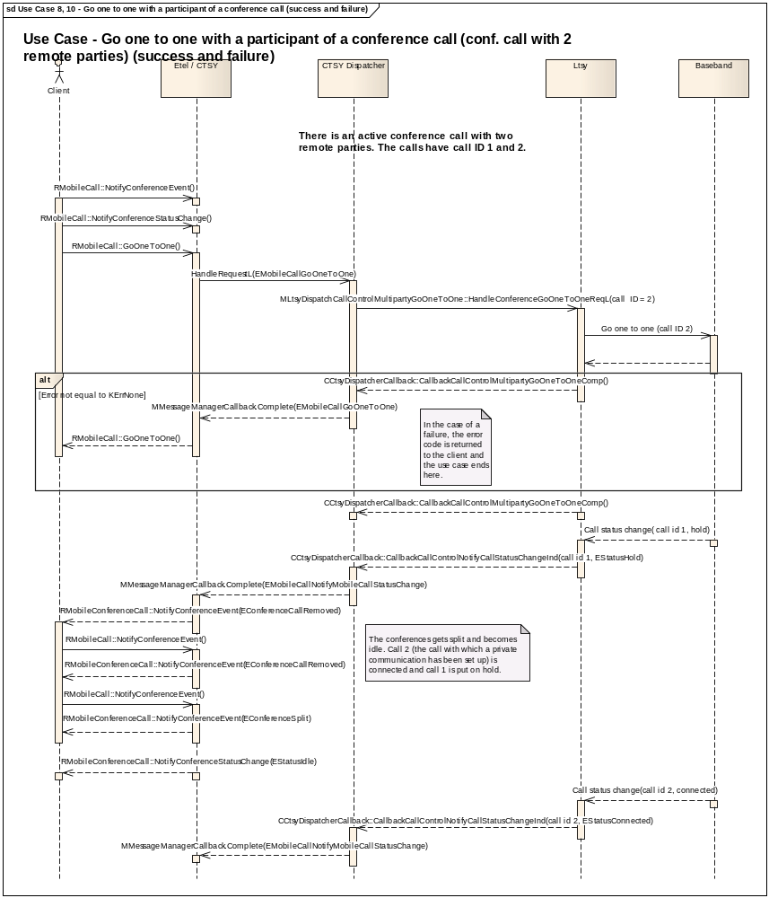

class MLtsyDispatchCallControlMultipartyConferenceGoOneToOne : public virtual MLtsyDispatchInterface
{
public:

static const TInt KLtsyDispatchCallControlMultipartyConferenceGoOneToOneApiId = KDispatchCallControlMultipartyFuncUnitId + 5;

/**
* The CTSY Dispatcher shall invoke this function on receiving the EMobileCallGoOneToOne
* request from the CTSY.
*
* It is a request call that is completed by invoking
* CCtsyDispatcherCallback::CallbackCallControlMultipartyConferenceGoOneToOneComp()
*
* Implementation of this interface should set up a private communication with the specified call
* in the conference. This call will then become connected when the call status notification
* arrives from the LTSY and the other call(s) will go on hold.
*
* If at the time of the go one to one request, there are two remote parties in the conference
* call, after the one to one is successful, the other call will go on hold and the conference
* will go idle (as there are not enough participants to be a valid conference anymore). If there
* are more than two remote parties in the conference call, then the conference call should go
* on hold.
*
* @param aCallId The Call ID of the call which the client wishes to set up a private communication with.
* This should be a call currently in the conference.
*
* @return KErrNone on success, otherwise another error code indicating the
* failure.
*
* @see RMobileCall::GoOneToOne()
*/
virtual TInt HandleConferenceGoOneToOneReqL(TInt aCallId) = 0;

}; // class MLtsyDispatchCallControlMultipartyConferenceGoOneToOne

Use Case 9: Go one-to-one with a conference with a party in a conference with three remote parties

- Create a conference call with three remote parties
- Go one-to-one with one of the participants
- This is similar to use case 8 except the conference goes on hold and gets split. One call is removed from the conference and is connected.

Use Case 11: Send DTMF through a conference call
- Create a conference call with two remote parties
- Send a DTMF string to the conference. The CTSY passes the call ID of one of the calls in the conference to the LTSY when the request to send the string is made.

Supplementary Services Functional Unit
The request handlers that must be implemented by the LTSY are declared in mltsydispatchsupplementaryservicesinterface.h.

The callback functions used to complete the supplementary services requests and also any indicator callbacks are declared in cctsydispatchercallback.h in the section starting with the comment

// SupplementaryServices related callbacks
IMPORT_C void CallbackSupplementaryServicesNotifyCallBarringStatusChangeInd(TInt aError, RMobilePhone::TMobilePhoneCBCondition aCondition);
Etc....

Use Case 1: Call Barring
This use case covers:
- Getting the call baring service settings.
- Receiving notification when the call barring service settings changed.
- Changing the settings of the call barring service.
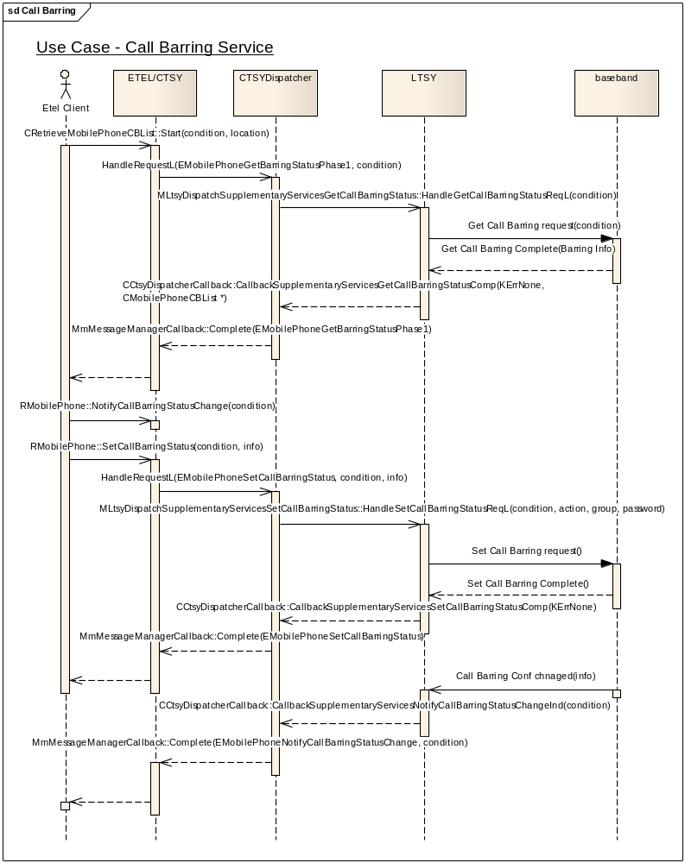

Implementation Notes:

The following interfaces and callbacks need to be implemented:
To get the call barring settings:
/**
* The CTSY Dispatcher shall invoke this function on receiving the EMobilePhoneGetBarringStatusPhase1
* request from the CTSY.
*
* It is a request call that is completed by invoking
* CCtsyDispatcherCallback::CallbackSupplementaryServicesGetCallBarringStatusComp()
*
* Implementation of this interface should get the call barring list.
*
*
* @param aCondition The barring conditions to interrogate.
*
* @return KErrNone on success, otherwise another error code indicating the
* failure.
*/
virtual TInt HandleGetCallBarringStatusReqL(RMobilePhone::TMobilePhoneCBCondition aCondition) = 0;

EXPORT_C void CCtsyDispatcherCallback::CallbackSupplementaryServicesGetCallBarringStatusComp(
TInt aError, CMobilePhoneCBList *aCallBarringList)
/**
*
* Callback function to be used by the Licensee LTSY to complete a pending
* MLtsyDispatchSupplementaryServicesGetCallBarringStatus::HandleGetCallBarringStatusReqL()
*
* Used to return to the Common TSY the status of the call barring service.
*
* @param aError The error code to be returned to the CTSY Dispatcher.
* @param aCallBarringList the call barring list
*
* @param aError KErrNone on success, or another error code indicating the error otherwise.
*
* @see CRetrieveMobilePhoneCBList::Start()
*/

To set the call barring service settings:
/**
* The CTSY Dispatcher shall invoke this function on receiving the EMobilePhoneSetCallBarringStatus
* request from the CTSY.
*
* It is a request call that is completed by invoking
* CCtsyDispatcherCallback::CallbackSupplementaryServicesSetCallBarringStatusComp()
*
* Implementation of this interface should set the call barring status for a call barring condition.
*
*
* @param aCondition The call barring condition to set.
* @param aAction The call barring action.
* @param aGroup The call barring service group.
* @param aPassword The password of the call barring service.
*
* @return KErrNone on success, otherwise another error code indicating the
* failure.
*/
virtual TInt HandleSetCallBarringStatusReqL(RMobilePhone::TMobilePhoneCBCondition aCondition,
RMobilePhone::TMobilePhoneServiceAction aAction,
RMobilePhone::TMobileService aGroup,
const TDesC& aPassword) = 0;

EXPORT_C void CCtsyDispatcherCallback::CallbackSupplementaryServicesSetCallBarringStatusComp(TInt aError)
/**
*
* Callback function to be used by the Licensee LTSY to complete a pending
* MLtsyDispatchSupplementaryServicesSetCallBarringStatus::HandleSetCallBarringStatusReqL()
*
* Used to indicate to the Common TSY the outcome of setting the call barring service.
*
* @param aError KErrNone on success, or another error code indicating the error otherwise.
*
* @see RMobilePhone::SetCallBarringStatus()
*/
To indicate that the call barring setting had changed:

EXPORT_C void CCtsyDispatcherCallback::CallbackSupplementaryServicesNotifyCallBarringStatusChangeInd(
TInt aError, RMobilePhone::TMobilePhoneCBCondition aCondition)
/**
*
* Callback function to be used by the Licensee LTSY to indicate a change to a call barring status.
* The Call Barring Supplementary Service is detailed in 3GPP TS 24.088.
*
*
* @param aError KErrNone on success, or another error code indicating the error otherwise.
* @param aCondition The call barring condition that have changed
*
* @see RMobilePhone::NotifyCallBarringStatusChange()
*/

Use Case 2: Call Forward
This use case covers:
- Receiving notification when the call forward service settings changed.
- Changing the settings of the call forward service.
- Receiving notification when a call has been forward.
- Getting the call forward service settings.

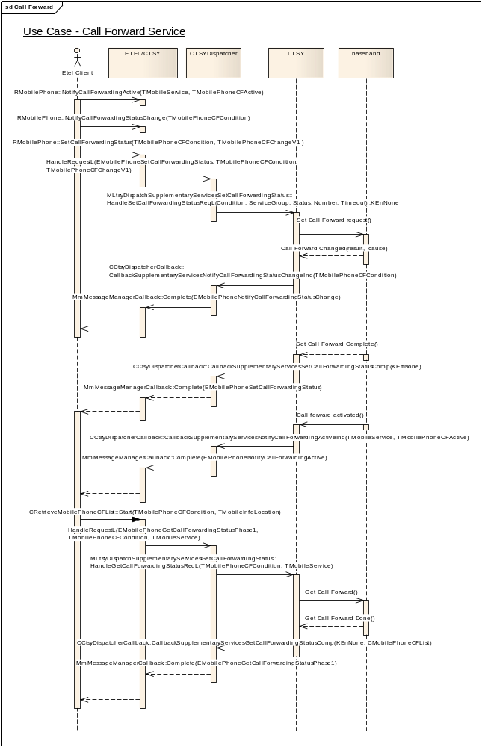

Implementation Notes:

The following interfaces and callbacks need to be implemented:
To get the call forward settings:
/**
* The CTSY Dispatcher shall invoke this function on receiving the EMobilePhoneGetCallForwardingStatusPhase1
* request from the CTSY.
*
* It is a request call that is completed by invoking
* CCtsyDispatcherCallback::CallbackSupplementaryServicesGetCallForwardingStatusComp()
*
* Implementation of this interface should get the call forwarding list.
*
* @param aCondition The call forwarding condition.
* @param aService The service group.
*
* @return KErrNone on success, otherwise another error code indicating the
* failure.
*/
virtual TInt HandleGetCallForwardingStatusReqL(RMobilePhone::TMobilePhoneCFCondition aCondition,
RMobilePhone::TMobileService aService) = 0;

EXPORT_C void CCtsyDispatcherCallback::CallbackSupplementaryServicesGetCallForwardingStatusComp(
TInt aError, CMobilePhoneCFList *aCallForwardingList)
/**
*
* Callback function to be used by the Licensee LTSY to complete a pending
* MLtsyDispatchSupplementaryServicesGetCallForwardingStatus::HandleGetCallForwardingStatusReqL()
*
* Used to return to the Common TSY the status of the call forwarding service.
*
* @param aError The error code to be returned to the CTSY Dispatcher.
* @param aCallForwardingList the call forwarding list
* @param aError KErrNone on success, or another error code indicating the error otherwise.
*
* @see CRetrieveMobilePhoneCFList::Start()
*/

To set the call forward service settings:
/**
* The CTSY Dispatcher shall invoke this function on receiving the EMobilePhoneSetCallForwardingStatus
* request from the CTSY.
*
* It is a request call that is completed by invoking
* CCtsyDispatcherCallback::CallbackSupplementaryServicesSetCallForwardingStatusComp()
*
* Implementation of this interface should sets a new call forwarding status and/or registered
* information for the call forwarding condition.
*
*
* @param aCondition The condition of the new call forwarding setting.
* @param aServiceGroup The basic service group to apply the CF status change to.
* @param aAction The action to take.
* @param aNumber The forwarding number.
* @param aTimeout The time out when aCondition is ECallForwardingNoReply.
*
* @return KErrNone on success, otherwise another error code indicating the
* failure.
*/
virtual TInt HandleSetCallForwardingStatusReqL(RMobilePhone::TMobilePhoneCFCondition aCondition,
RMobilePhone::TMobileService aServiceGroup,
RMobilePhone::TMobilePhoneServiceAction aAction,
const TDesC& aNumber,
TInt aTimeout) = 0;

EXPORT_C void CCtsyDispatcherCallback::CallbackSupplementaryServicesSetCallForwardingStatusComp(
TInt aError)
/**
*
* Callback function to be used by the Licensee LTSY to complete a pending
* MLtsyDispatchSupplementaryServicesSetCallForwardingStatus::HandleSetCallForwardingStatusReqL()
*
* Used to indicate to the Common TSY the outcome of setting the call forwarding service.
*
* @param aError KErrNone on success, or another error code indicating the error otherwise.
*
* @see RMobilePhone::SetCallForwardingStatus()
*/
To indicate that the call had been forward:

EXPORT_C void CCtsyDispatcherCallback::CallbackSupplementaryServicesNotifyCallForwardingActiveInd(
TInt aError, RMobilePhone::TMobileService aServiceGroup, RMobilePhone::TMobilePhoneCFActive aActiveType)
/**
*
* Callback function to be used by the Licensee LTSY to indicate
* when a call is made on a line and a call forwarding service is active
* on this line at the time. The Call Forwarding Supplementary Service is
* detailed in 3GPP TS 24.082.
*
*
* @param aError KErrNone on success, or another error code indicating the error otherwise.
* @param aServiceGroup The basic service group the call forwarding is active.
* @param aActiveType Specifies whether CF unconditional or one of the conditional CF services is active
*
* @see RMobilePhone::NotifyCallForwardingActive()
*/

To indicate that the call forward setting had changed:

EXPORT_C void CCtsyDispatcherCallback::CallbackSupplementaryServicesNotifyCallForwardingStatusChangeInd(
TInt aError, RMobilePhone::TMobilePhoneCFCondition aCallForwardingCondition)
/**
*
* Callback function to be used by the Licensee LTSY to indicate a Call Forwarding status changes.
* The Call Forwarding Supplementary Service is detailed in 3GPP TS 24.082.
*
*
* @param aError KErrNone on success, or another error code indicating the error otherwise.
* @param aCallForwardingCondition The call forwarding condition that changed status
*
* @see RMobilePhone::NotifyCallForwardingStatusChange()
*/

Use Case 3: Call Waiting
This use case covers:
- Getting the call waiting service settings.
- Receiving notification when the call waiting service settings changed.
- Changing the setting of the call waiting service.
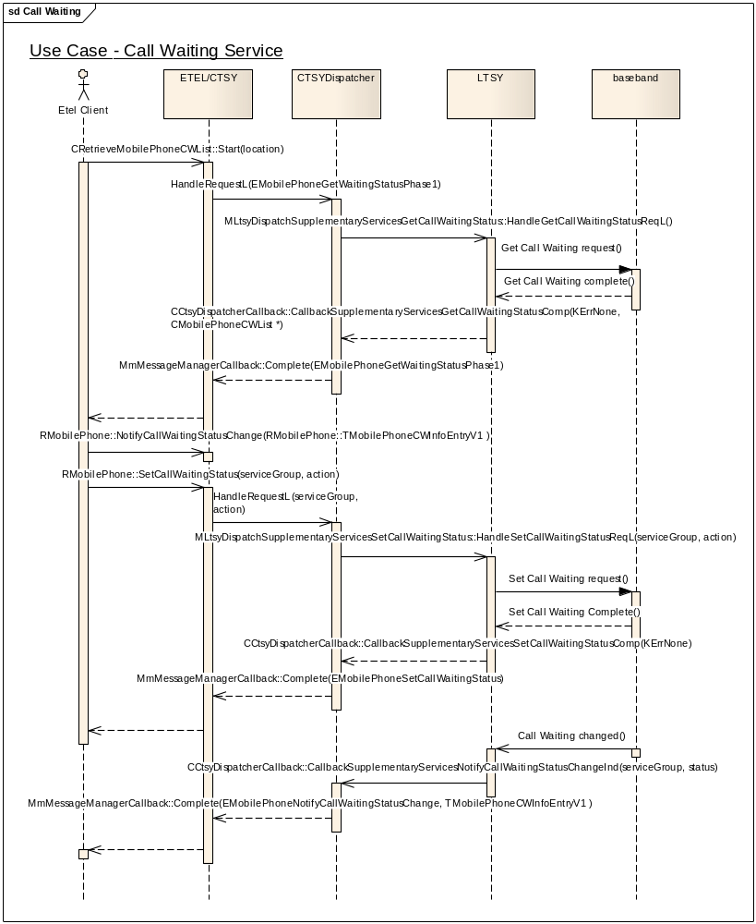

Implementation Notes:

The following interfaces and callbacks need to be implemented:
To get the call waiting settings:
/**
* The CTSY Dispatcher shall invoke this function on receiving the EMobilePhoneGetWaitingStatusPhase1
* request from the CTSY.
*
* It is a request call that is completed by invoking
* CCtsyDispatcherCallback::CallbackSupplementaryServicesGetCallWaitingStatusComp()
*
* Implementation of this interface should get the call waiting list.
*
* @return KErrNone on success, otherwise another error code indicating the
* failure.
*/
virtual TInt HandleGetCallWaitingStatusReqL() = 0;

EXPORT_C void CCtsyDispatcherCallback::CallbackSupplementaryServicesGetCallWaitingStatusComp(
TInt aError, CMobilePhoneCWList *aCallWaitingList)
/**
*
* Callback function to be used by the Licensee LTSY to complete a pending
* MLtsyDispatchSupplementaryServicesGetCallWaitingStatus::HandleGetCallWaitingStatusReqL()
*
* Used to return to the Common TSY the status of the call waiting service.
*
* @param aError KErrNone on success, or another error code indicating the error otherwise.
* @param aError The error code to be returned to the CTSY Dispatcher.
* @param aCallWaitingList The list of the waiting calls status
*
* @see CRetrieveMobilePhoneCWList::Start()
*/

To set the call waiting service settings:
/**
* The CTSY Dispatcher shall invoke this function on receiving the EMobilePhoneSetCallWaitingStatus
* request from the CTSY.
*
* It is a request call that is completed by invoking
* CCtsyDispatcherCallback::CallbackSupplementaryServicesSetCallWaitingStatusComp()
*
* Implementation of this interface should set the call waiting status.
*
*
* @param aServiceGroup The service group to change.
* @param aAction The action to do with that service group.
*
* @return KErrNone on success, otherwise another error code indicating the
* failure.
*/
virtual TInt HandleSetCallWaitingStatusReqL(RMobilePhone::TMobileService aServiceGroup, RMobilePhone::TMobilePhoneServiceAction aAction) = 0;

EXPORT_C void CCtsyDispatcherCallback::CallbackSupplementaryServicesSetCallWaitingStatusComp(
TInt aError)
/**
*
* Callback function to be used by the Licensee LTSY to complete a pending
* MLtsyDispatchSupplementaryServicesSetCallWaitingStatus::HandleSetCallWaitingStatusReqL()
*
* Used to indicate to the Common TSY the outcome of setting the call waiting service.
*
* @param aError KErrNone on success, or another error code indicating the error otherwise.
*
* @see RMobilePhone::SetCallWaitingStatus()
*/
To indicate that the call waiting setting had changed:

EXPORT_C void CCtsyDispatcherCallback::CallbackSupplementaryServicesNotifyCallWaitingStatusChangeInd(
TInt aError,
RMobilePhone::TMobileService aServiceGroup,
RMobilePhone::TMobilePhoneCWStatus aStatus)
/**
*
* Callback function to be used by the Licensee LTSY to indicate a change to
* a call waiting status. The Call Waiting Supplementary Service
* is detailed in 3GPP TS 24.083.
*
*
* @param aError KErrNone on success, or another error code indicating the error otherwise.
* @param aServiceGroup The relevant service group
* @param aStatus The new call waiting status
*
* @see RMobilePhone::NotifyCallWaitingStatusChange()
*/

Use Case 4: Network Service
This use case covers:
- Sending a network service request.
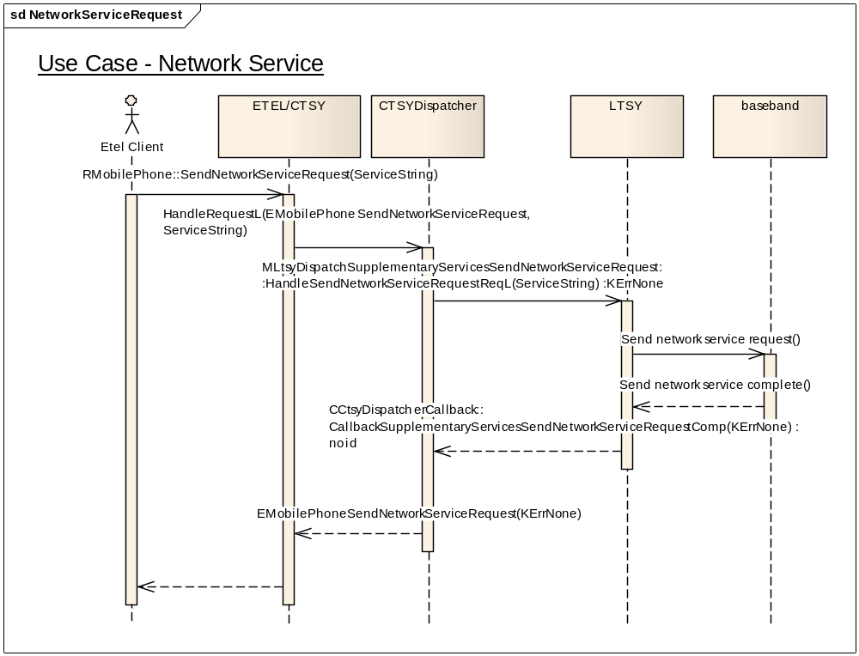

Implementation Notes:

The following interfaces and callbacks need to be implemented:
To send the network service request:
/**
* The CTSY Dispatcher shall invoke this function on receiving the EMobilePhoneSendNetworkServiceRequest
* request from the CTSY.
*
* It is a request call that is completed by invoking
* CCtsyDispatcherCallback::CallbackSupplementaryServicesSendNetworkServiceRequestComp()
*
* Implementation of this interface should send the request to the network after FDN check.
*
*
* @param aRequest The supplementary services string that was entered by the user and need to be send to the network.
*
* @return KErrNone on success, otherwise another error code indicating the
* failure.
*/
virtual TInt HandleSendNetworkServiceRequestReqL(const TDesC& aRequest) = 0;

EXPORT_C void CCtsyDispatcherCallback::CallbackSupplementaryServicesSendNetworkServiceRequestComp(
TInt aError)
/**
*
* Callback function to be used by the Licensee LTSY to complete a pending
* MLtsyDispatchSupplementaryServicesSendNetworkServiceRequest::HandleSendNetworkServiceRequestReqL()
*
* Used to indicate to the Common TSY the outcome of sending a network service request with FDN check.
*
* @param aError KErrNone on success, or another error code indicating the error otherwise.
*
* @see RMobilePhone::SendNetworkServiceRequest()
*/

We can also use the no FDN check of those methods:
/**
* The CTSY Dispatcher shall invoke this function on receiving the EMobilePhoneSendNetworkServiceRequestNoFdnCheck
* request from the CTSY.
*
* It is a request call that is completed by invoking
* CCtsyDispatcherCallback::CallbackSupplementaryServicesSendNetworkServiceRequestNoFdnCheckComp()
*
* Implementation of this interface should send the request to the network without FDN check.
*
*
* @param aRequest The supplementary services string that was entered by the user and need to be send to the network.
*
* @return KErrNone on success, otherwise another error code indicating the
* failure.
*/
virtual TInt HandleSendNetworkServiceRequestNoFdnCheckReqL(const TDesC& aRequest) = 0;

EXPORT_C void CCtsyDispatcherCallback::CallbackSupplementaryServicesSendNetworkServiceRequestNoFdnCheckComp(
TInt aError)
/**
*
* Callback function to be used by the Licensee LTSY to complete a pending
* MLtsyDispatchSupplementaryServicesSendNetworkServiceRequestNoFdnCheck::HandleSendNetworkServiceRequestNoFdnCheckReqL()
*
* Used to indicate to the Common TSY the outcome of sending a network service request without FDN check.
*
* @param aError KErrNone on success, or another error code indicating the error otherwise.
*
* @see RMobilePhone::SendNetworkServiceRequestNoFdnCheck()
*/

Use Case 5: USSD
This use case covers:
- Sending a USSD message to the network.
- Receive a USSD message from the network.
- Release a USSD session.
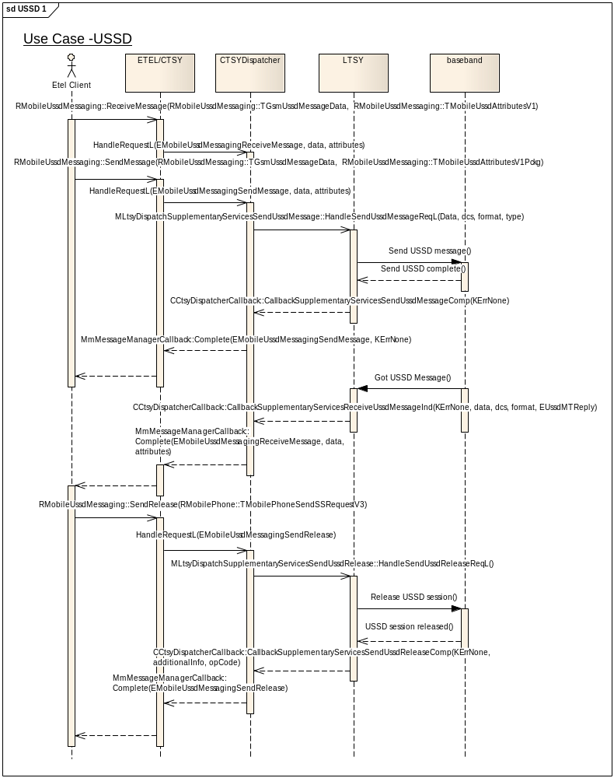

Implementation Notes:

The following interfaces and callbacks need to be implemented:
To send the USSD message:
/**
* The CTSY Dispatcher shall invoke this function on receiving the EMobileUssdMessagingSendMessage
* request from the CTSY.
*
* It is a request call that is completed by invoking
* CCtsyDispatcherCallback::CallbackSupplementaryServicesSendUssdMessageComp()
*
* Implementation of this interface should send an USSD message to the network.
*
*
* @param aData The actual data to send in the message.
* @param aDcs The data coding scheme of the message.
* @param aFormat The message format.
* @param aType The message type (RMobileUssdMessaging::EUssdMORequest, RMobileUssdMessaging::EUssdMOReply
* or RMobileUssdMessaging::EUssdMOAcknowledgement).
*
* @return KErrNone on success, KErrGsmSSUssdBusy if the latest USSD session was not yet released,
* otherwise another error code indicating the failure.
*/
virtual TInt HandleSendUssdMessageReqL(const TDesC8& aData, TUint8 aDcs,
RMobileUssdMessaging::TMobileUssdDataFormat aFormat, RMobileUssdMessaging::TMobileUssdMessageType aType) = 0;

EXPORT_C void CCtsyDispatcherCallback::CallbackSupplementaryServicesSendUssdMessageComp(TInt aError)
/**
*
* Callback function to be used by the Licensee LTSY to complete a pending
* MLtsyDispatchSupplementaryServicesSendUssdMessage::HandleSendUssdMessageReqL()
*
* Used to indicate to the Common TSY the outcome of sending an USSD message.
*
* @param aError KErrNone on success, or another error code indicating the error otherwise.
*
* @see RMobileUssdMessaging::SendMessage()
*/

To indicate that a USSD Message had been received from the network:
EXPORT_C void CCtsyDispatcherCallback::CallbackSupplementaryServicesReceiveUssdMessageInd(
TInt aError, TDesC8 *aMessage, TUint8 aDcs,
RMobileUssdMessaging::TMobileUssdMessageType aType,
RMobileUssdMessaging::TMobileUssdDataFormat aFormat)
/**
* Callback function to be used by the Licensee LTSY to indicate that a
* USSD message was received from the network. The USSD Supplementary Service
* is detailed in 3GPP TS 24.090.
*
*
* @param aError KErrNone on success, or another error code indicating the error otherwise.
* @param aMessage The message that was received
* @param aDcs The Data Coding Scheme of the received USSD message
* @param aType The message type (depend on the invoke part of the message:
* UnstructuredSS-Notify - RMobileUssdMessaging::EUssdMTNotify;
* UnstructuredSS-Request - RMobileUssdMessaging::EUssdMTRequest;
* ProcessUnstructuredSS-Request - RMobileUssdMessaging::EUssdMTReply)
* @param aFormat The message format
*
* @see RMobileUssdMessaging::ReceiveMessage()
*/
To release a USSD session:
/**
* The CTSY Dispatcher shall invoke this function on receiving the EMobileUssdMessagingSendRelease
* request from the CTSY.
*
* It is a request call that is completed by invoking
* CCtsyDispatcherCallback::CallbackSupplementaryServicesSendUssdReleaseComp()
*
* Implementation of this interface should send a USSD release message to the network.
*
* @return KErrNone on success, otherwise another error code indicating the
* failure.
*/
virtual TInt HandleSendUssdReleaseReqL() = 0;

EXPORT_C void CCtsyDispatcherCallback::CallbackSupplementaryServicesSendUssdReleaseComp(
TInt aError, TUint8 aOpCode, const TDesC& aAdditionalInfo)
/**
*
* Callback function to be used by the Licensee LTSY to complete a pending
* MLtsyDispatchSupplementaryServicesSendUssdRelease::HandleSendUssdReleaseReqL()
*
* Used to indicate to the Common TSY the outcome of sending an USSD release.
*
* @param aError The error code to be returned to the CTSY Dispatcher.
* @param aOpCode The Operation Code.
* @param aAdditionalInfo Any additional information
* @param aError KErrNone on success, or another error code indicating the error otherwise.
*
* @see RMobileUssdMessaging::SendRelease()
*/

Packet Services Functional Unit
The request handlers that must be implemented by the LTSY are declared in mltsydispatchpacketservicesinterface.h.
The callback functions used to complete the call control requests and also any indicator callbacks are declared in cctsydispatchercallback.h in the section starting with the comment:
// PacketServices related callbacks
IMPORT_C void CallbackPacketServicesNotifyPacketAttachModeChangeInd(TInt aError);
IMPORT_C void CallbackPacketServicesNotifyQosProfileChangedGPRSInd(TInt aError, const TDesC& aContextName, RPacketQoS::TQoSGPRSNegotiated* aQoSGPRSNegotiated);
Etc....

Use Case 1 : Attach/Detach
- Boot the packet service.
- Attach to network
- Detach from network
- Update attach mode
- Verify attach mode
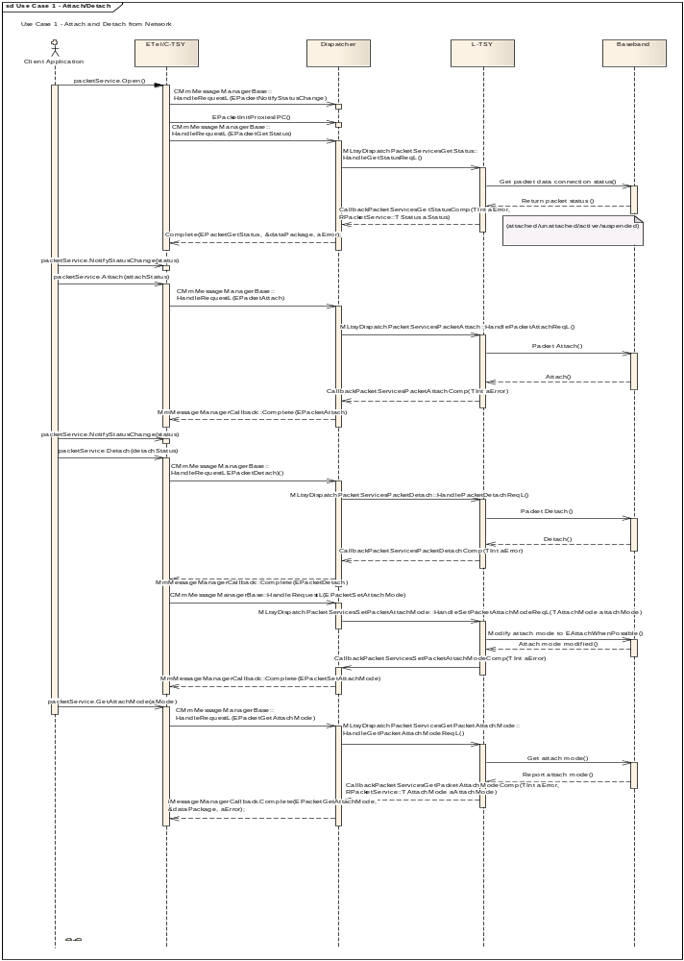
class MLtsyDispatchPacketServicesPacketAttach : public virtual MLtsyDispatchInterface
{
public:
static const TInt KLtsyDispatchPacketServicesPacketAttachApiId = KDispatchPacketServicesFuncUnitId + 1;

/**
* The CTSY Dispatcher shall invoke this function on receiving the EPacketAttach
* request from the CTSY.
*
* It is a request call that is completed by invoking
* CCtsyDispatcherCallback::CallbackPacketServicesPacketAttachComp()
*
* Implementation of this interface should issue an attach request to the LTSY.
*
* @return KErrNone on success, otherwise another error code indicating the
* failure.
*/
virtual TInt HandlePacketAttachReqL() = 0;

}; // class MLtsyDispatchPacketServicesPacketAttach

class MLtsyDispatchPacketServicesGetPacketAttachMode : public virtual MLtsyDispatchInterface
{
public:
static const TInt KLtsyDispatchPacketServicesGetPacketAttachModeApiId = KDispatchPacketServicesFuncUnitId + 2;
/**
* The CTSY Dispatcher shall invoke this function on receiving the EPacketGetAttachMode
* request from the CTSY.
*
* It is a request call that is completed by invoking
* CCtsyDispatcherCallback::CallbackPacketServicesGetPacketAttachModeComp()
*
* Implementation of this interface will return the attach mode. However if the call is
* being made during a packet service open process it will skip the get attach mode call.
*
* @return KErrNone on success, otherwise another error code indicating the
* failure.
*/
virtual TInt HandleGetPacketAttachModeReqL() = 0;

}; // class MLtsyDispatchPacketServicesGetPacketAttachMode
class MLtsyDispatchPacketServicesPacketDetach : public virtual MLtsyDispatchInterface
{
public:

static const TInt KLtsyDispatchPacketServicesPacketDetachApiId = KDispatchPacketServicesFuncUnitId + 4;

/**
* The CTSY Dispatcher shall invoke this function on receiving the EPacketDetach
* request from the CTSY.
*
* It is a request call that is completed by invoking
* CCtsyDispatcherCallback::CallbackPacketServicesPacketDetachComp()
*
* Implementation of this interface should issue a detach request from the LTSY.
*
* @return KErrNone on success, otherwise another error code indicating the
* failure.
*/
virtual TInt HandlePacketDetachReqL() = 0;

}; // class MLtsyDispatchPacketServicesPacketDetach

void CallbackPacketServicesGetStatusComp(TInt aError, RPacketService::TStatus aPacketStatus);
/**
*
* Callback function to be used by the Licensee LTSY to complete a pending
* MLtsyDispatchPacketServicesDeactivatePdpContext::HandleGetStatusReqL
*
*
* @param aError The error code to be returned to the CTSY Dispatcher.
* @param aPacketStatus The packet status as return from the ltsy
*
* @see RPacketService::GetStatus()
*/
void CallbackPacketServicesPacketAttachComp(TInt aError);
/**
*
* Callback function to be used by the Licensee LTSY to complete a pending
* MLtsyDispatchPacketServicesPacketAttach::HandlePacketAttachReqL()
*
*
* @param aError The error code to be returned to the CTSY Dispatcher.
*/
void CallbackPacketServicesPacketDetachComp(TInt aError);
/**
*
* Callback function to be used by the Licensee LTSY to complete a pending
* MLtsyDispatchPacketServicesPacketDetach::HandlePacketDetachReqL()
*
*
* @param aError The error code to be returned to the CTSY Dispatcher.
*
*/
void CallbackPacketServicesSetPacketAttachModeComp(TInt aError);
/**
*
* Callback function to be used by the Licensee LTSY to complete a pending
* MLtsyDispatchPacketServicesSetPacketAttachMode::HandleSetPacketAttachModeReqL()
*
* @param aError The error code to be returned to the CTSY Dispatcher.
*
* @see RPacketService::SetAttachMode()
*/

Use Case 2 : Set Default Configuration
- Set default configuration, either GPRS, R99 or R5
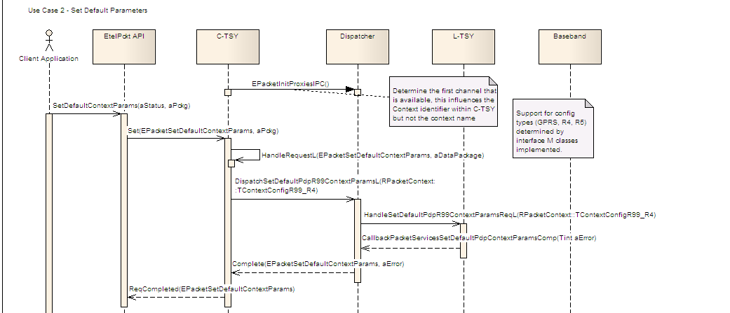
class MLtsyDispatchPacketServicesSetDefaultPdpContextGprsParams : public virtual MLtsyDispatchInterface
{
public:
static const TInt KLtsyDispatchPacketServicesSetDefaultPdpContextGprsParamsApiId = KDispatchPacketServicesFuncUnitId + 11;
/**
* The CTSY Dispatcher shall invoke this function on receiving the EPacketSetDefaultContextParams
* request from the CTSY.
*
* It is a request call that is completed by invoking
* CCtsyDispatcherCallback::CallbackPacketServicesSetDefaultPdpContextParamsComp()
*
*
* Implementation of this interface should set default configuration for Packet Context using GPRS params.
*
* @param aContextConfigGprs GPRS configuration input parameters.
*
* @return KErrNone on success, otherwise another error code indicating the
* failure.
*/
virtual TInt HandleSetDefaultPdpContextGprsParamsReqL(const RPacketContext::TContextConfigGPRS& aContextConfigGprs) = 0;

}; // class MLtsyDispatchPacketServicesSetDefaultPdpContextGprsParams

void CallbackPacketServicesSetDefaultPdpContextParamsComp(TInt aError);
/**
*
* Callback function to be used by the Licensee LTSY to complete a pending
* MLtsyDispatchPacketServicesSetDefaultPdpContextParams::HandleSetDefaultPdpContextParamsReqL()
*
*
* @param aError The error code to be returned to the CTSY Dispatcher.
*
* @see Link to all relevant the Etel client side APIs here, put () at the end
*/

Use Case 3 : Activation - Initialise Context
- Initialise the context, determine the port name.
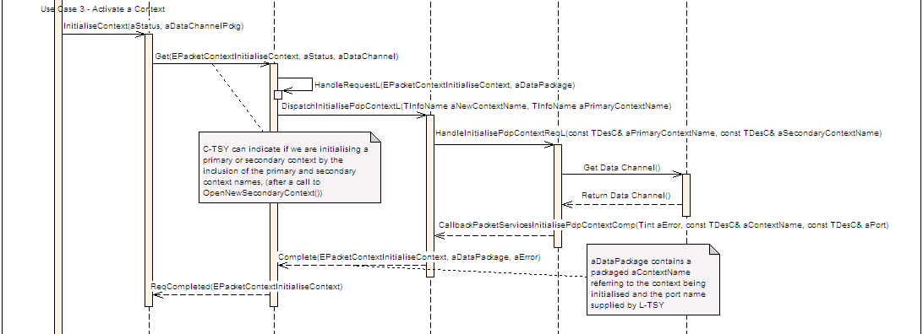
class MLtsyDispatchPacketServicesInitialisePdpContext : public virtual MLtsyDispatchInterface
{
public:
static const TInt KLtsyDispatchPacketServicesInitialisePdpContextApiId = KDispatchPacketServicesFuncUnitId + 7;
/**
* The CTSY Dispatcher shall invoke this function on receiving the EPacketContextInitialiseContext
* request from the CTSY.
*
* It is a request call that is completed by invoking
* CCtsyDispatcherCallback::CallbackPacketServicesInitialisePdpContextComp()
*
* Implementation of this interface should initialise either primary or secondary contexts
*
*
* @param aPrimaryContextName Primary context name in the form of a character string, the descriptor should be TBuf<10>
* @param aSecondaryContextName Optional secondary context name in the form of a character string, the descriptor should be TBuf<10>
*
* @return KErrNone on success, otherwise another error code indicating the
* failure.
*/
virtual TInt HandleInitialisePdpContextReqL(const TDesC& aPrimaryContextName, const TDesC& aSecondaryContextName) = 0;
}; // class MLtsyDispatchPacketServicesInitialisePdpContext
EXPORT_C void CCtsyDispatcherCallback::CallbackPacketServicesInitialisePdpContextComp(
TInt aError,
const TDesC& aContextName,
const TDesC& aPort)
/**
*
* Callback function to be used by the Licensee LTSY to complete a pending
* MLtsyDispatchPacketServicesInitialisePdpContext::HandleInitialisePdpContextReqL()
*
* Complete initialisation of the context indicating the context name and port.
*
* @param aError KErrNone on success, or another error code indicating the error otherwise.
* @param aContextName The name of the current context, the descriptor should be TBuf<10>
* @param aPort The current port descriptor, the descriptor should be a TName
* @see RPacketServise::InitialiseContext()
*/

Use Case 3 : Activation - Set Configuration
- Set context configuration, include PCO buffer
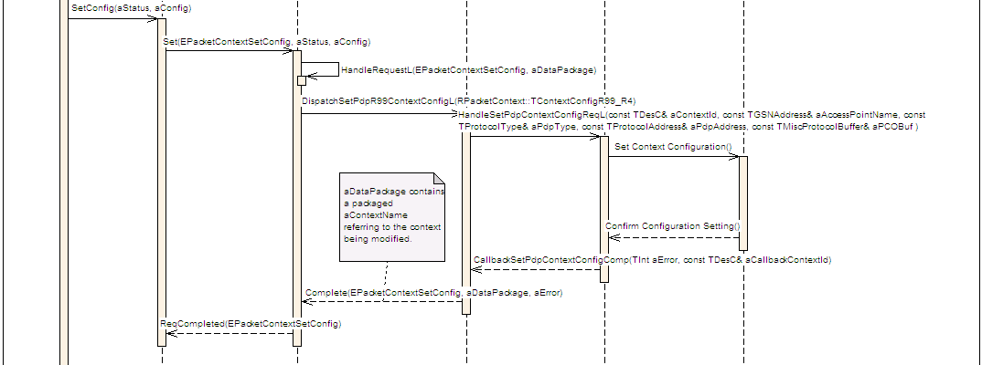
class MLtsyDispatchPacketServicesSetPdpContextConfig : public virtual MLtsyDispatchInterface
{
public:
static const TInt KLtsyDispatchPacketServicesSetPdpContextConfigApiId = KDispatchPacketServicesFuncUnitId + 5;
/**
* The CTSY Dispatcher shall invoke this function on receiving the EPacketContextSetConfig
* request from the CTSY.
*
* It is a request call that is completed by invoking
* CCtsyDispatcherCallback::CallbackPacketServicesSetPdpContextConfigComp()
*
* Implementation of this interface should pass LTSY the parameters it needs to set the
* context configuration
*
*
* @param contextId The context name, the maximum length of the descriptor should not
* exceed KMaxInfoName.
* @param iAccessPointName the access name which identifies the GGSN to be used
* @param iPdpType the protocol type
* @param iPdpAddress the PDP address for this context
* @param aPcoBuffer the pco buffer
*
* @return KErrNone on success, otherwise another error code indicating the
* failure.
*/
virtual TInt HandleSetPdpContextConfigReqL(const TDesC& aContextId,
const RPacketContext::TGSNAddress& aAccessPointName,
const RPacketContext::TProtocolType aPdpType,
const RPacketContext::TProtocolAddress& aPdpAddress,
const RPacketContext::TMiscProtocolBuffer& aPcoBuffer) = 0;

}; // class MLtsyDispatchPacketServicesSetPdpContextConfig

void CallbackPacketServicesSetPdpContextConfigComp(TInt aError, const TDesC& aContextName);

/**
*
* Callback function to be used by the Licensee LTSY to complete a pending
* MLtsyDispatchPacketServicesSetPdpContextConfig::HandleSetPdpContextConfigReqL()
*
*
* @param aError The error code to be returned to the CTSY Dispatcher.
* @param aContextName the context name that was configured, the maximum length of the
* descriptor should not exceed KMaxInfoName.
*/

Use Case 3 : Activation - Set QoS
- Set QoS profile parameters
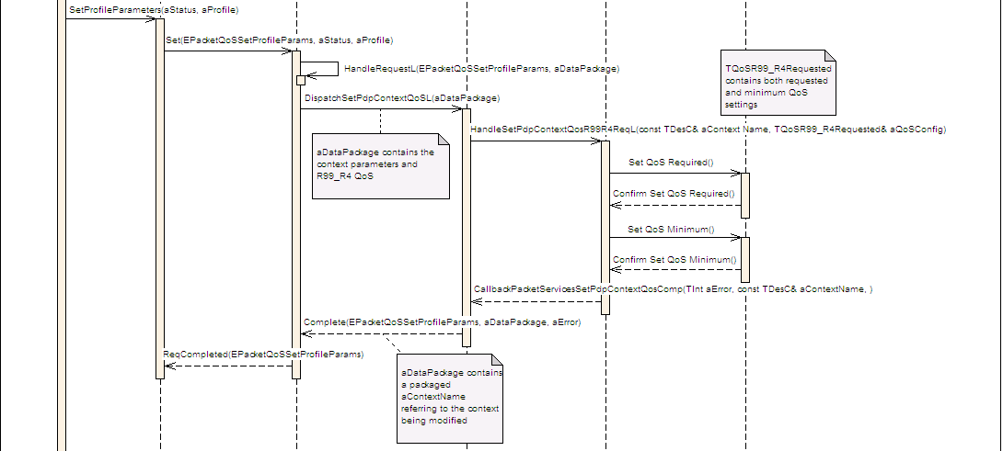
class MLtsyDispatchPacketServicesSetPdpContextQosGprs : public virtual MLtsyDispatchInterface
{
public:

static const TInt KLtsyDispatchPacketServicesSetPdpContextQosGprsApiId = KDispatchPacketServicesFuncUnitId + 14;

/**
* The CTSY Dispatcher shall invoke this function on receiving the EPacketQoSSetProfileParams
* request from the CTSY.
*
* It is a request call that is completed by invoking
* CCtsyDispatcherCallback::CallbackPacketServicesSetPdpContextQosComp()
*
* Implementation of this interface should set GPRS QoS parametes for the given context.
*
*
* @param aContextName the name of the context, the maximum length of the descriptor
* should not exceed KMaxInfoName.
* @param aQoSConfig the QoS configuration parameters.
*
* @return KErrNone on success, otherwise another error code indicating the
* failure.
*/
virtual TInt HandleSetPdpContextQosGprsReqL(const TDesC& aContextName, const RPacketQoS::TQoSGPRSRequested& aQoSConfig) = 0;

}; // class MLtsyDispatchPacketServicesSetPdpContextQosGprs

void CallbackPacketServicesSetPdpContextQosComp(TInt aError, const TDesC& aContextName);
/**
*
* Callback function to be used by the Licensee LTSY to complete one of the following pending
* MLtsyDispatchPacketServicesSetPdpContextQosGprs::HandleSetPdpContextQosReqL()
* MLtsyDispatchPacketServicesSetPdpContextQosR99R4::HandleSetPdpContextQosReqL()
* MLtsyDispatchPacketServicesSetPdpContextQosR5::HandleSetPdpContextQosReqL()
*
*
* @param aError The error code to be returned to the CTSY Dispatcher.
* @param aContextName The context name, the maximum length of the descriptor should not
* exceed KMaxInfoName.
* @see RPacketQoS::SetProfileParameters.
*/

Use Case 3 : Activation – Activating/Activated
- Request Activation
- Determine negotiated QoS settings
- Confirm context configuration
- Modify connection speed.
- Move to Active state.
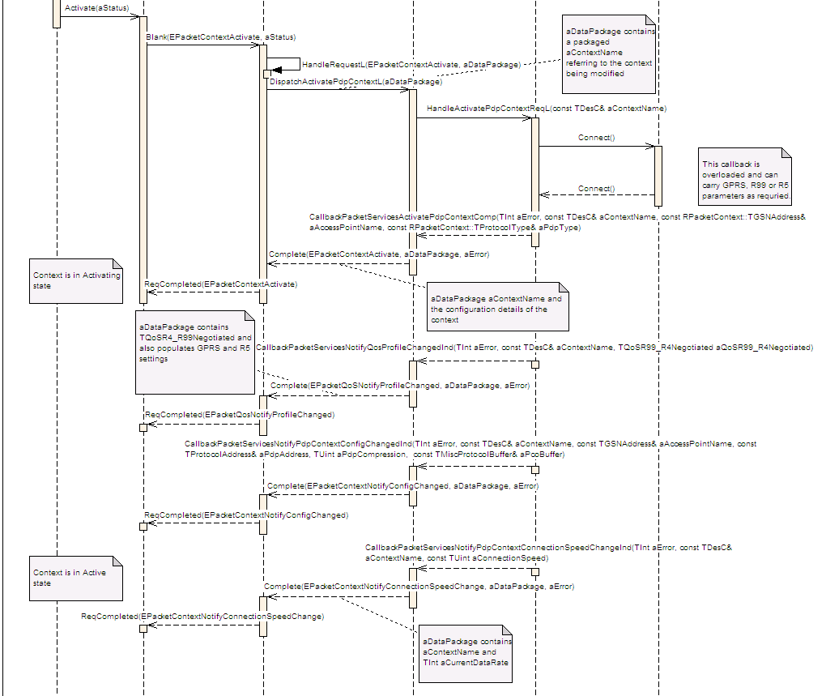
class MLtsyDispatchPacketServicesActivatePdpContext : public virtual MLtsyDispatchInterface
{
public:

static const TInt KLtsyDispatchPacketServicesActivatePdpContextApiId = KDispatchPacketServicesFuncUnitId + 13;

/**
* The CTSY Dispatcher shall invoke this function on receiving the EPacketContextActivate
* request from the CTSY.
*
* It is a request call that is completed by invoking
* CCtsyDispatcherCallback::CallbackPacketServicesActivatePdpContextComp()
*
* Implementation of this interface should activate the context given.
*
* @param aContextName the context name.
*
* @return KErrNone on success, otherwise another error code indicating the
* failure.
*/
virtual TInt HandleActivatePdpContextReqL(const TDesC& aContextName) = 0;

}; // class MLtsyDispatchPacketServicesActivatePdpContext

void CallbackPacketServicesActivatePdpContextComp(TInt aError, const TDesC& aContextName, const RPacketContext::TGSNAddress& aAccessPointName, const RPacketContext::TProtocolType aPdpType);
/**
*
* Callback function to be used by the Licensee LTSY to complete a pending
* MLtsyDispatchPacketServicesActivatePdpContext::HandleActivatePdpContextReqL()
*
* @param aError The error code to be returned to the CTSY Dispatcher.
* @param aContextName The name of the context.
* @param aAccessPointName The access point name of the context
* @param aPdpType The pdp type of the context.
*
* @see RPacketContext:Activate()
*/
void CallbackPacketServicesNotifyQosProfileChangedGPRSInd(TInt aError, const TDesC& aContextName, RPacketQoS::TQoSGPRSNegotiated* aQoSGPRSNegotiated);
/**
*
* Callback function to be used by the Licensee LTSY to notify change in the GPRS QoS profile (IPCEPacketQoSNotifyProfileChanged).
*
*
* @param aError The error code to be returned to the CTSY Dispatcher.
* @param aContextName the context name.
* @param aQoSGPRSNegotiated context negotiated GPRS QOS profile to be returned to the CTSY Dispatcher.
*
* @see RPacketQoS::NotifyProfileChanged()
*
*/
void CallbackPacketServicesNotifyPdpContextConfigChangedInd(TInt aError, const TDesC& aContextName, const RPacketContext::TGSNAddress& aAccessPointName, const RPacketContext::TProtocolAddress& aPdpAddress, const TUint aPdpCompression, const RPacketContext::TMiscProtocolBuffer& aPcoBuffer);
/**
* Callback function to be used by the Licensee LTSY to notify change in the context
* configuration (IPC EPacketContextNotifyConfigChanged)
*
* @param aError The error code.
*
* @param aContextName The name of the context which the change in configuration refers to.
*
* @param aAccessPointName The name of the access point. This should be a descriptor of maximum length
* RPacketContext::KGSNNameLength such as a RPacketContext::TGSNAddress
*
* @param aPdpAddress The protocol address. This should be a descriptor of maximum length
* RPacketContext::KMaxPDPAddressLength such as a RPacketContext::TProtocolAddress
*
* @param aPdpCompression The PDP compression level.
*
* @param aPcoBuffer The PCO buffer. This should be a descriptor of maximum length
* RPacketContext::KMiscProtocolBufferLength such as a RPacketContext::TMiscProtocolBuffer
*
* @see RPacketContext::NotifyConfigChanged()
*/
void CallbackPacketServicesNotifyPdpContextConnectionSpeedChangeInd(TInt aError, const TDesC& aContextName, const TUint aConnectionSpeed);
/**
*
* Callback function to be used by the Licensee LTSY to notify context connection speed change (IPC EPacketContextNotifyConnectionSpeedChange).
*
* @param aError The error code to be returned.
* @param aContextName context name.
* @param aConnectionSpeed context connection speed in bits per second.
*/

User Case 4 : Modify Existing Context
- Set new configuration
- Invoke modification to use new context
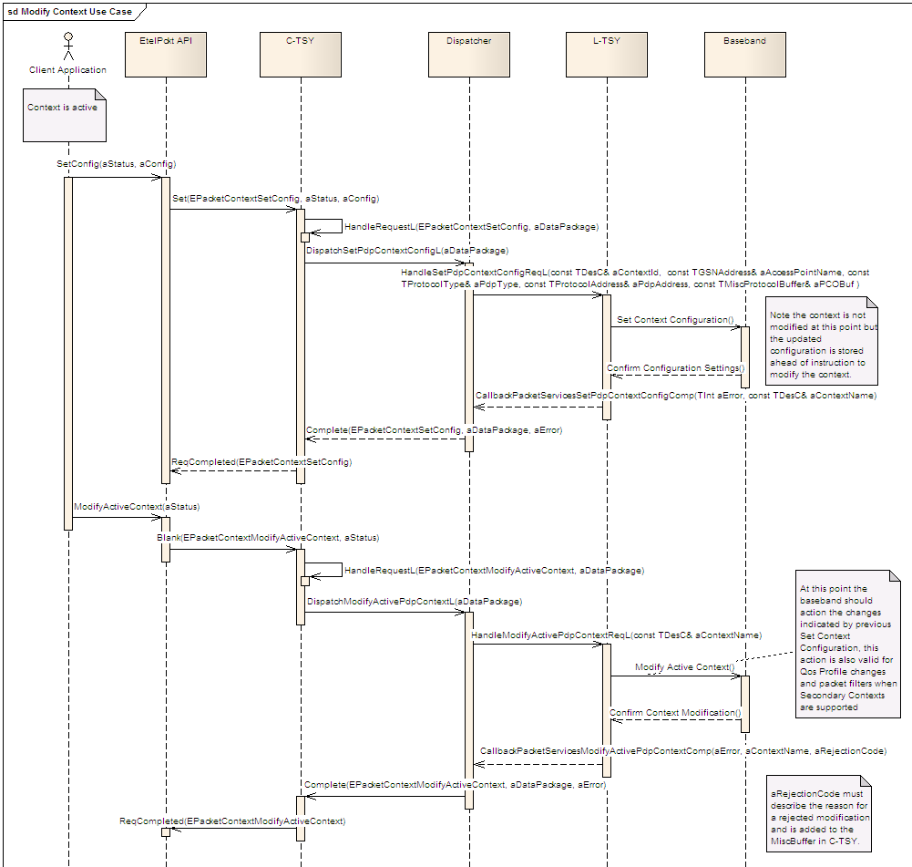
class MLtsyDispatchPacketServicesModifyActivePdpContext : public virtual MLtsyDispatchInterface
{
public:

static const TInt KLtsyDispatchPacketServicesModifyActivePdpContextApiId = KDispatchPacketServicesFuncUnitId + 6;

/**
* The CTSY Dispatcher shall invoke this function on receiving the EPacketContextModifyActiveContext
* request from the CTSY.
*
* It is a request call that is completed by invoking
* CCtsyDispatcherCallback::CallbackPacketServicesModifyActivePdpContextComp()
*
* Implementation of this interface should signal to the Licensee TSY that it can action the modification
* of an existing context, the changes being indicated via appropriate RPacketContext::SetConfig and
* RPacketContext::SetProfileParameters calls
*
* @param aContextName Context name for which the modification is intended
*
* @return KErrNone on success, otherwise another error code indicating the
* failure.
*/
virtual TInt HandleModifyActivePdpContextReqL(const TDesC& aContextName) = 0;
}; // class MLtsyDispatchPacketServicesModifyActivePdpContext

void CallbackPacketServicesModifyActivePdpContextComp(TInt aError, const TDesC& aContextName, TInt8 aRejectionCode);
/**
*
* Callback function to be used by the Licensee LTSY to complete a pending
* MLtsyDispatchPacketServicesModifyActivePdpContext::HandleModifyActivePdpContextReqL()
*
*
* @param aError The error code to be returned to the CTSY Dispatcher.
* @param aContextName The context name that has been modified.
* @param aRejectionCode The reason code for any failure of modification.
*
* @see RPacketContext::ModifyActiveContext
*/

User Case 5: Two Contexts Activation
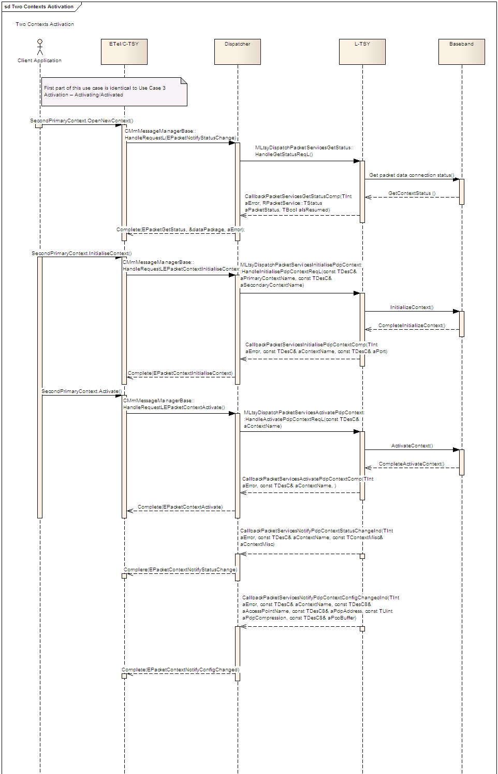

User Case 6: Secondary Context Activation
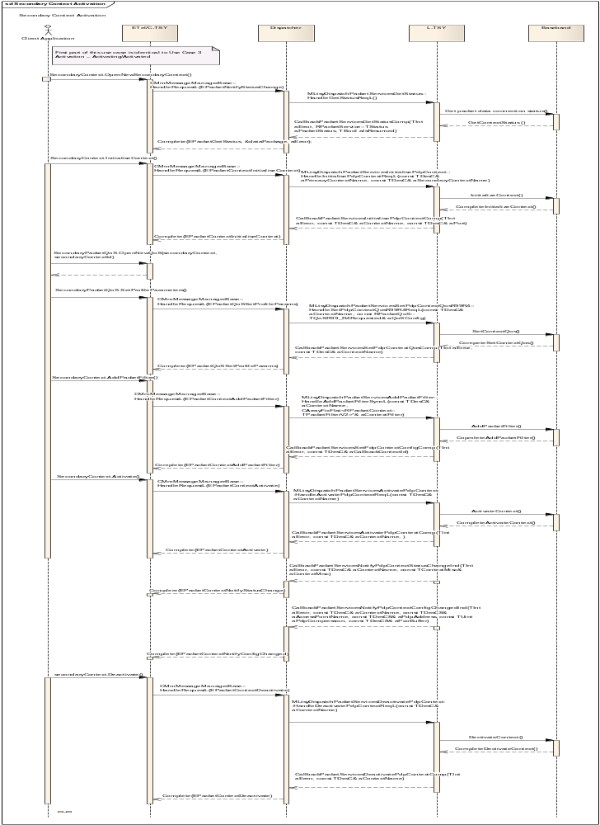

class MLtsyDispatchPacketServicesAddPacketFilter : public MLtsyDispatchInterface
{
public:

static const TInt KLtsyDispatchPacketServicesAddPacketFilterApiId = KDispatchPacketServicesFuncUnitId + 19;

/**
* The CTSY Dispatcher shall invoke this function on receiving the EPacketContextAddPacketFilter
* request from the CTSY.
* Implementation of this interface should add a packet filter to the packet service.
*
* It is a request call that is completed by invoking
* CCtsyDispatcherCallback::CallbackPacketServicesSetPdpContextConfigComp()
*
* @param aContextName The name of the context, the maximum length of the
* descriptor should not exceed KMaxInfoName.
* @param aContextFilter An array contains up to eight filters to be used
* for configuring the secondary context.
*
* @return KErrNone on success, otherwise another error code indicating the
* failure.
*/
virtual TInt HandleAddPacketFilterSyncL(const TDesC& aContextName, CArrayFixFlat<RPacketContext::TPacketFilterV2>& aContextFilter) = 0;

}; // class MLtsyDispatchPacketServicesAddPacketFilter

User Case 7: Secondary Context Activation - Remove Packet Filter
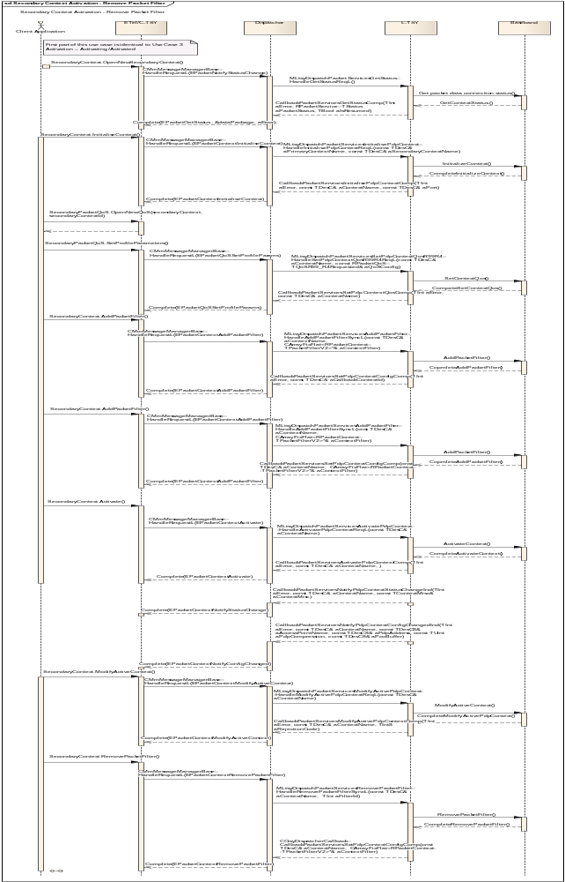

class MLtsyDispatchPacketServicesRemovePacketFilter : public MLtsyDispatchInterface
{
public:

static const TInt KLtsyDispatchPacketServicesRemovePacketFilterApiId = KDispatchPacketServicesFuncUnitId + 28;
/**
* The CTSY Dispatcher shall invoke this function on receiving the EPacketContextRemovePacketFilter
* request from the CTSY.
* Implementation of this interface should remove a packet filter from the packet service.
*
* It is a request call that is completed by invoking
* CCtsyDispatcherCallback::CallbackPacketServicesSetPdpContextConfigComp()
*
* @param aContextName The name of the context, the maximum length of the
* descriptor should not exceed KMaxInfoName.
* @param aFilterId The filter Id to remove.
*
* @return KErrNone on success, otherwise another error code indicating the
* failure.
*/
virtual TInt HandleRemovePacketFilterSyncL(const TDesC& aContextName, TInt aFilterId) = 0;

}; // class MLtsyDispatchPacketServicesRemovePacketFilter

Unit Test 19: Initialise MBMS Context
- Initialise the MBMS Context
- Update the MBMS configuration

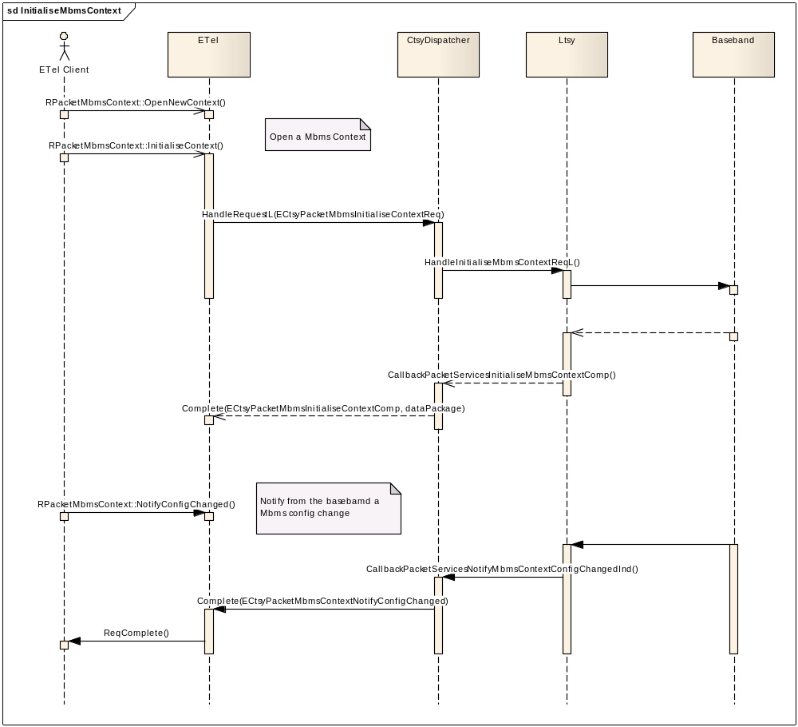
class MLtsyDispatchPacketServicesInitialiseMbmsContext : public MLtsyDispatchInterface
{
public:

static const TInt KLtsyDispatchPacketServicesInitialiseMbmsContextApiId = KDispatchPacketServicesFuncUnitId + 24;

/**
* The CTSY Dispatcher shall invoke this function on receiving the ECtsyPacketMbmsInitialiseContextReq
* request from the CTSY.
*
* It is a request call that is completed by invoking
* CCtsyDispatcherCallback::CallbackPacketServicesInitialiseMbmsContextComp()
*
* Implementation of this interface should initialise the Mbms Context
* (Multimedia Broadcast Multicast Service).
*
* @param aContextName The context name in the form of a character string
* the maximum length of the descriptor should not exceed KMaxInfoName.
*
*
* @return KErrNone on success, otherwise another error code indicating the
* failure.
*
* @see RPacketMbmsContext::InitialiseContext()
*/
virtual TInt HandleInitialiseMbmsContextReqL(const TDesC& aContextName) = 0;

}; // class MLtsyDispatchPacketServicesInitialiseMbmsContext

void CCtsyDispatcherCallback::CallbackPacketServicesInitialiseMbmsContextComp(
TInt aError, const TDesC& aContextName, const TDesC& aChannelId)
/**
*
* Callback function to be used by the Licensee LTSY to complete a pending
* MLtsyDispatchPacketServicesInitialiseMbmsContext::HandleInitialiseMbmsContextReqL()
*
* Returns the MBMS data to the CTSY.
*
* @param aError The error code.
* @param aContextName The name of the current context, the descriptor should be a maximum length of KMaxInfoName.
* @param aChannelId The current channelId descriptor, the descriptor should be a maximum length of KMaxName.
*
* @see RPacketMbmsContext::InitialiseContext()
*
*/

void CCtsyDispatcherCallback::CallbackPacketServicesNotifyMbmsContextConfigChangedInd(
TInt aError, const TDesC& aContextName, const RPacketMbmsContext::TContextConfigMbmsV1& aContextConfigMbms)
/**
*
* Callback function to be used by the Licensee LTSY to notify the Mbms configuration has
* changed on a given context. (IPC ECtsyPacketMbmsContextNotifyConfigChanged).
*
* Pending client side RPacketMbmsContext::NotifyConfigChanged() will be completed with the new
* configuration data.
*
* @param aError The error code to be returned.
* @param aContextName The context name.
* @param aContextConfigMbms The context configuration data.
*
* @see RPacketMbmsContext::NotifyConfigChanged()
*/

Unit Test 20: Get MBMS network service status
- Get the MBMS network service status
- Notify of a MBMS network service status change

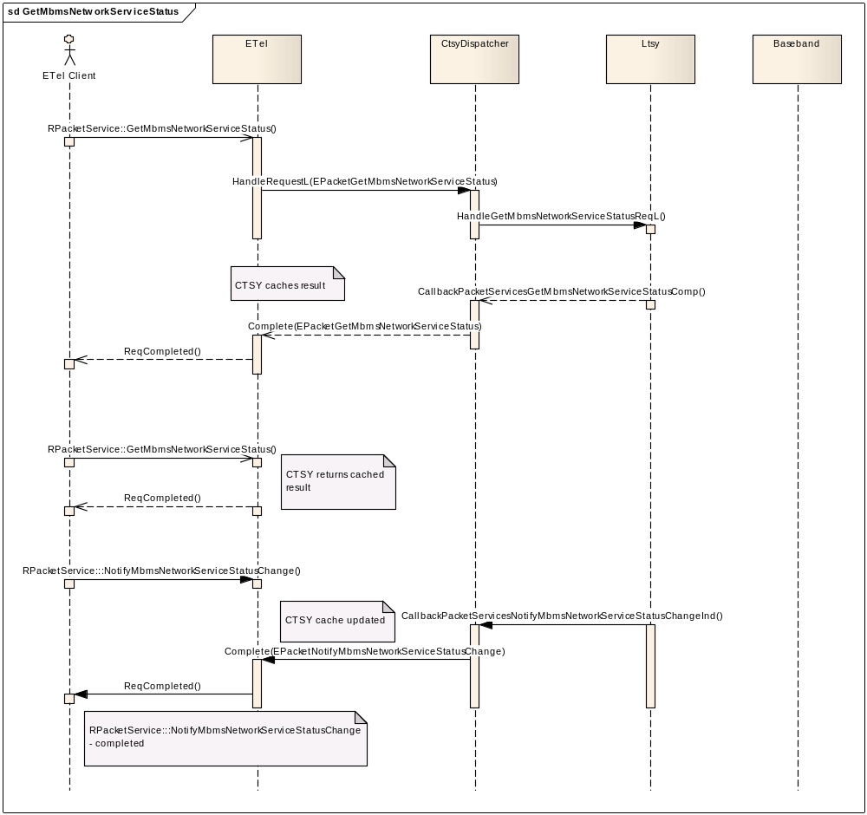

class MLtsyDispatchPacketServicesGetMbmsNetworkServiceStatus : public MLtsyDispatchInterface
{
public:

static const TInt KLtsyDispatchPacketServicesGetMbmsNetworkServiceStatusApiId = KDispatchPacketServicesFuncUnitId + 25;

/**
* The CTSY Dispatcher shall invoke this function on receiving the EPacketGetMbmsNetworkServiceStatus
* request from the CTSY.
*
* It is a request call that is completed by invoking
* CCtsyDispatcherCallback::CallbackPacketServicesGetMbmsNetworkServiceStatusComp()
*
* Implementation of this interface should retrieve the current MBMS
* (Multimedia Broadcast Multicast Service) network state.
*
* There can be 3 states that MBMS feature availability could return,
* Unknown - when UE is not GMM Attached.
* Supported - When UE is GMM Attached and it is known that cell supports MBMS.
* Not Supported - When UE is GMM Attached and it is know that cell does not support MBMS.
*
* The state is only known from GMM Attach response from the network or during a Routing Area update.
* A consequence of this is that it is required for the UE to be in GMM Attach mode in order
* for either of these messages to be received. If the UE is not in GMM ATTACH then it is unable
* to determine MBMS network support.
*
* @param aAttemptAttach If a GMM attached is to be performed.
*
* @return KErrNone on success, otherwise another error code indicating the
* failure.
*
* @see RPacketService::GetMbmsNetworkServiceStatus()
*/
virtual TInt HandleGetMbmsNetworkServiceStatusReqL(TBool aAttemptAttach) = 0;

}; // class MLtsyDispatchPacketServicesInitialiseMbmsContext

void CCtsyDispatcherCallback::CallbackPacketServicesGetMbmsNetworkServiceStatusComp(
TInt aError, TMbmsNetworkServiceStatus aMbmsNetworkServiceStatus)
/**
*
* Callback function to be used by the Licensee LTSY to complete a pending
* MLtsyDispatchPacketServicesGetMbmsNetworkServiceStatus::HandleGetMbmsNetworkServiceStatusReqL()
*
* The CTSYs cache of the network service state will be updated and a pending client side
* RPacketService::GetMbmsNetworkServiceStatus() will be completed.
*
* @param aError The error code to be returned.
* @param aMbmsNetworkServiceStatus The network service status.
*
* @see RPacketService::GetMbmsNetworkServiceStatus()
*
*/

void CCtsyDispatcherCallback::CallbackPacketServicesNotifyMbmsNetworkServiceStatusChangeInd(
TInt aError, TMbmsNetworkServiceStatus aMbmsNetworkServiceStatus)
/**
*
* Callback function to be used by the Licensee LTSY to update the CTSY's cache of the current
* Mbms network service state (IPC EPacketNotifyMbmsNetworkServiceStatusChange).
*
* This will result in the completion on a pending client side RPacketService::NotifyMbmsNetworkServiceStatusChange()
*
* @param aError The error code to be returned.
* @param aMbmsNetworkServiceStatus The network service status.
*
* @see RPacketService::NotifyMbmsNetworkServiceStatusChange()
* @see RPacketService::GetMbmsNetworkServiceStatus()
*/

Unit Test 21 & 22: Update the MBMS monitored service list & Update the MBMS Session List
- Update the MBMS monitored service list
- Notify of a service availability change

(Note update the MBMS session list mirrors the update of the monitored service list and thus is not documented here)
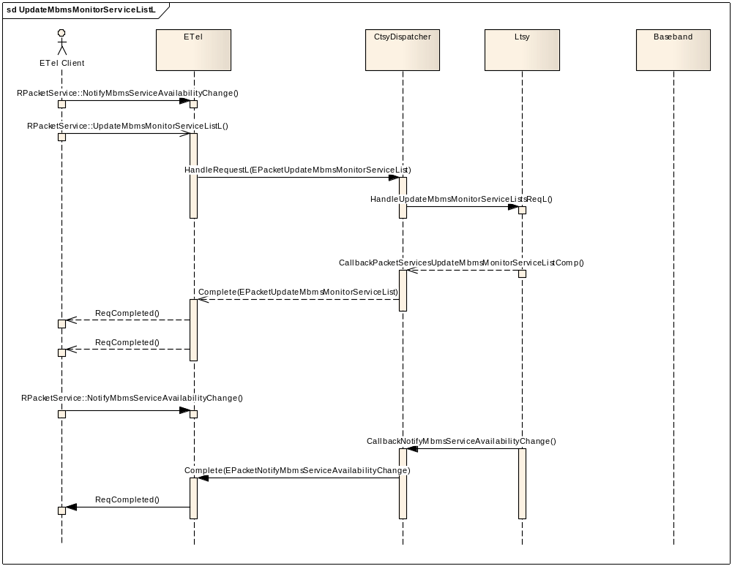

class MLtsyDispatchPacketServicesUpdateMbmsMonitorServiceList : public MLtsyDispatchInterface
{
public:

static const TInt KLtsyDispatchPacketServicesUpdateMbmsMonitorServiceListApiId = KDispatchPacketServicesFuncUnitId + 26;

/**
* The CTSY Dispatcher shall invoke this function on receiving the EPacketUpdateMbmsMonitorServiceList
* request from the CTSY.
*
* It is a request call that is completed by invoking
* CCtsyDispatcherCallback::CallbackPacketServicesUpdateMbmsMonitorServiceListComp()
*
* Implementation of this interface should request to update the MBMS (Multimedia Broadcast Multicast Service)
* monitor service availability list with the change list entries as per the action mentioned.
* The CTSY stores the monitor service availability list, this list is updated on a successful completion.
*
* @param aAction The MBMS action (add, remove or remove all).
* @param aServiceList The current MBMS monitor service availability list as held by the CTSY.
* @param aChangeList The list of entries to be changed as per the action. (e.g. the action = Add,
* the change list will contain entries to be added to the MBMS monitor service availability list)
*
* @return KErrNone on success, otherwise another error code indicating the
* failure.
*
* @see RPacketService::UpdateMbmsMonitorServiceListL()
* @see RPacketService::NotifyMbmsServiceAvailabilityChange()
* @see CRetrievePcktMbmsMonitoredServices()
*/
virtual TInt HandleUpdateMbmsMonitorServiceListsReqL(TMbmsAction aAction, const CPcktMbmsMonitoredServiceList& aServiceList, const CPcktMbmsMonitoredServiceList& aChangeList) = 0;

}; // class MLtsyDispatchPacketServicesUpdateMbmsMonitorServiceList

void CCtsyDispatcherCallback::CallbackPacketServicesUpdateMbmsMonitorServiceListComp(TInt aError)
/**
*
* Callback function to be used by the Licensee LTSY to complete a pending
* MLtsyDispatchPacketServicesUpdateMbmsMonitorServiceList::HandleUpdateMbmsMonitorServiceListsReqL()
*
* This callback is for the success case. The CTSYs monitor service list will be updated as via the
* change list and action.
*
* The pending client side RPacketService::NotifyMbmsServiceAvailabilityChange() will be completed with
* KErrNone.
*
* @param aError The error code to be returned.
*
* @see RPacketService::UpdateMbmsMonitorServiceListL()
* @see RPacketService::NotifyMbmsServiceAvailabilityChange()
* @see CRetrievePcktMbmsMonitoredServices()
*
*/

void CCtsyDispatcherCallback::CallbackPacketServicesNotifyMbmsServiceAvailabilityChangeInd(
TInt aError, const RArray<TUint>& aAvailableServiceIds)
/**
*
* Callback function to be used by the Licensee LTSY to update the CTSYs MBMS monitor service list availabilty state
* (IPC EPacketNotifyMbmsServiceAvailabilityChange).
*
* Services in the supplied list will be marked as available in the CTSYs MBMS monitor service list, services not in
* the list will be marked as un-available.
*
* This will result in the completion on a pending client side RPacketService::NotifyMbmsServiceAvailabilityChange()
*
* @param aError The error code to be returned.
* @param aAvailableServiceIds The list of Service Ids which are currently available.
*
* @see RPacketService::NotifyMbmsServiceAvailabilityChange
* @see CRetrievePcktMbmsMonitoredServices
*/

SAT Functional Unit
The request handlers that must be implemented by the LTSY are declared in mltsydispatchsatinterface.h.
The callback functions used to complete the call control requests and also any indicator callbacks are declared in cctsydispatchercallback.h in the section starting with the comment:

// Sat related callbacks

IMPORT_C void CallbackSatUssdControlSupportedChangeInd(TInt aError, TBool aSupported);
IMPORT_C void CallbackSatPcmdInd(TInt aError, const TDesC8& aData);
Etc..

Use Case 1 : Initialisation
This use case covers the APIs that are invoked during the initialisation of the SAT portion in the Common TSY. CTSY caches some values and sets up notification for certain Proactive Commands that are handled by the CTSY.
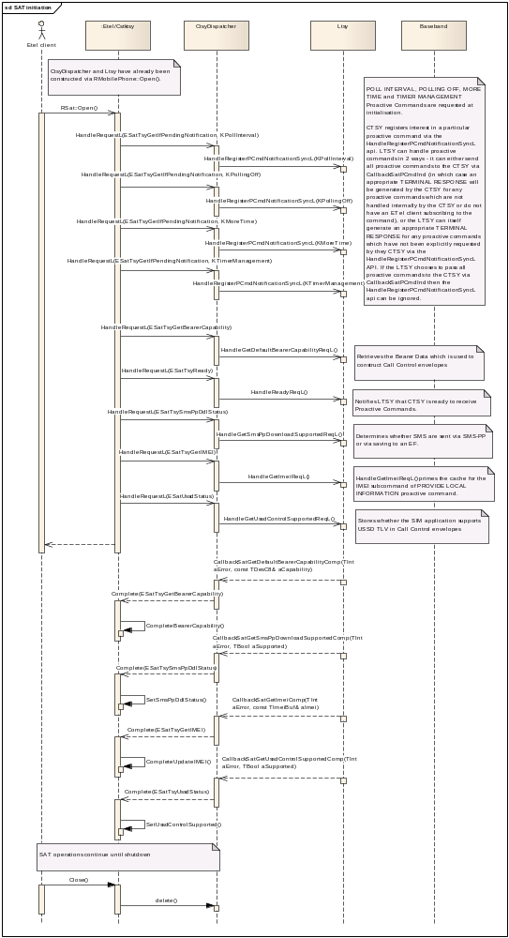

Implementation Notes
MLtsyDispatchSatGetMoSmsControlActivated::HandleGetMoSmsControlActivatedReqL should be completed with CCtsyDispatcherCallback::CallbackSatGetMoSmsControlActivatedComp.
MLtsyDispatchSatPCmdNotification::HandlePCmdNotificationReqL is used to set up notifications for the POLL INTERVAL, POLLING OFF, MORE TIME and TIMER MANAGEMENT Proactive Commands. Note that HandlePCmdNotificationReqL is an optional interface that is used to request notification of particular proactive commands but can be ignored depending upon the implementation of the LTSY: the LTSY may either pass all Proactive Commands directly to the CTSY which gives the CTSY responsibility for generating all terminal responses, or if the LTSY contains code that processes Proactive Commands then the LTSY may choose to send to the CTSY only the proactive commands for which notifications have been requested via the HandlePCmdNotificationReqL API, and in this case unhandled proactive commands (i.e. those for which no HandlePCmdNotificationReqL has been received) would require the LTSY to generate the appropriate TERMINAL RESPONSE.
If the LTSY chooses to send all Proactive Commands directly to the CTSY then the LTSY does not have to implement the HandlePCmdNotificationReqL interface, and the CTSY will generate the appropriate TERMINAL RESPONSE for any unhandled proactive commands.
MLtsyDispatchSatGetImei::HandleGetImeiReqL caches the IMEI for use in PROVIDE LOCAL INFO Proactive Commands and should be completed with CCtsyDispatcherCallback::CallbackSatGetImeiComp.
MLtsyDispatchSatGetDefaultBearerCapability::HandleGetDefaultBearerCapabilityReqL caches the bearer capability which is used to construct ENVELOPE (CALL CONTROL) and should be completed with CCtsyDispatcherCallback::CallbackSatGetDefaultBearerCapabilityComp.
MLtsyDispatchSatGetUssdControlSupported::HandleGetUssdControlSupportedReqL establishes whether USSD TLV strings are supported by the SIM in ENVELOPE (CALL CONTROL) and should be completed with CCtsyDispatcherCallback::CallbackSatGetUssdControlSuppportedComp.
Note that if the USSD TLV status schange during the operation of the phone, the CCtsyDispatcherCallback::CallbackSatUssdControlSupportedChangeInd indicator is used. This is an unsolicited notification from the LTSY to the CTSY.
MLtsyDispatchSatReady::HandleReadyReqL indicates that the CTSY is ready to process Proactive Commands and receive Indicator notifications from the LTSY.
MLtsyDispatchSatGetSmsPpDownloadSupported::HandleGetSmsPpDownloadSupportedReqL is used to ascertain whether data download via SMS Point-to-point" is allocated and activated in the SIM Service Table. It should be completed via CCtsyDispatcherCallback::CallbackSatGetSmsPpDownloadSupportedComp.

Use Case 2 : Sample Proactive Command Session with User interaction
This use case covers
- Reception of SET UP MENU proactive command and TERMINAL RESPONSE.
- MENU SELECTION envelope.
- DISPLAY TEXT proactive command and TERMINAL RESPONSE.
- SELECT ITEM proactive command.
See 3GPP TS 11.14 section 6 for further information about these Proactive Commands.
Note that MLtsyDispatchSatPCmdNotification::HandlePCmdNotificationReqL is an optional interface that is used to request notification of particular proactive commands but can be ignored depending upon the implementation of the LTSY: the LTSY may either pass all Proactive Commands directly to the CTSY which gives the CTSY responsibility for generating all terminal responses, or if the LTSY contains code that processes Proactive Commands then the LTSY may choose to send to the CTSY only the proactive commands for which notifications have been requested via the HandlePCmdNotificationReqL API, and in this case unhandled proactive commands (i.e. those for which no HandlePCmdNotificationReqL has been received) would require the LTSY to generate the appropriate TERMINAL RESPONSE.
If the LTSY chooses to send all Proactive Commands directly to the CTSY then the LTSY does not have to implement the HandlePCmdNotificationReqL interface, and the CTSY will generate the appropriate TERMINAL RESPONSE for any unhandled proactive commands.

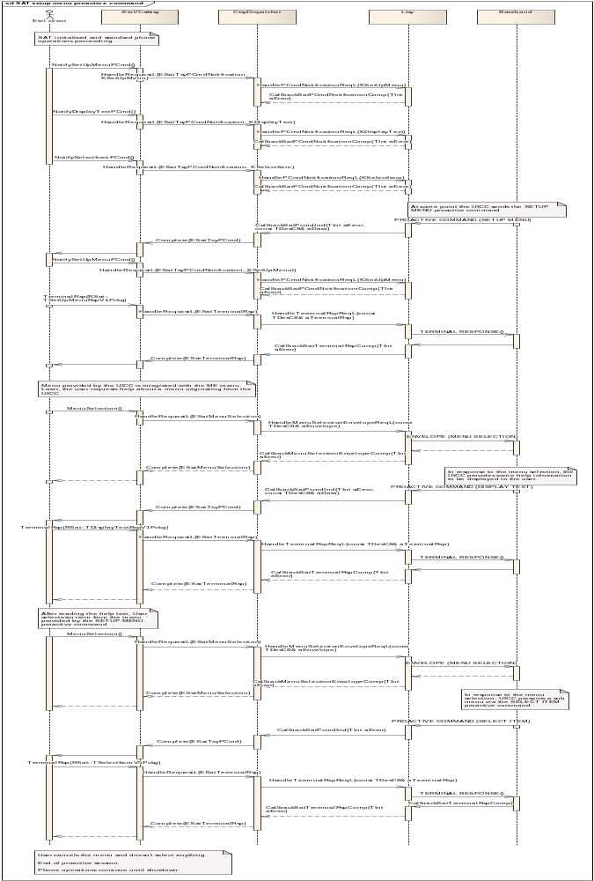

All proactive commands are sent to CTSY and CTSY generates TERMINAL RESPONSE for unhandled proactive commands.
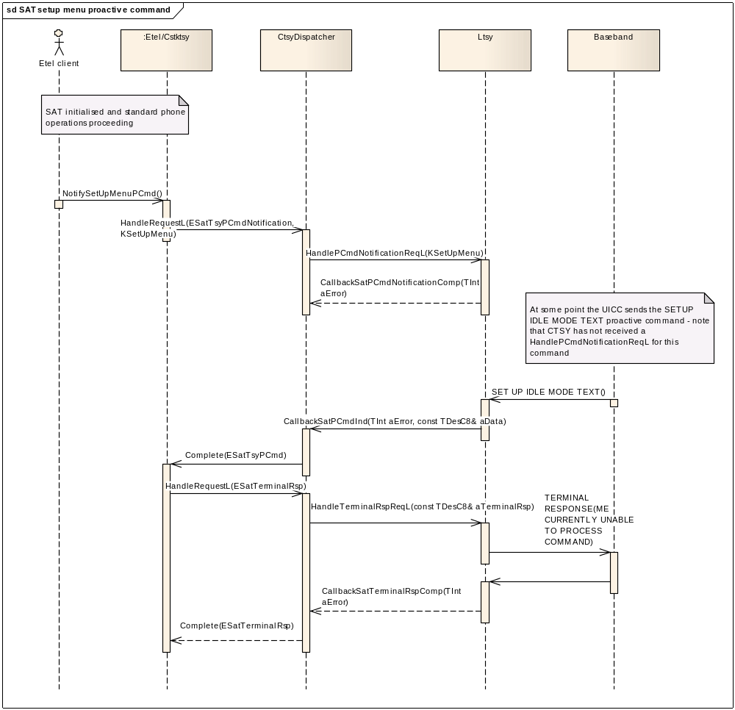

Only subscribed proactive commands are sent to CTSY and LTSY generates TERMINAL RESPONSE for unhandled proactive commands.
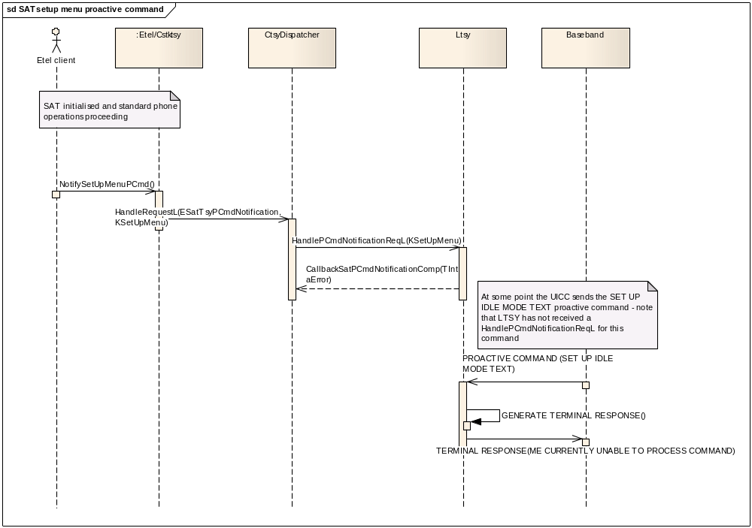

Use Case 3 : Getting Icon Ef(Img) records, Icon instances and Icon CLUTs
This use case covers
- Getting an icons Ef(Img) record based on the record number.
- Getting an icon image instance based on the record number and instance in the record.
- Getting the CLUT (Colour lookup table) for a given image instance.

Use Case 4 : Setting up the Event list, and example event download (User Activity)
This use case covers
- Receiving a Pro-Active command to setup the event list for notifications of a User Activity and sending the terminal response from the RSat client side.
- Sending a User Activity event from the client side and handling the event download envelope.
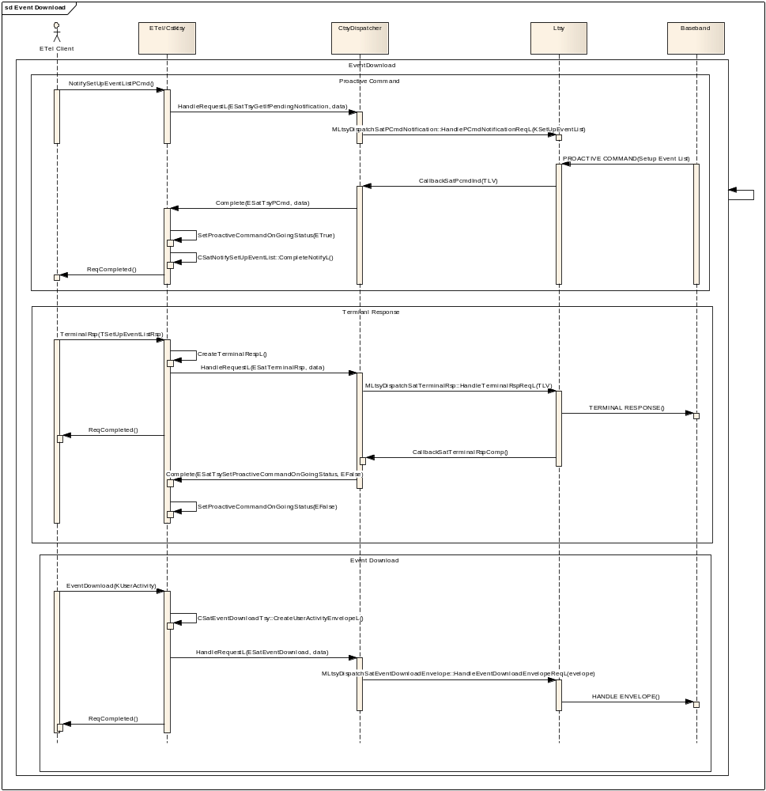

Use Case 5 : Call Control functionality
ETel/RSat client registers for notification of Call/SS/USSD control via RSat::NotifySetUpCallPCmd. The current implementation notifies a client of any strings that should be displayed to the client if call modification occurs, however the details of any call modification are not passed to the client.
When a Call/SS/USSD request is passed to LTSY an FDN check is first performed. If it is permissible for the number to be dialled (i.e. FDN disabled, or number appears in FDN list) then the call details are passed to the CTSY via CallbackSatCreateCallControlEnvelopeInd so that it may construct the envelope which will be passed to the SIM in order for it to perform possible modification.
The CTSY constructs the envelope and sends it down to the LTSY via HandleCallAndMoSmsControlEnvelopeReqL. The LTSY should forward this to the SIM and return the response via CallbackSatCallControlEnvelopeResponseInd.
The CTSY then parses the response and notifies the ETel/RSat client of any strings (alpha id) that should be displayed to the user.
In the current implementation the LTSY is responsible for parsing the response and dialling the possibly modified call. Note that for MO-SM control, the CTSY parses the response rather than the LTSY.
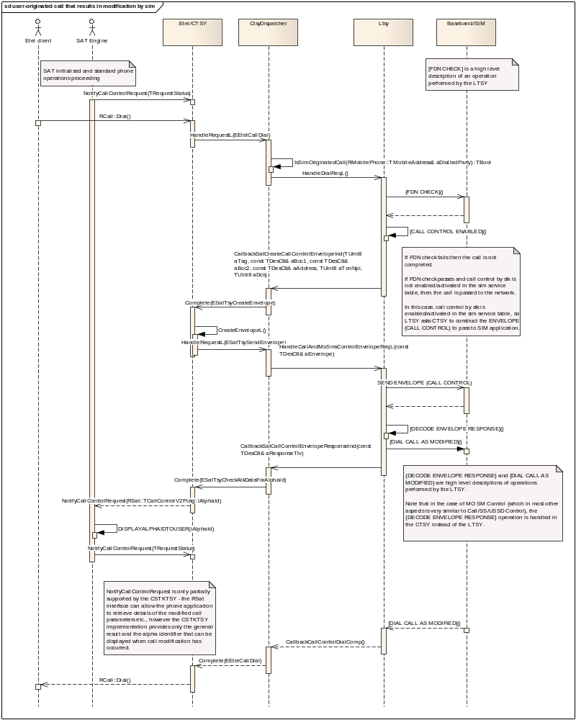

Use Case 6 : Timer Management functionality
This use case covers:
- Receiving a Pro-Active command to start a timer and handling the terminal response created from the SIM ATK CTSY
- Waiting for the timer to expire and handling the timer expiration envelope.
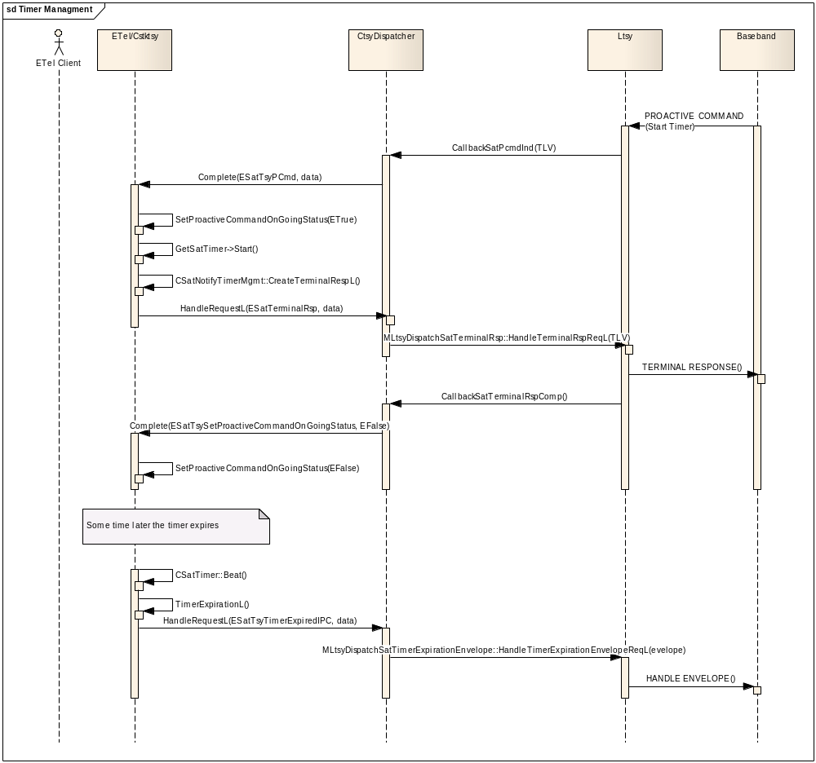

Use Case 7 : Setting the polling interval
This use case covers:
- Receiving a Pro-Active command to set the polling interval to a new value, where the Pro-Active command is parsed and the new poll interval is passed via a Handler to the LTSY.
- The completion of the Handler to set the new poll interval which generates a Terminal Response from the SIM ATK CTSY
- Receiving a Pro-Active command to set the polling interval off (same procedure as setting a new poll interval)
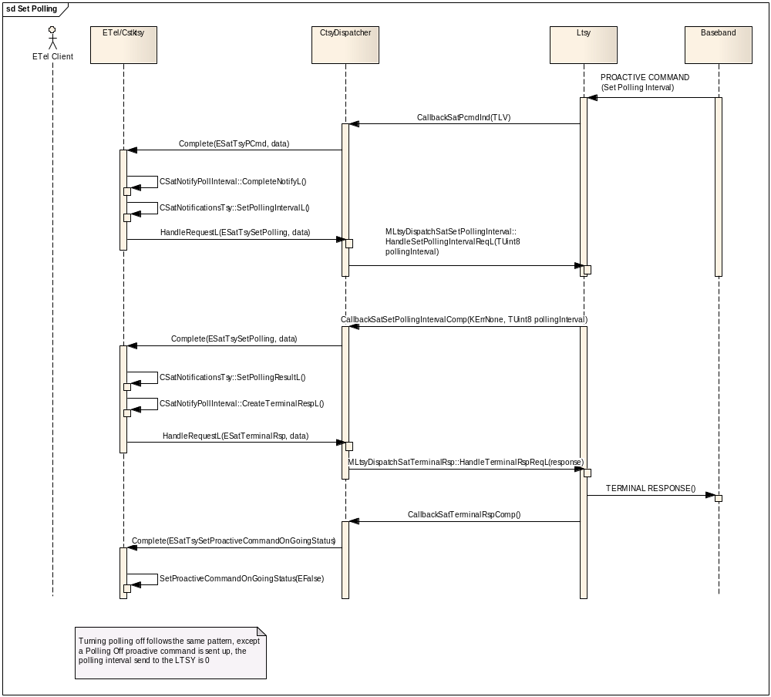

Use Case 8 : Mo SMS Control functionality
This use case covers:
- Setting up a Client side notify for when a Send Sm Pro-Active command has been received (RSat::NotifySendSmPCmd).
- Setting up a Client side notify for when a Mo Sm (Short Message) control request has been received (RSat:: NotifyMoSmControlRequest).
- Receiving a Pro-Active command to send a Sm.
- Using the data from the Pro-Active command, send an SMS via a RSat::SendMessageNoLogging call
- The LTSY handling the send request which results in the LTSY requiring a MoSmControl Envelope command to be created.
- Handling by the LTSY of the created MoSmControl Envelope (passed to the baseband)
- The LTSY handling the basebands response which is passed to the SIM ATK CTSY, where it is parsed and sent back to the LTSY containing the details required to send the SMS. The outstanding NotifyMoSmControlRequest is also completed.
- The completion of sending the SMS from the Baseband back to ETel (the outstanding SendMessageNoLogging is completed)
- The terminal response to complete the Proactive command.
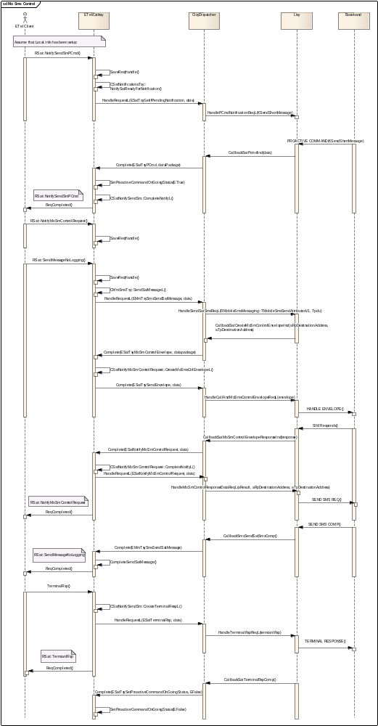

Use Case 9 : Sms PP and Cell Broadcast Data Download
This use case covers:
- A request for the SIM ATK to create a Sms PP envelope when Sms PP is allocated and activated in the SIM (the envelope is passed to the SIM)
- A request for the SIM ATK to create a Sms PP envelope when Sms PP is not allocated and activated in the SIM (the Sms is written to the store)
- A request for the SIM ATK to create a Cell Broadcast Data Download envelope (the envelope is passed to the SIM)

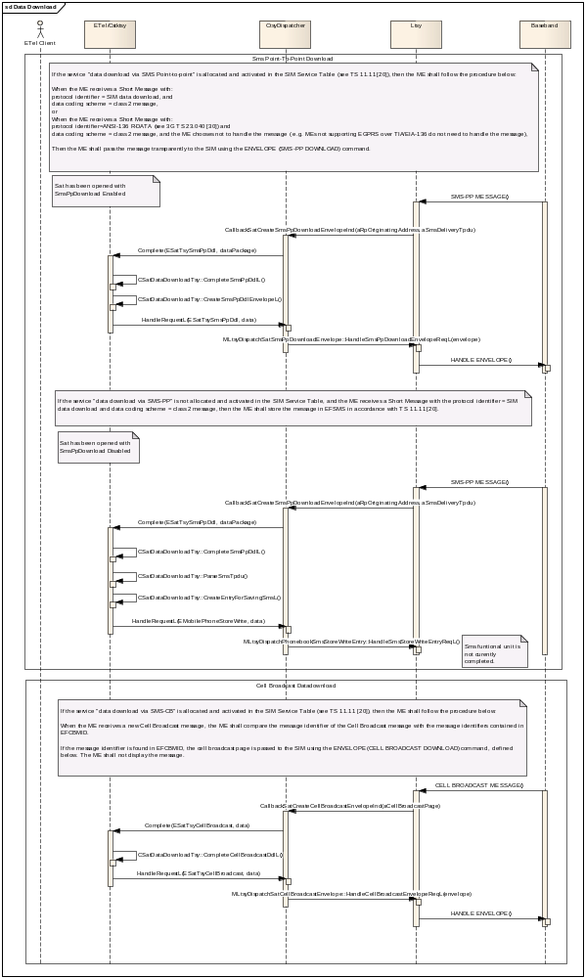

Use Case 10 : Refresh

The REFRESH command is described fully in ETSI TS 102 223. It tells you three main things:
- It can indicate that one or more of the files on the UICC have changed.
- It can request that the UICC has been reset.
- It can request that one of the applications running on the UICC be refreshed.

Any application that deals with UICC data may want to receive notification when files change (e.g. address book application may want to know if the address book data changes).
The phone's main SAT application decides when other applications receive REFRESH commands. If the main SAT application is in the middle of editing UICC data, it can delay the REFRESH notification to other applications until it has finished editing:
To request notification of a REFRESH proactive command, the main SAT application calls both RSat::NotifyRefreshRequired() and RSat::NotifyRefreshPCmd(), while other applications only call RSat::NotifyRefreshPCmd().
When the main SAT application has called both notifiers, a request down to the LTSY is sent (via HandlePCmdNotificationReqL) thus requesting registration to notifications when Refresh Proactive commands are sent from the baseband.
Once a Refresh Proactive command is sent the CTSY completes the outstanding RSat::NotifyRefreshRequired().This tells the main SAT application that a REFRESH is pending and gives the main SAT application a chance to tidy up.
Once the main SAT application is ready, it calls RSat::RefreshAllowed(),this tells the LTSY (via a HandleRefreshAllowedReqL) that it can complete any outstanding RSat::NotifyRefreshPCmd() requests (via CallbackSatRefreshAllowedComp).
At this point the applications can do the refresh (the type of Refresh is indicated in the original proactive command).
Once completed the main SAT application sends a Terminal Response to the initial proactive command.
In the error case where the LTSY completes the CallbackSatRefreshAllowedComp with an error, the outstanding RSat::NotifyRefreshPCmd() are completed with the same error code. The LTSY then has the responsibility to create the Terminal response this is done via an indicator call CallbackSatCreateRefreshTerminalRspInd, where the Terminal response is created in the CTSY, this is then sent back via the normal terminal response route.

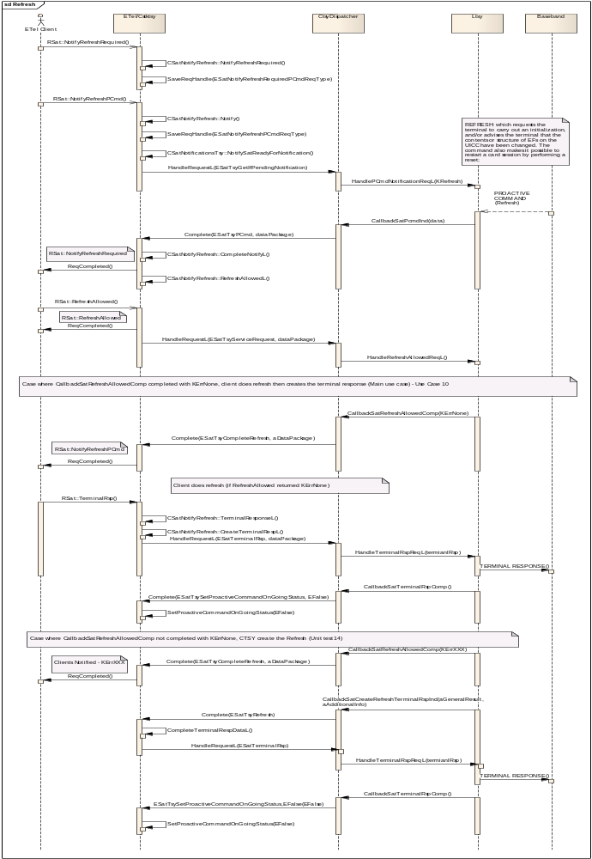

Further Information

People
Role | Person / People
Reviewers | Symbian
Contributors | Neil McAlpine, Sophie Yim, Rob Pallister, Francis Fisher, Richard Moorhouse, Marek Daniluk, Alon Wureit, Yiftach Kaplan, Thanh Dao
Distribution | Symbian

References
No. | Document Reference | Version | Description
[R1] | How to run CTSY and LTSY.doc |  | Details of building/running the CTSY and LTSY using the new configuration.
[R2] | Common_TSY_How To_Implementation_Guideline.doc |  | Simple guide to start writing a CTSY
[R3] | Common TSY Plugin API Specification.doc |  | Detailed description of message sequences for various use-cases

- Building the CTSY, CtsyDispatcher, LtsySkeleton and MockLTSY

For details on how to build the components referred to in this document, please refer to the document entitled: How to run CTSY and LTSY.doc [R1].

- Frequently Asked Questions
  - Why does CtsyDispatcher require that callback APIs be invoked from ETEL thread of execution?
Following standard Symbian patterns the Etel server and CTSY plugin are executed within a single thread of execution, namely the ETEL thread. This is a system critical thread, meaning any assert that is triggered on this thread will cause the device to reboot.
The CTSY is not written in a thread-safe way, meaning it is expected that callbacks triggered by events being received by the LTSY should be invoked within the Etel thread of execution and not on another thread.
The architecture of the LTSY does not preclude the use of multiple threads and an example where multiple threads maybe needed is if the event handling for callbacks into the LTSY, from the baseband are via a synchronous message handler, which runs in a blocking wait loop.
The CtsyDispatcher does not provide this thread-switching itself and it is the responsibility of the LTSY to perform the thread-switching back to the Etel thread in order that the callback into the CtsyDispatcher is running under the correct thread of execution.
The reasons for not providing this as part of the CtsyDispatcher are:
- If the baseband interface is such that thread-switching is required then it is likely that the LTSY must have to do this anyway even if CtsyDispatcher were also to offer this within the handling of the callback, therefore the preference is for the LTSY to do all necessary thread-switching. For example there is often not a one-to-one relationship between requests made into the LTSY and API calls into the baseband. E.g. reading data from the SIM may require two calls from the LTSY to the baseband in order to a) select file, b) read file. For simplicity, it is expected that the invocation of these APIs should be triggered from the same thread and therefore there would be a requirement for the LTSY to perform thread-switching itself where completion of the first API (e.g. select file) triggers a thread-switch back to main thread to do the next part of the request, namely the read file request.
- It adds complexity to the CtsyDispatcher for a feature that is not uniformly required by all LTSYs. The callback API offered by the CtsyDispatcher allows for a simple use of stack based variables to be populated and passed into the CtsyDispatcher that can simply be passed up to the CTSY for processing. By introducing a thread-switch in the CtsyDispatcher the stack based argument data received from the LTSY must be saved on the heap such that they are available for use after the thread-switch. It is an objective to keep the CtsyDispatcher as simple as possible and to be merely act as a translation between the dispatcher interface and the CTSY message based interface.
- The optional receive thread (see 6.2) framework that maybe incorporated into the LTSY if needed offers a better point for performing thread switching since it is much lower in the stack meaning all the code above this point (e.g. LTSY, CtsyDispatcher and CTSY) does not need to be written thread-safe. Implementing an LTSY where it is processing and dispatching requests from multiple threads is likely to require more effort than a single-threaded LTSY.
To aid the LTSY with this thread-switching a framework is provided as part of the LtsySkeleton that may optionally used – see 6.2.

